






Develop and update local knowledge
D1.HRS.CL1.06
D1.HOT.CL1.09
D2.TTA.CL2.11
Trainer Guide

Develop and update local knowledge

D1.HRS.CL1.06
D1.HOT.CL1.09
D2.TTA.CL2.11

Trainer Guide





Project Base
William Angliss Institute of TAFE
555 La Trobe Street
Melbourne 3000 Victoria
Telephone: | (03) 9606 2111
Facsimile: | (03) 9670 1330
Acknowledgements
Project Director: | Wayne Crosbie
Chief Writer: | Alan Hickman
Subject Writer: | Alan Hickman
Project Manager/Editor: | Alan Maguire
DTP/Production | Daniel Chee, Mai Vu, Jirayu Thangcharoensamut, Kaly Quach

The Association of Southeast Asian Nations (ASEAN) was established on 8 August 1967. The Member States of the Association are Brunei Darussalam, Cambodia, Indonesia, Lao PDR, Malaysia, Myanmar, Philippines, Singapore, Thailand and Viet Nam.
The ASEAN Secretariat is based in Jakarta, Indonesia.
General Information on ASEAN appears online at the ASEAN Website: www.asean.org.
All text is produced by William Angliss Institute of TAFE for the ASEAN Project on “Toolbox Development for Priority Tourism Labour Division”.
This publication is supported by the Australian Government’s aid program through the ASEAN-Australia Development Cooperation Program Phase II (AADCP II).
Copyright: Association of Southeast Asian Nations (ASEAN) 2012.
All rights reserved.
Disclaimer
Every effort has been made to ensure that this publication is free from errors or omissions. However, you should conduct your own enquiries and seek professional advice before relying on any fact, statement or matter contained in this book. The ASEAN Secretariat and William Angliss Institute of TAFE are not responsible for any injury, loss or damage as a result of material included or omitted from this course. Information in this module is current at the time of publication. Time of publication is indicated in the date stamp at the bottom of each page.
Some images appearing in this resource have been purchased from stock photography suppliers Shutterstock and iStockphoto and other third party copyright owners and as such are non-transferable and non-exclusive. Clip arts, font images and illustrations used are from the Microsoft Office Clip Art and Media Library. Some images have been provided by and are the property of William Angliss Institute.
Additional images have been sourced from Flickr and SXC and are used under Creative Commons licence: http://creativecommons.org/licenses/by/2.0/deed.en

File name: TG_Develop_&_update_local_knowledge_refined





Table of contents
Competency Based Training (CBT) and assessment an introduction for trainers 1
Competency standard 11
Notes and PowerPoint slides 15
Recommended training equipment 129
Instructions for Trainers for using PowerPoint – Presenter View 131
Appendix – ASEAN acronyms 133

Competency Based Training (CBT) and assessment an introduction for trainers

Competency
Competency refers to the ability to perform particular tasks and duties to the standard of performance expected in the workplace.
Competency requires the application of specified knowledge, skills and attitudes relevant to effective participation, consistently over time and in the workplace environment.
The essential skills and knowledge are either identified separately or combined.
Knowledge identifies what a person needs to know to perform the work in an informed and effective manner.
Skills describe the application of knowledge to situations where understanding is converted into a workplace outcome.
Attitude describes the founding reasons behind the need for certain knowledge or why skills are performed in a specified manner.
Competency covers all aspects of workplace performance and involves:
- Performing individual tasks
- Managing a range of different tasks
- Responding to contingencies or breakdowns
- Dealing with the responsibilities of the workplace
- Working with others.

Unit of Competency
Like with any training qualification or program, a range of subject topics are identified that focus on the ability in a certain work area, responsibility or function.
Each manual focuses on a specific unit of competency that applies in the hospitality workplace.
In this manual a unit of competency is identified as a ‘unit’.
Each unit of competency identifies a discrete workplace requirement and includes:
- Knowledge and skills that underpin competency
- Language, literacy and numeracy
- Occupational safety and health requirements.
Each unit of competency must be adhered to in training and assessment to ensure consistency of outcomes.

Element of Competency
An element of competency describes the essential outcomes within a unit of competency.
The elements of competency are the basic building blocks of the unit of competency. They describe in terms of outcomes the significant functions and tasks that make up the competency.
In this manual elements of competency are identified as an ‘element’.

Performance criteria
Performance criteria indicate the standard of performance that is required to demonstrate achievement within an element of competency. The standards reflect identified industry skill needs.
Performance criteria will be made up of certain specified skills, knowledge and attitudes.

Learning
For the purpose of this manual learning incorporates two key activities:
- Training
- Assessment.
Both of these activities will be discussed in detail in this introduction.
Today training and assessment can be delivered in a variety of ways. It may be provided to participants:
- On-the-job – in the workplace
- Off-the-job – at an educational institution or dedicated training environment
- As a combination of these two options.
No longer is it necessary for learners to be absent from the workplace for long periods of time in order to obtain recognised and accredited qualifications.

Learning Approaches
This manual will identify two avenues to facilitate learning:
Competency Based Training (CBT)
This is the strategy of developing a participant’s competency.
Educational institutions utilise a range of training strategies to ensure that participants are able to gain the knowledge and skills required for successful:
- Completion of the training program or qualification
- Implementation in the workplace.
The strategies selected should be chosen based on suitability and the learning styles of participants.

Competency Based Assessment (CBA)
This is the strategy of assessing competency of a participant.
Educational institutions utilise a range of assessment strategies to ensure that participants are assessed in a manner that demonstrates validity, fairness, reliability, flexibility and fairness of assessment processes.

Flexibility in Learning
It is important to note that flexibility in training and assessment strategies is required to meet the needs of participants who may have learning difficulties. The strategies used will vary, taking into account the needs of individual participants with learning difficulties. However they will be applied in a manner which does not discriminate against the participant or the participant body as a whole.
Catering for Participant Diversity
Participants have diverse backgrounds, needs and interests. When planning training and assessment activities to cater for individual differences, trainers and assessors should:
- Consider individuals’ experiences, learning styles and interests
- Develop questions and activities that are aimed at different levels of ability
- Modify the expectations for some participants
- Provide opportunities for a variety of forms of participation, such as individual, pair and small group activities
- Assess participants based on individual progress and outcomes.
The diversity among participants also provides a good reason for building up a learning community in which participants support each other’s learning.
Participant Centred Learning
This involves taking into account structuring training and assessment that:
- Builds on strengths – Training environments need to demonstrate the many positive features of local participants (such as the attribution of academic success to effort, and the social nature of achievement motivation) and of their trainers (such as a strong emphasis on subject disciplines and moral responsibility). These strengths and uniqueness of local participants and trainers should be acknowledged and treasured
- Acknowledges prior knowledge and experience – The learning activities should be planned with participants’ prior knowledge and experience in mind
- Understands learning objectives – Each learning activity should have clear learning objectives and participants should be informed of them at the outset. Trainers should also be clear about the purpose of assignments and explain their significance to participants
- Teaches for understanding – The pedagogies chosen should aim at enabling participants to act and think flexibly with what they know
- Teaches for independent learning – Generic skills and reflection should be nurtured through learning activities in appropriate contexts of the curriculum. Participants should be encouraged to take responsibility for their own learning
- Enhances motivation – Learning is most effective when participants are motivated. Various strategies should be used to arouse the interest of participants
- Makes effective use of resources – A variety of teaching resources can be employed as tools for learning
- Maximises engagement – In conducting learning activities, it is important for the minds of participants to be actively engaged
- Aligns assessment with learning and teaching – Feedback and assessment should be an integral part of learning and teaching
- Caters for learner diversity – Trainers should be aware that participants have different characteristics and strengths and try to nurture these rather than impose a standard set of expectations.
Active Learning
The goal of nurturing independent learning in participants does not imply that they always have to work in isolation or solely in a classroom. On the contrary, the construction of knowledge in tourism and hospitality studies can often best be carried out in collaboration with others in the field. Sharing experiences, insights and views on issues of common concern, and working together to collect information through conducting investigative studies in the field (active learning) can contribute a lot to their eventual success.
Active learning has an important part to play in fostering a sense of community in the class. First, to operate successfully, a learning community requires an ethos of acceptance and a sense of trust among participants, and between them and their trainers. Trainers can help to foster acceptance and trust through encouragement and personal example, and by allowing participants to take risks as they explore and articulate their views, however immature these may appear to be. Participants also come to realise that their classmates (and their trainers) are partners in learning and solving.
Trainers can also encourage cooperative learning by designing appropriate group learning tasks, which include, for example, collecting background information, conducting small-scale surveys, or producing media presentations on certain issues and themes. Participants need to be reminded that, while they should work towards successful completion of the field tasks, developing positive peer relationships in the process is an important objective of all group work.

Competency Based Training (CBT)
Principle of Competency Based Training
Competency based training is aimed at developing the knowledge, skills and attitudes of participants, through a variety of training tools.
Training Strategies
The aims of this curriculum are to enable participants to:
- Undertake a variety of subject courses that are relevant to industry in the current environment
- Learn current industry skills, information and trends relevant to industry
- Learn through a range of practical and theoretical approaches
- Be able to identify, explore and solve issues in a productive manner
- Be able to become confident, equipped and flexible managers of the future
- Be ‘job ready’ and a valuable employee in the industry upon graduation of any qualification level.
To ensure participants are able to gain the knowledge and skills required to meet competency in each unit of competency in the qualification, a range of training delivery modes are used.
Types of Training
In choosing learning and teaching strategies, trainers should take into account the practical, complex and multi-disciplinary nature of the subject area, as well as their participant’s prior knowledge, learning styles and abilities.
Training outcomes can be attained by utilising one or more delivery methods:
Lecture/Tutorial
This is a common method of training involving transfer of information from the trainer to the participants. It is an effective approach to introduce new concepts or information to the learners and also to build upon the existing knowledge. The listener is expected to reflect on the subject and seek clarifications on the doubts.
Demonstration
Demonstration is a very effective training method that involves a trainer showing a participant how to perform a task or activity. Through a visual demonstration, trainers may also explain reasoning behind certain actions or provide supplementary information to help facilitate understanding.
Group Discussions
Brainstorming in which all the members in a group express their ideas, views and opinions on a given topic, is a free flow and exchange of knowledge among the participants and the trainer. The discussion is carried out by the group on the basis of their own experience, perceptions and values. This will facilitate acquiring new knowledge. When everybody is expected to participate in the group discussion, even the introverted persons will also get stimulated and try to articulate their feelings.
The ideas that emerge in the discussions should be noted down and presentations are to be made by the groups. Sometimes consensus needs to be arrived at on a given topic. Group discussions are to be held under the moderation of a leader guided by the trainer. Group discussion technique triggers thinking process, encourages interactions and enhances communication skills.
Role Play
This is a common and very effective method of bringing into the classroom real life situations, which may not otherwise be possible. Participants are made to enact a particular role so as to give a real feel of the roles they may be called upon to play. This enables participants to understand the behaviour of others as well as their own emotions and feelings. The instructor must brief the role players on what is expected of them. The role player may either be given a ready-made script, which they can memorise and enact, or they may be required to develop their own scripts around a given situation. This technique is extremely useful in understanding creative selling techniques and human relations. It can be entertaining and energising and it helps the reserved and less literate to express their feelings.

Simulation Games
When trainees need to become aware of something that they have not been conscious of, simulations can be a useful mechanism. Simulation games are a method based on "here and now" experience shared by all the participants. The games focus on the participation of the trainees and their willingness to share their ideas with others. A "near real life" situation is created providing an opportunity to which they apply themselves by adopting certain behaviour. They then experience the impact of their behaviour on the situation. It is carried out to generate responses and reactions based on the real feelings of the participants, which are subsequently analysed by the trainer.
While use of simulation games can result in very effective learning, it needs considerable trainer competence to analyse the situations.
Individual /Group Exercises
Exercises are often introduced to find out how much the participant has assimilated. This method involves imparting instructions to participants on a particular subject through use of written exercises. In the group exercises, the entire class is divided into small groups, and members are asked to collaborate to arrive at a consensus or solution to a problem.
Case Study
This is a training method that enables the trainer and the participant to experience a real life situation. It may be on account of events in the past or situations in the present, in which there may be one or more problems to be solved and decisions to be taken. The basic objective of a case study is to help participants diagnose, analyse and/or solve a particular problem and to make them internalise the critical inputs delivered in the training. Questions are generally given at the end of the case study to direct the participants and to stimulate their thinking towards possible solutions. Studies may be presented in written or verbal form.
Field Visit
This involves a carefully planned visit or tour to a place of learning or interest. The idea is to give first-hand knowledge by personal observation of field situations, and to relate theory with practice. The emphasis is on observing, exploring, asking questions and understanding. The trainer should remember to brief the participants about what they should observe and about the customs and norms that need to be respected.
Group Presentation
The participants are asked to work in groups and produce the results and findings of their group work to the members of another sub-group. By this method participants get a good picture of each other's views and perceptions on the topic and they are able to compare them with their own point of view. The pooling and sharing of findings enriches the discussion and learning process.
Practice Sessions
This method is of paramount importance for skills training. Participants are provided with an opportunity to practice in a controlled situation what they have learnt. It could be real life or through a make-believe situation.

Games
This is a group process and includes those methods that involve usually fun-based activity, aimed at conveying feelings and experiences, which are everyday in nature, and applying them within the game being played. A game has set rules and regulations, and may or may not include a competitive element. After the game is played, it is essential that the participants be debriefed and their lessons and experiences consolidated by the trainer.
Research
Trainers may require learners to undertake research activities, including online research, to gather information or further understanding about a specific subject area.

Competency Based Assessment (CBA)
Principle of Competency Based Assessment
Competency based assessment is aimed at compiling a list of evidence that shows that a person is competent in a particular unit of competency.
Competencies are gained through a multitude of ways including:
- Training and development programs
- Formal education
- Life experience
- Apprenticeships
- On-the-job experience
- Self-help programs.
All of these together contribute to job competence in a person. Ultimately, assessors and participants work together, through the ‘collection of evidence’ in determining overall competence.
This evidence can be collected:
- Using different formats
- Using different people
- Collected over a period of time.
The assessor, who is ideally someone with considerable experience in the area being assessed, reviews the evidence and verifies the person as being competent or not.
Flexibility in Assessment
Whilst allocated assessment tools have been identified for this subject, all attempts are made to determine competency and suitable alternate assessment tools may be used, according to the requirements of the participant.
The assessment needs to be equitable for all participants, taking into account their cultural and linguistic needs.
Competency must be proven regardless of:
- Language
- Delivery Method
- Assessment Method.
Assessment Objectives
The assessment tools used for subjects are designed to determine competency against the ‘elements of competency’ and their associated ‘performance criteria’.
The assessment tools are used to identify sufficient:
- Knowledge, including underpinning knowledge
- Skills
- Attitudes
Assessment tools are activities that trainees are required to undertake to prove participant competency in this subject.
All assessments must be completed satisfactorily for participants to obtain competence in this subject. There are no exceptions to this requirement, however, it is possible that in some cases several assessment items may be combined and assessed together.
Types of Assessment
Allocated Assessment Tools
There are a number of assessment tools that are used to determine competency in this subject:
- Work projects
- Written questions
- Oral questions
- Third Party Report
- Observation Checklist.
Instructions on how assessors should conduct these assessment methods are explained in the Assessment Manuals.
Alternative Assessment Tools
Whilst this subject has identified assessment tools, as indicated above, this does not restrict the assessor from using different assessment methods to measure the competency of a participant.
Evidence is simply proof that the assessor gathers to show participants can actually do what they are required to do.
Whilst there is a distinct requirement for participants to demonstrate competency, there are many and diverse sources of evidence available to the assessor.
Ongoing performance at work, as verified by a supervisor or physical evidence, can count towards assessment. Additionally, the assessor can talk to customers or work colleagues to gather evidence about performance.
A range of assessment methods to assess competency include:
- Practical demonstrations
- Practical demonstrations in simulated work conditions
- Problem solving
- Portfolios of evidence
- Critical incident reports
- Journals
- Oral presentations
- Interviews
- Videos
- Visuals: slides, audio tapes
- Case studies
- Log books
- Projects
- Role plays
- Group projects
- Group discussions
- Examinations.
Recognition of Prior Learning
Recognition of Prior Learning is the process that gives current industry professionals who do not have a formal qualification, the opportunity to benchmark their extensive skills and experience against the standards set out in each unit of competency/subject.
Also known as a Skills Recognition Audit (SRA), this process is a learning and assessment pathway which encompasses:
- Recognition of Current Competencies (RCC)
- Skills auditing
- Gap analysis and training
- Credit transfer.
Assessing competency
As mentioned, assessment is the process of identifying a participant’s current knowledge, skills and attitudes sets against all elements of competency within a unit of competency. Traditionally in education, grades or marks were given to participants, dependent on how many questions the participant successfully answered in an assessment tool.
Competency based assessment does not award grades, but simply identifies if the participant has the knowledge, skills and attitudes to undertake the required task to the specified standard.
Therefore, when assessing competency, an assessor has two possible results that can be awarded:
- Pass Competent (PC)
- Not Yet Competent (NYC).
Pass Competent (PC)
If the participant is able to successfully answer or demonstrate what is required, to the expected standards of the performance criteria, they will be deemed as ‘Pass Competent’ (PC).
The assessor will award a ‘Pass Competent’ (PC) if they feel the participant has the necessary knowledge, skills and attitudes in all assessment tasks for a unit.
Not Yet Competent’ (NYC)
If the participant is unable to answer or demonstrate competency to the desired standard, they will be deemed to be ‘Not Yet Competent’ (NYC).
This does not mean the participant will need to complete all the assessment tasks again. The focus will be on the specific assessment tasks that were not performed to the expected standards.
The participant may be required to:
a) Undertake further training or instruction
b) Undertake the assessment task again until they are deemed to be ‘Pass Competent’.

Competency standard
UNIT TITLE: DEVELOP AND UPDATE LOCAL KNOWLEDGE |  |  |  |  |  |  | NOMINAL HOURS: | 30
UNIT NUMBER: | D1.HRS.CL1.06 | D1.HOT.CL1.09 |  | D2.TTA.CL2.11
UNIT DESCRIPTOR: This unit deals with the skills and knowledge required to develop and update local knowledge in a range of settings within the in the hotel and travel industries workplace context.
ELEMENTS AND PERFORMANCE CRITERIA |  |  | UNIT VARIABLE AND ASSESSMENT GUIDE
Element 1: Develop local knowledge  - Identify and access sources for information on the local area, correctly  - Identify and obtain information to assist queries on local/national tourism industry, correctly  - Store and update information according to enterprise procedures  - Share information with colleagues  Element 2: Update local knowledge  - Use informal and/or formal research to update local knowledge  - Share updated knowledge with customers and colleagues, as appropriate  - Incorporate the sharing of local knowledge into day to day working activities |  |  | Unit Variables  The Unit Variables provide advice to interpret the scope and context of this unit of competence, allowing for differences between enterprises and workplaces. It relates to the unit as a whole and facilitates holistic assessment.  This unit applies to all industry sectors that require the worker to develop and update local knowledge to be applied within the labour divisions of the hotel and travel industries and may include:  - Front Office  - Housekeeping  - Food and Beverage Service  - Food Production  - Travel Agencies  - Tour Operation  Information may include:  General information on the tourism industry  Local tourism destinations, facilities, infrastructure and modes of transportation  Tourism products, services, facilities, rates
Element 3: Maintain contact with local communities  - Provide accurate local tourism information in response to queries  - Use local knowledge to promote tourism products and services to encourage usage and purchase  - Make customers aware of possible extras, add-ons and further benefits  - Report queries and results to designated person within enterprise for follow-up purposes |  |  | Environmental issues  Local transport  Local attractions, tours, events, places of interest  Local customs.  Informal and/or formal research may include:  Networking activities  Familiarization activities  Internet research  Travel and tourism literature.  Tourism products and services may include:  Destinations  Facilities  Accommodation  Attractions, tours, places of interest  Transportation.
Assessment Guide
The following skills and knowledge must be assessed as part of this unit:
Knowledge of the enterprise’s policies and procedures in regard to developing and updating local knowledge
Knowledge of the enterprise’s policies and procedures in regard to sharing local knowledge and responding to queries
Demonstrated ability to provide accurate local tourism information regarding the local environment in response to queries relevant to job role
Ability to source information
Ability to store and maintain information.
Linkages to other units
Maintain hospitality industry knowledge
Maintain tourism industry knowledge
Work effectively with colleagues and customers.
Critical Aspects of Assessment
Evidence of the following is essential:
The ability to identify and promote local tourism products and services
The ability to source accurate and current information on the local area
The ability to apply general knowledge of the local area to answer commonly asked customer questions, relevant to the job role.
Context of Assessment
This unit may be assessed on or off the job:
Assessment should include practical demonstration either in the workplace or through a simulation activity, supported by a range of methods to assess underpinning knowledge
Assessment must relate to the individual’s work area or area of responsibility.
Resource Implications
Training and assessment to include access to a real or simulated workplace; and access to workplace standards, procedures, policies, guidelines, tools and equipment.
Assessment Methods
The following methods may be used to assess competency for this unit:
Case studies
Observation of practical candidate performance
Oral and written questions
Portfolio evidence
Problem solving
Role plays
Third party reports completed by a supervisor
Project and assignment work.
Key Competencies in this Unit
Level 1 = competence to undertake tasks effectively
Level 2 = competence to manage tasks
Level 3 = competence to use concepts for evaluating
 |  |  | Key Competencies |  | Level | Examples
 |  |  | Collecting, organizing and analysing information |  | 1 | Interpret procedures correctly
 |  |  | Communicating ideas and information |  | 2 | Interact with customers; promote local tourism products and services
 |  |  | Planning and organizing activities |  | 2 | Prioritize actions
 |  |  | Working with others and in teams |  | 1 | Identify opportunities for designated person to take follow-up action
 |  |  | Using mathematical ideas and techniques |  | -
 |  |  | Solving problems |  | 1 | Use relevant enterprise procedures to resolve problems
 |  |  | Using technology |  | 1 | Use internet to identify and obtain sources of local knowledge

Notes and PowerPoint slides
Slide
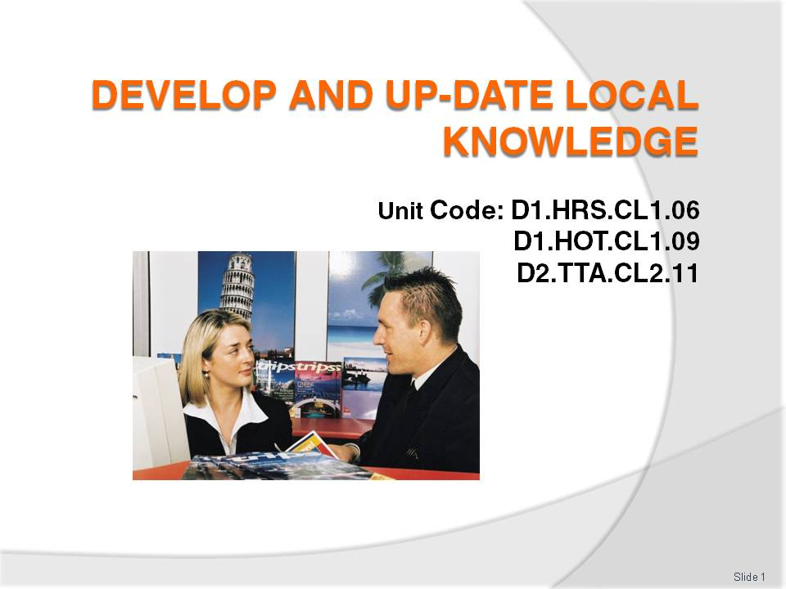
Slide No | Trainer Notes
 | Trainer welcomes trainees to class.

Slide
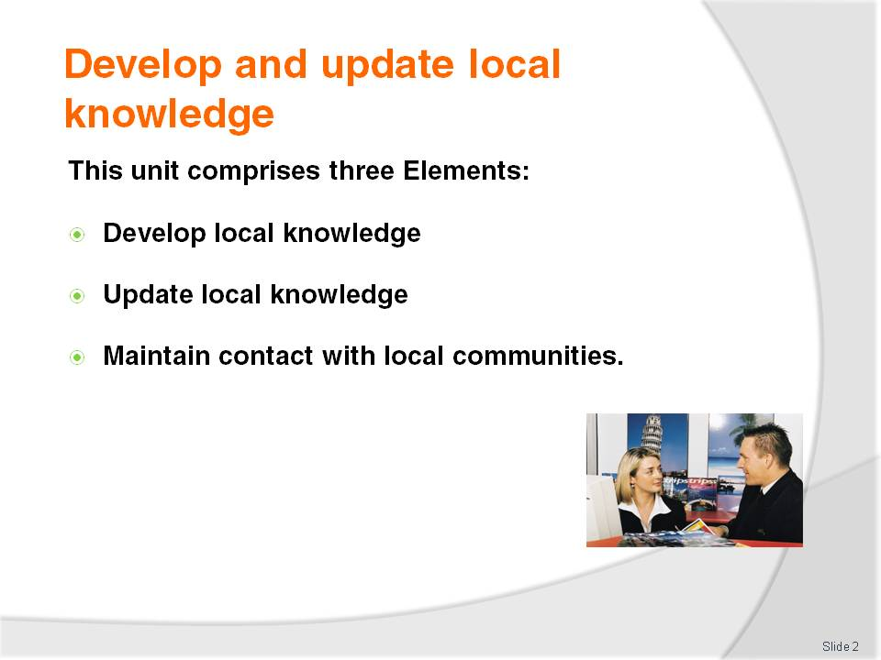
Slide No | Trainer Notes
Trainer advises trainees this Unit comprises three Elements, as listed on the slide explaining:
Each Element comprises a number of Performance Criteria which will be identified throughout the class and explained in detail
Trainees can obtain more detail from their Trainee Manual
At times the course presents advice and information about reporting procedures but where their workplace requirements differ to what is presented, the workplace practices and standards must be observed.

Slide
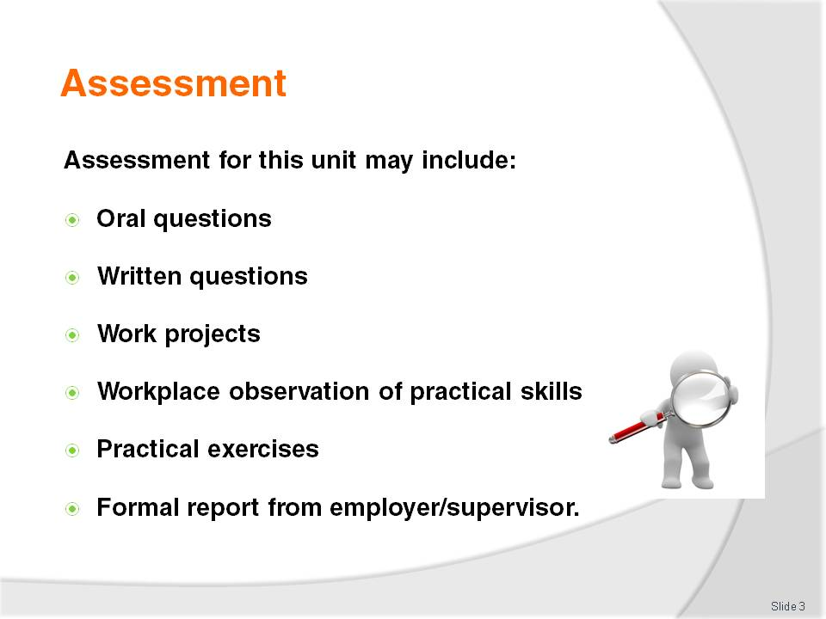
Slide No | Trainer Notes
Trainer advises trainees that assessment for this Unit may take several forms all of which are aimed at verifying they have achieved competency for the Unit as required.
Trainer indicates to trainees the methods of assessment that will be applied to them for this Unit.

Slide
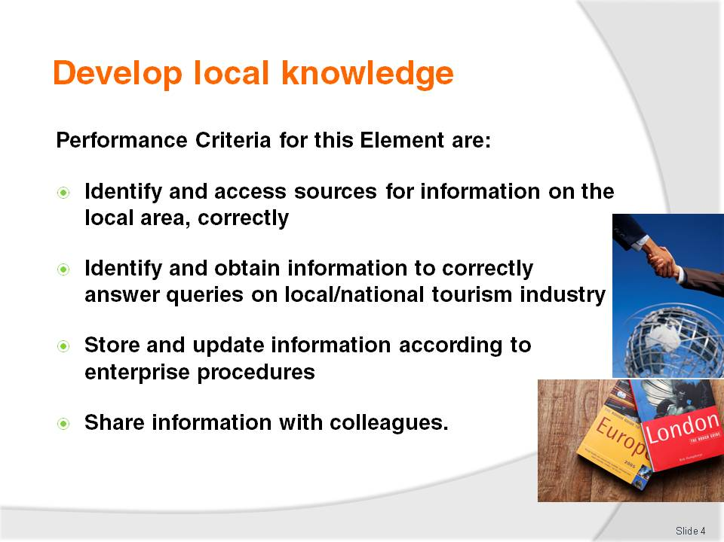
Slide No | Trainer Notes
Trainer identifies for trainees the Performance Criteria for this Element, as listed on the slide.
Class Activity – General discussion
Trainer leads a general class discussion on the development of local knowledge for workers in the hospitality and tourism industries asking questions such as:
Why is there a need for workers to have local knowledge?
How might staff use local knowledge in their day to day work?
What aspects of the local area might workers need to develop local knowledge about?
What sources of local knowledge can you identify?
What personal experiences do you have of providing local knowledge to visitors/tourists?
Have you ever been in a foreign country or different region and wanted some local information but were unable to get it? How did that make you feel? What is your opinion of that place now?

Slide
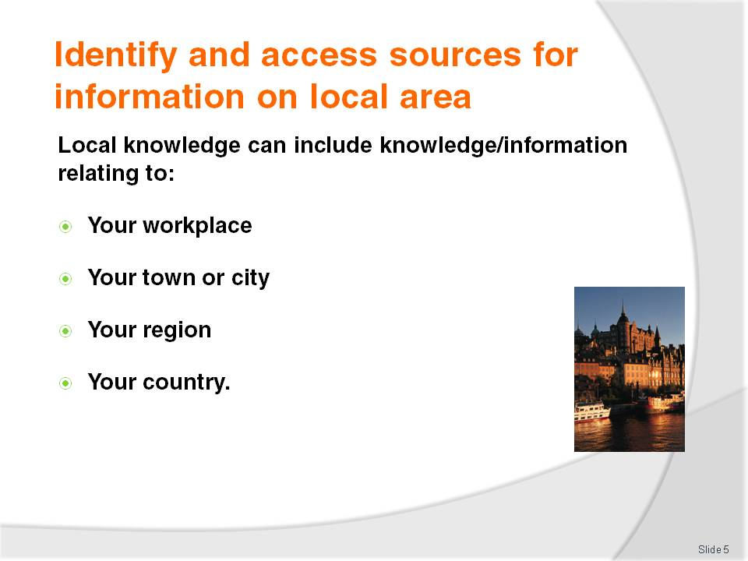
Slide No | Trainer Notes
Trainer instructs trainees that industry and product knowledge are vital pre-requisites for effective performance within the industry.
Trainer identifies ‘local’ knowledge may include information about:
The venue (trainee workplace) also known as ‘product’ knowledge
The town or city in which they work and where their workplace is located
The region – covering the surrounding area, provinces, municipalities
The country – highlighting the need for ‘all of country’ knowledge when dealing with international visitors.

Slide
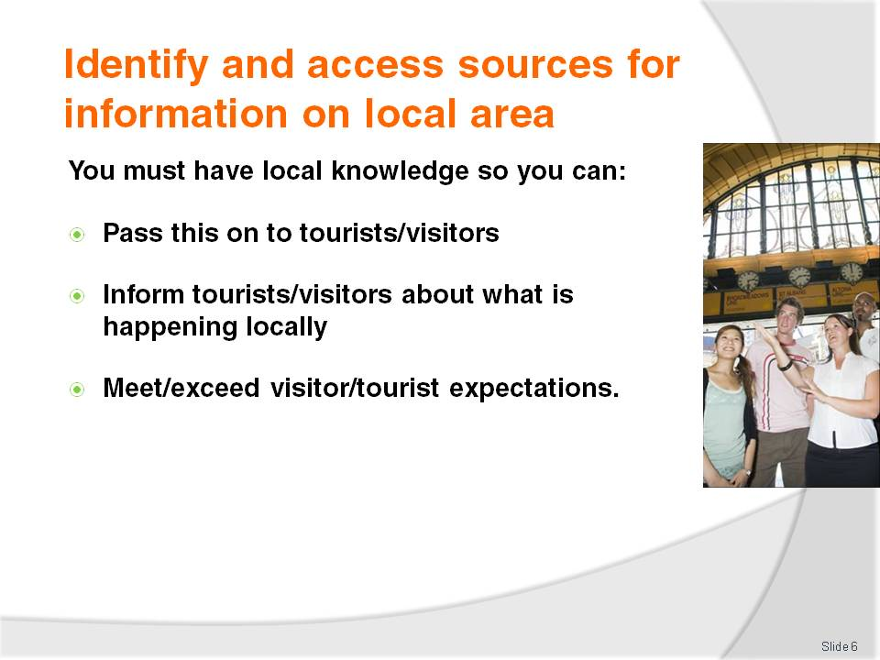
Slide No | Trainer Notes
Trainer explains to trainees it is important to have appropriate and sufficient local knowledge so they can:
Pass this on to tourists/visitors and enhance visitor/tourist experience
Inform tourists/visitors about what is happening locally and convince them to spend more time (and money) in the area or town which will help create more jobs and generate even more tourism, more businesses, more opportunities, and more benefit to the region and the country
Meet tourist and visitor expectation. Tourists/visitors expect staff at a hotel to be able to advise them about local events, attractions.

Slide
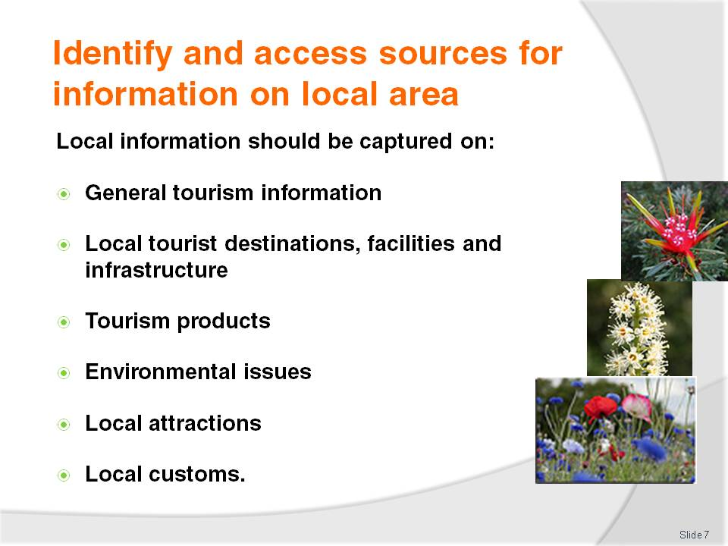
Slide No | Trainer Notes
Trainer explains to trainees when developing local knowledge they should aim to capture information on:
General information on the tourism industry – trends in visitations, country of origin of tourists and in-bound tourist numbers
Local tourism destinations including facilities and infrastructure such as toilets, public transport, emergency services
Tourism products including tourism services, facilities and rates/costs, ticket prices
Environmental issues including eco-tourism, weather, ‘at risk’ species of flora and fauna
Local attractions including local tours, events and places of interest
Local customs – what visitors should do or not do, things they should avoid saying or doing and local food and drinks.
Class Activity – Small Group Exercise
Trainer divides trainees into six groups and asks them to prepare without reference to any outside sources the most comprehensive list of local information they can in relation to each of the six categories listed on the slide (above).
Each group should have a different category, and should be given 30 minutes to generate their list of information.
After 30 minutes the group presents their list to the class who respond by:
Confirming the information provided
Amending or updating the information presented
Adding new information to the list.

Slide
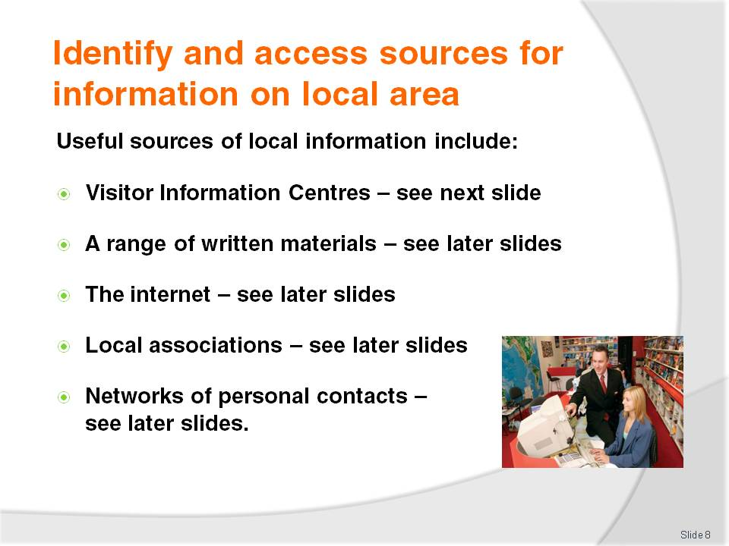
Slide No | Trainer Notes
Trainer advises trainees there are several standard sources that can be used to identify and capture local information, identifying:
Visitor Information Centres
Written materials
The internet
Local associations
Personal network of contacts.
Trainer advises each of the above will be detailed on subsequent slides.

Slide
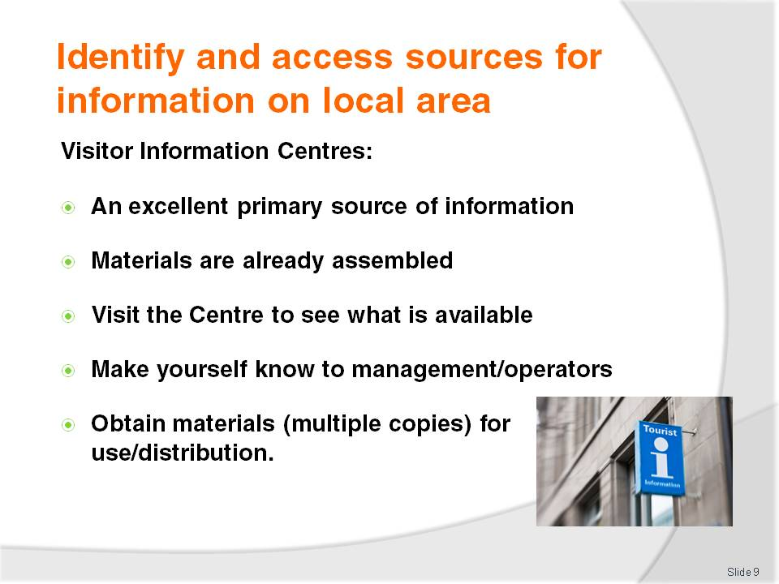
Slide No | Trainer Notes
Trainer tells trainees in respect of Visitor Information Centres:
They are an excellent source of information and should be one of the first places visited to obtain local information. They have already done most of the work in compiling and assembling local information
They must visit the local Centre to see to view the facilities available, the displays on show and obtain a first-hand experience of the ambience and what the Centre has to offer
They need to introduce themselves to management at the Centre or to the staff working in the Centre –in order to create a personal relationship with the Centre, and to facilitate the use of the Centre for obtaining materials and local knowledge
Take multiple copies of the materials (brochures, flyers, maps) for distribution to other staff, and to give to tourists/visitors.
Class Activity – Excursion
Trainer arranges a visit to the local Visitor Information Centre to:
View facilities
Obtain sample materials
Establish a contact person/point
Meet and talk to staff about:
- Important local dates, celebrations, festivals, events
- How to promote the local area
- How to source local information
- Benefits of providing visitors/tourists with local information
- How venues can obtain copies of materials promoting local information and how they can identify when existing materials are updated and need to be replaced.

Slide
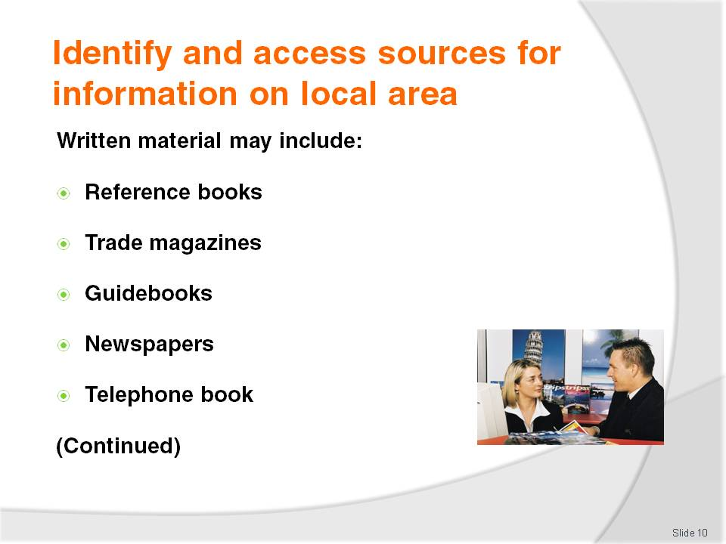
Slide No | Trainer Notes
Trainer explains to trainees that written materials useful in capturing local knowledge/information can include:
Reference books on the country, region or specific aspects of the country (such as its flora and fauna, its history and customs, famous people, trade details, plans for the area/country)
Trade magazines which may be purchased from newsagents or obtained via subscription. These detail events within the industry and are an excellent source of local, national and global information. Trade magazines can focus on sectors of the industry (such as food and beverage, housekeeping, bars, MICE, spas) and/or provide generic information on, for example, travel, tourism or hospitality
Guidebooks. Numerous guidebooks exist on every major tourist destination/country. While these are often read by tourists to help them obtain a ‘feel’ for the country they are visiting, they can also be useful to staff working in those countries as a reference and resource
Newspapers. Many large circulation newspapers feature some aspect of the travel, tourism and hospitality industries on a regular/weekly basis. These features can include:
- Food and drink reviews of restaurants, dining rooms, certain dishes, nominated cuisines, bars, drink types, wines
- Industry movements identifying staff who are moving between properties, ownership of venues and the companies buying and selling properties, new properties coming into the marketplace, venues undergoing renovations and refurbishment and venues closing their doors
- Travel articles describing travel experiences of correspondents, travel destinations and tourist attractions, explaining how to travel between destinations and differentiating between travel and transportation options
- Issues of interest. These may include coverage of a wide range of topics impacting on the industry such as taxation, impact of events locally and internationally, effect of currency fluctuations on inbound and outbound tourists/visitors, industry trends and new products and services
The local telephone book. Where ‘display adverts’ are used the local telephone book can provide much valuable information about local businesses and local competitors (such as products, facilities and services available, star rating, location relative to other attractions, credit cards accepted, affiliations with clubs, groups or other organisations).
Class Activity – Internet Research
Trainer arranges for trainees to have internet access and asks them to visit websites of trade magazines and note any magazines, articles, links of interest.
Trainer suggests trainees visit the following:
http://www.media-directory.asia/magazine/business-magazines/hotel-hospitality-business/singapore/c-1874
http://www.traveldailyasia.com/LocalNews/Singapore.aspx
http://hotelresource.tradepub.com/
http://www.travelandleisure.com/
http://ehotelier.com/directory/?magazines-books.
Trainer also adds any sites for magazines relevant to their country and/or industry or industry sector.
Class Activity – Text-based materials
Trainer assembles a range of relevant text-based materials for trainees to view and gain an appreciation of in relation to the development of ‘local knowledge’.
The text-based materials must include:
Reference books relevant to the country/area
Guidebooks such as Lonely Planet or similar
A range of local newspapers with an emphasis on sections and/or articles focusing on local events
Local telephone book.

Slide
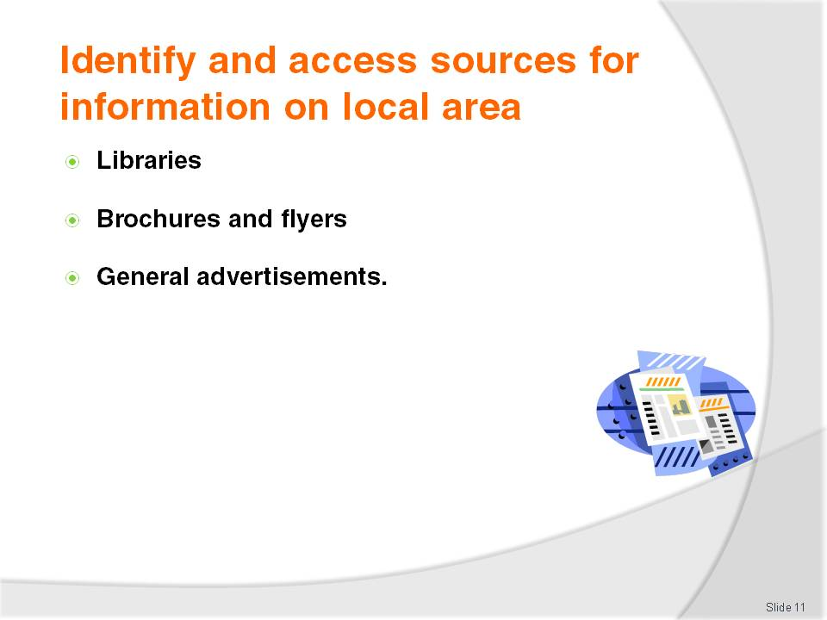
Slide No | Trainer Notes
Trainer continues to provide trainees with information about written materials that can be used to develop local knowledge:
Libraries. Where there is access to public libraries they are a great source of material as it is free. It is important to visit the local library to see what is available. They can often arrange inter-library loans too
Brochures and flyers. Most suppliers and service support industries (local council, authorities, competitors) provide various forms of printed information that can assist with information in relation to:
- Product information detailing, for example, the products available at a shop, venue, attraction, destination
- Services provided at the location to which the brochure applies
- Contact details for their business to which the brochure applies. This includes the telephone number, street address, web details and other information including hours of operation, credit cards accepted
- Maps of the local district
Advertisements whether in the newspaper or in other formats (brochures, flyers, guide books). These are an excellent source of information about other venues in the industry, new products and services, prices, special deals and offers.
Class Activity – Guest Speaker
Trainer arranges for representative from the local library to attend and inform trainees regarding:
Books (videos, DVDs) available at the library that will assist with developing local knowledge
How to register to obtain loans of books and other materials
Terms of use of library materials
Using inter-library loans.
Class Activity – Discussion on Brochures and Flyers
Trainer obtains a wide range of brochures and flyers advertising local events, venues and:
Distributes them for trainees to read
Leads a discussion focusing on:
- Identifying a comprehensive list of local events, attractions, festivals
- Identifying relevant dates, times, seasons for events
- Identifying costs/prices for entry, tickets, accommodation
- Discussing how accurate the advertisements/brochures are in relation to trainee personal experience with the venue or attraction
- Discussing when it may be appropriate to distribute each brochure of flyer to tourists/visitors.

Slide
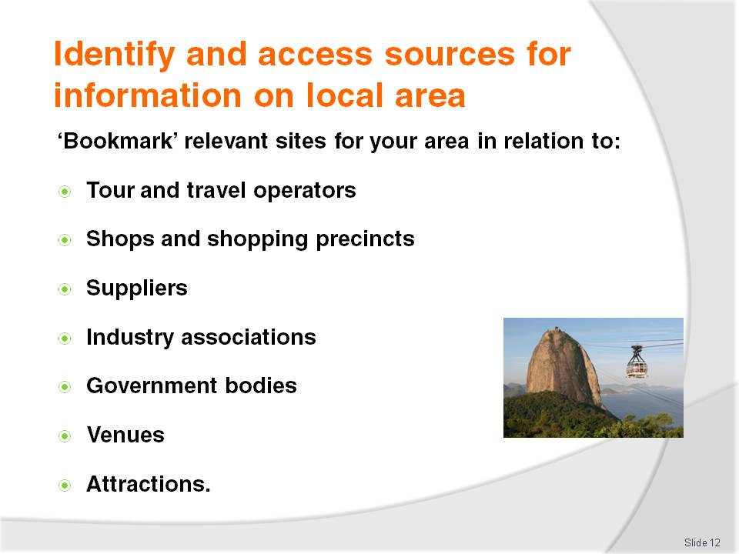
Slide No | Trainer Notes
Trainer introduces to trainees the online options for gathering local information explaining the extent to which such information is available can vary widely depending on the region, the business and attractions in the area and the degree to which infrastructure exists to support the technology.
Trainer suggests trainees undertake internet research and ‘Bookmark’ relevant sites to facilitate future visits/research on that site, suggesting research should be done regarding:
Tour and travel operators especially those who provide local one-day or half-day tours such as bus trips, self-drive, small groups
Shops for which the local area is famous. For example, some destinations are famous for jewellery, some for electronic goods and others for clothing and fashion
Suppliers – food, beverages, other supplies, equipment
Industry associations such as industry representative bodies and groups, and peak industry bodies
Government bodies such as liquor, gaming, food safety, occupational safety and health, and tobacco agencies
Venues. These should be properties similar to the workplace to enable comparisons with what similar venues do
Attractions – the natural and man-made attractions in the local area.
Classroom Activity – Internet research
Trainer arranges for trainees to have internet access and asks them to:
Research their local area in relation to the categories presented on the slide
Obtain downloads and hard copies of relevant information
Create a list of useful and important websites for sharing and future reference
Register to receive relevant newsletters and E-mags.

Slide
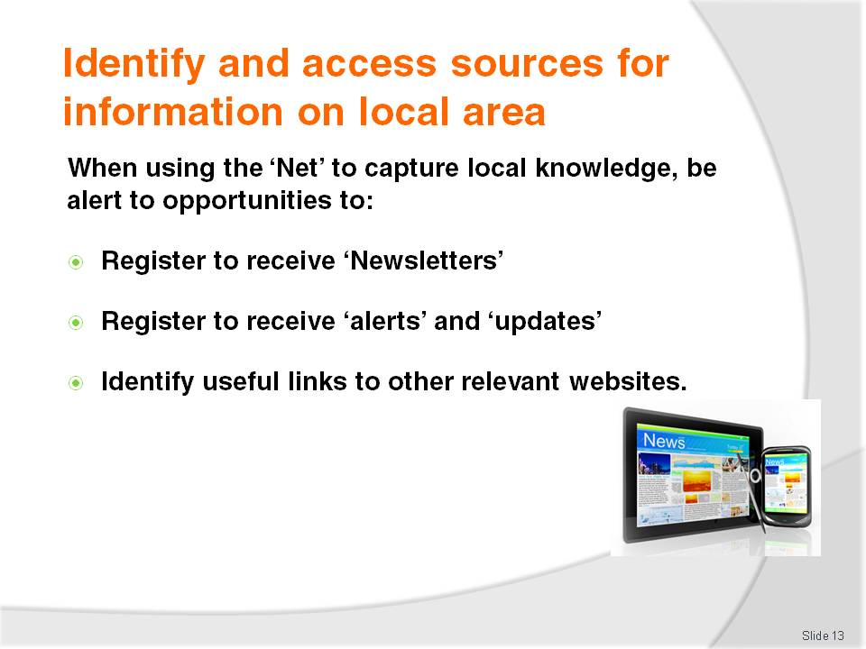
Slide No | Trainer Notes
Trainer advises trainees that when using the Internet to develop their local knowledge they should be alert to the potential to:
Register to receive regular or free newsletters, updates and alerts from relevant websites to assist in the development and updating of local knowledge and information
Identify other web pages that may be useful depending on the type of venue and region the trainees are working in.
Classroom Activity – Internet Exercise
Trainer arranges for trainees to have internet access and asks trainees to:
Visit and report back on relevant online newsletters as identified by the trainer for the country in which they are teaching
Visit and register for newsletters at:
- http://www.thetravelmagazine.net/cy-4-86--east-southeast-asia--singapore.html
- https://app.stb.gov.sg/asp/index.asp
- http://www.filipinotravel.com.ph/corporate/newsletter.php
- http://www.traveldojo.com/brunei/
- http://www.indochinatravelservice.com/newsletter/.

Slide
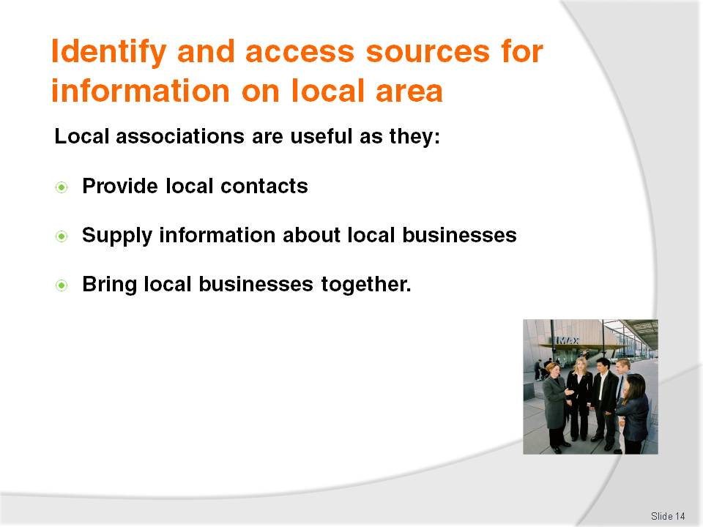
Slide No | Trainer Notes
Trainer states that many regions and towns have established a ‘tourism’ association and/or local Chamber of Commerce or similar, identifying that these can be invaluable in terms of:
Providing contacts to use when developing individual industry network – more on next slide
Supplying information about local businesses and the products and services they provide
Bringing local businesses together in a supportive and mutually beneficial environment.
Class Activity – Guest Speaker
Trainer arranges for a representative from a local association/group to visit and talk to trainees about:
The role of the association in the local community
Members of the association
Costs involved in joining and being a member
Benefits they have brought to the local community
Examples of work they have done
When and where they meet
Why tourism businesses should join and be part of the group or association.
Slide
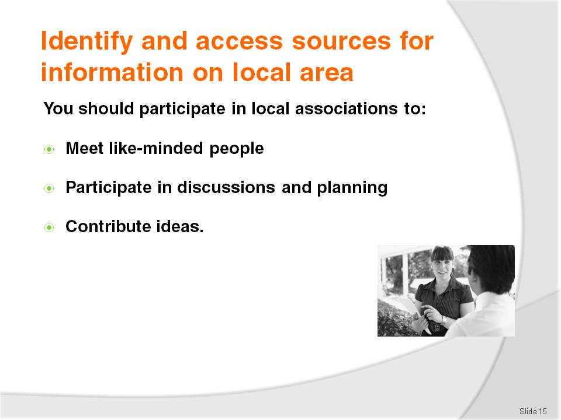
Slide No | Trainer Notes
Trainer tells trainees these associations will meet regularly and it is important for them as representatives of their venue to attend these meetings to:
Meet like-minded people and demonstrate interest in the industry and the local area. These people will also be the start of a network of professional industry contacts (as outlined in following slides)
Participate in discussions which will ultimately have some impact on their workplace, their job and visitors to the area
Contribute ideas which will benefit their venue and the local area or economy.
Classroom Activity – Excursion
Trainer arranges for trainee group to attend as observers at a local association meeting to:
Meet members
Listen to the discussions at meeting
Observe meeting protocols
Gain an insight into the operation of associations of this type
Meet people to include in their network of professional industry contacts.

Slide
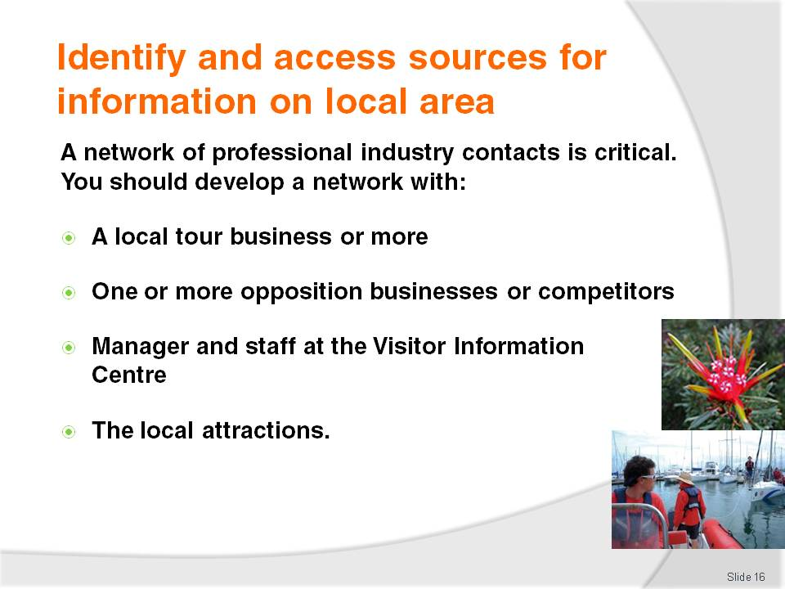
Slide No | Trainer Notes
Trainer explains to trainees that ‘Networking’ is a great way of learning about many industry-related topics. To develop a useful network of contacts they will need to make deliberate attempts to target and talk to people they respect within targeted aspects of the industry they work in.
Trainer suggests they start creating a network of contacts as soon as possible, including relationships (networks) with:
Someone from one or more local tour business to enable identification of what is available regarding local tours e.g. new tours, changes to existing tours, new or different inclusions and prices
A person in an opposition venue in town to allow sharing concerns and information, and to learn from each other. Even though the business may be in direct competition with another venue, it is nonetheless advantageous to develop a good working relationship with the opposition
The manager of the Visitor Information Centre in order to take advantage of the many tourism materials they have to offer
Staff at local attractions to maintain currency of knowledge about what they have available, new items and inclusions, operating times, prices for entry, rides and package deals
Local associations – as identified on previous slide.
Class Activity – Group Discussion
Trainer leads discussion asking trainees questions such as:
Who might you include in your industry network of contacts?
Why would you include these people?
How would you go about establishing the contact?

Slide
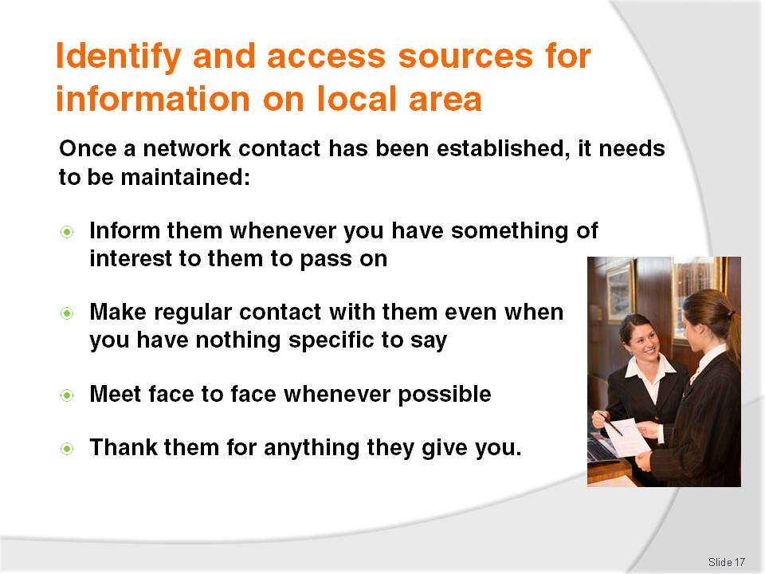
Slide No | Trainer Notes
Trainer emphasises to trainees they have to make the effort to create and maintain their network. They cannot rely on others contacting them and initiating the contact.
Trainer also highlights that, after they have made initial contact with these people, they must keep in contact with them:
They need to contact their network when they find out something they think their network might like to know. This highlights the two-way nature of the concept of networking
They need to occasionally contact them just to ‘stay in touch’ even when there is nothing specific to pass on to them. Often they remember something they need to say when contact is made with them and a call to them demonstrates the value placed on them as a network member.

Slide
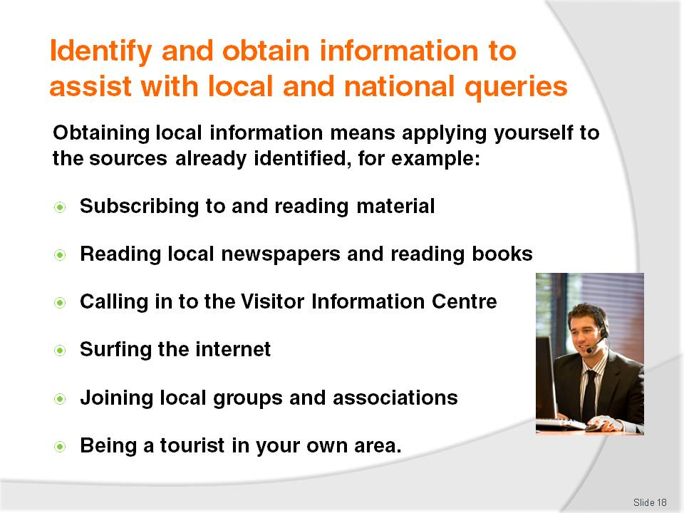
Slide No | Trainer Notes
Trainer reinforces to trainees the need for them to be proactive in capturing necessary local or national information to assist visitors.
Trainer informs trainees obtaining the information they need is a matter of applying themselves to the sources identified previously, which in practice can mean:
Subscribing to, and reading, industry magazines, newsletters, updates, fact sheets, reports, research findings
Reading through local and city newspapers especially those sections carrying articles and features on hospitality, travel and tourism, events, festivals, attractions
Visiting the Visitor Information Centre and meeting the manager/staff and collecting brochures and advertising material. Obtain multiple copies of brochures to place them in display area (at reception, concierge, the foyer area) so they can be given to visitors and guests
Surfing the internet:
- Viewing websites/pages
- Downloading, saving, bookmaking or printing relevant information and sites
- Registering on e-mail lists to receive newsletters and updates from relevant industry government agencies, suppliers and/or support services
- Downloading E-Mags relevant to industry sector. Many of these are free-of-charge but some require payment
Joining your local industry association and taking an active interest in the issues foremost in their minds by participating in discussions, meetings, research
Reading books. Aim to read widely and include local, regional and national books
Being a tourist in the local area. This involves getting out and having a look around to see what is happening, what people are doing, what the competition is doing, and what people are saying.
Class Activity – Major Excursion
Trainer arranges for trainees to be a tourist in their own area and:
Visit local tourist attractions, landmarks and places of interest as if they were a tourist/visitor to the area
Take notes of local information they obtain
Capture brochures, printed advertising and other relevant materials (price lists, schedules)
Talk to operators to grow their network of contacts
Experience as many local tourist attractions as possible to gain first-hand knowledge and experience to serve as the basis for providing local information to visitors.

Slide
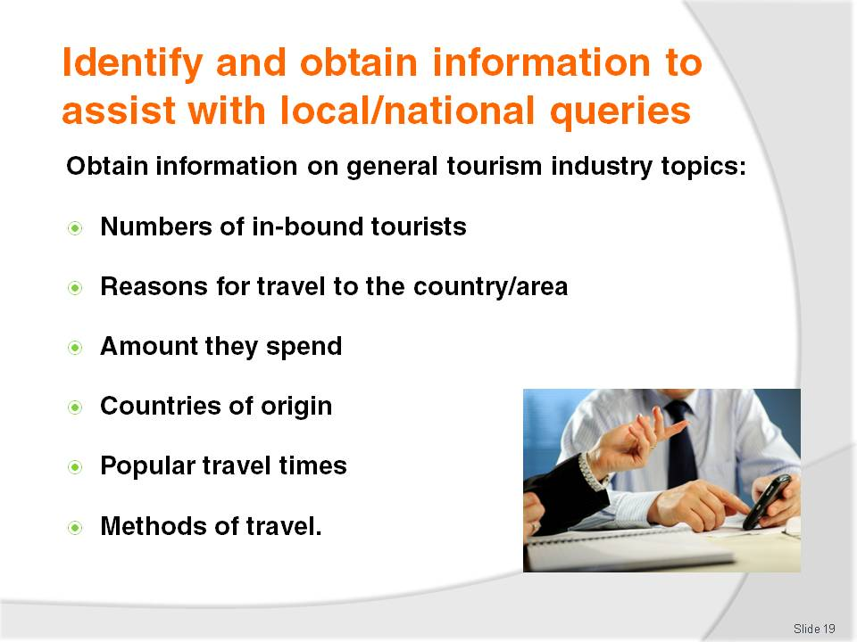
Slide No | Trainer Notes
Trainer advises trainees when identifying and obtaining information, effort must be taken to capture knowledge about the following ‘general industry information’ topics:
Numbers of inbound tourists and any trends (such as, for example, whether numbers are increasing or decreasing and to what extent)
Reasons for their visits – business, visiting relatives, tourism
Amount spent on a per head and per night basis
Countries of origin determining the 10 most popular countries from which overseas visitors/tourists come
Most popular times of the year for travel highlighting festivals, religious events, holiday periods, seasonal influences
Method of travel identifying the percentages who travel by air, road, train, sea to come to the country.

Slide
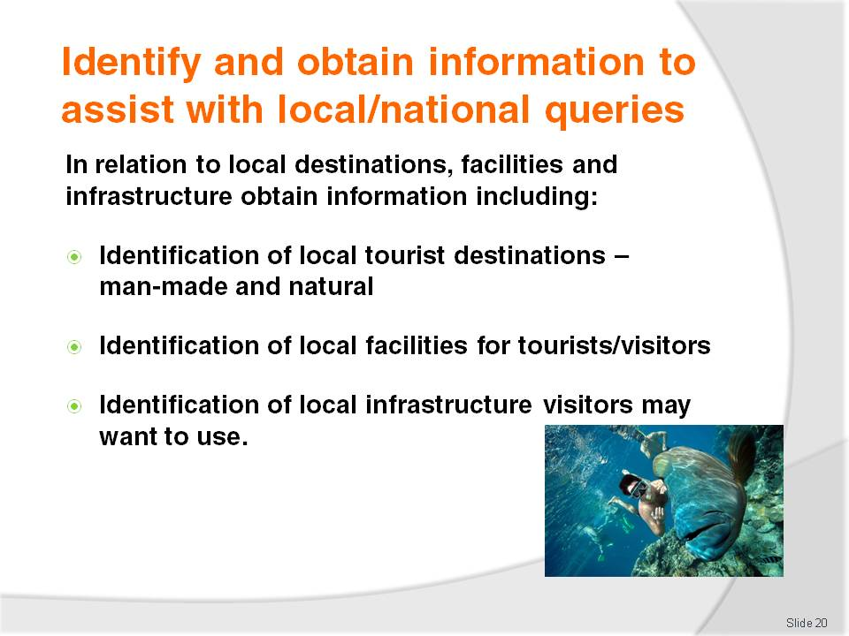
Slide No | Trainer Notes
Trainer recommends to trainees that in relation to local destinations, facilities and infrastructure they obtain information including:
Identification of local tourism destinations such as towns, villages, lakes, rivers tourists could be expected to visit. Within these destinations there may be ‘attractions’ (discussed on later slides). For local destinations they need to determine:
- Route to the destination including options, where applicable
- Distance
- Opening hours
- Cost, if any, to visit
Identification of local facilities for tourists such as toilets, medical facilities, hospitals, baby changing facilities, disabled facilities, Visitor Information Centres, money exchanges, police stations, embassies. For local facilities they need to determine:
- Locations and routes from the workplace to them
- Time to travel
- Opening times
- Fees charged, where applicable, for services rendered
- Contact details including telephone number, website
Identification of local infrastructure supporting tourism such as local rail services, transportation terminals, ferry services, buses, taxis, domestic airlines and/or charter services. In some cases transport infrastructure can extend into an ‘attraction’ or ‘service’ in its own right. For example, tourists may visit an area purposely to experience:
- Hot air balloon travel, elephant or camel rides, houseboats, all-terrain vehicles, trishaws, cable cars.
For transport services they need to determine:
Locations of airports, train stations, bus depots and bus stops
Routes to each service
Timetables
Cost for travel/tickets including taxi rates
Where and how to buy tickets.
Class Activity – Small Group Exercise
Trainer divides class into small groups and allocates one local destination/attraction to each group and asks them to:
Develop a list of all the local information they should know about this to pass on to visitors. This should be based on possible questions visitors might ask and/or information they would want to know if they were visitors about to go to the destination/attraction
Develop a list of all the local information they actually know about to pass on to visitors
Identify how they will find the necessary information fill the gaps in their local knowledge regarding this destination/attraction.

Slide
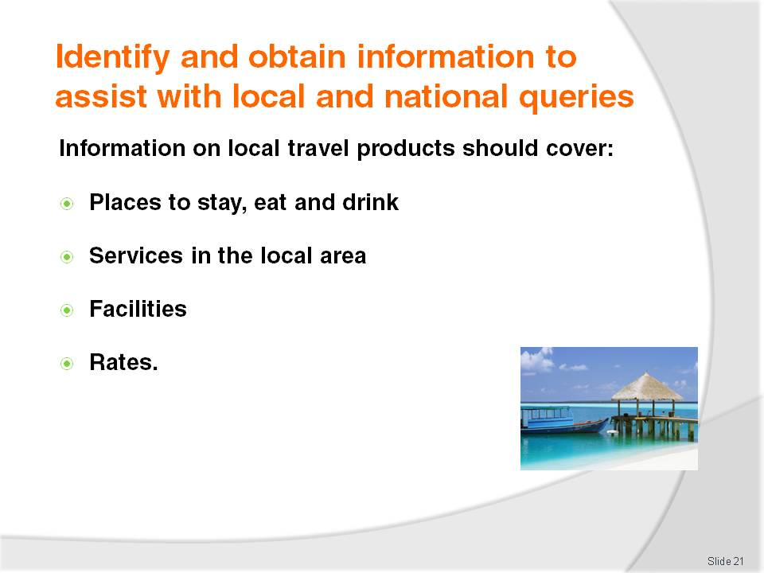
Slide No | Trainer Notes
Trainer advises trainees they also need to obtain information on local travel products and services, such as:
Places to:
- Stay – accommodation options available locally including hotels (of different ratings) and back-packer accommodation. Attention should also be paid to identifying any eco-friendly accommodation venues
- Eat – covering the differing dining options from eat-in (fine dining to more modest establishments), different cuisine types, street stalls/vendors and fast-food outlets
- Bars – and locations for buying take-out liquor
Services, such as:
- Hire cars
- Money exchanges and banks
- Secretarial services for business visitors
- Dry cleaning and laundry
- Security
- Immigration advice
- Emergency services
- In-house services available to guests at a venue/hotel.
Facilities, taking into account:
- In-house facilities for guests – spa, swimming pool, gymnasium, business centre, internet connection
- Local facilities – as identified above: toilets, disabled access/wheelchair ramps, parking, transportation, arts centres
Rates. This is a very big area and one subject to on-going change. ‘Rates’ refers to the prices charged by providers for the products, services they provide. Rates include:
- Room rates for accommodation; for single, double, family, taking into account any allowable discount
- Fees to enter an amusement or theme park and/or the cost of tickets and rides
- Fees for travelling on cable cars, trains, buses, taxis, ferries
- Exchange rates for changing money between currencies
- Charges made by businesses for products sold and services rendered such as exchanging money, meals, shopping
- Taxations rates and identification of goods and/or services they apply to, and any refunds or rebates international visitors may be entitlement when they leave the country.

Slide
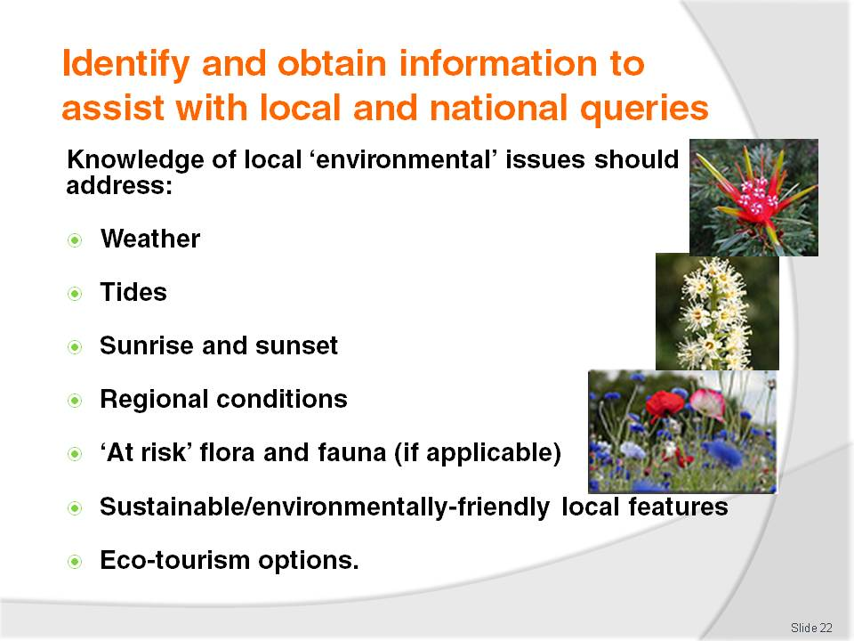
Slide No | Trainer Notes
Trainer recommends to trainees they also capture local information on ‘environmental’ issues which will vary greatly depending on the geographical location of their workplace but should include:
Weather and the seasons: when it is likely to be hot, cold, wet, windy or other as appropriate to the individual location
Tides especially where tourism focuses on boating and fishing
Times of sunrise and sunsets
Regional variations in weather such as identification of micro-climatic conditions for certain areas
Items deemed to be ‘at risk’ – flora and fauna
Sustainable features of the local area/region
Options available for visitors seeking an eco-tourism experience.

Slide
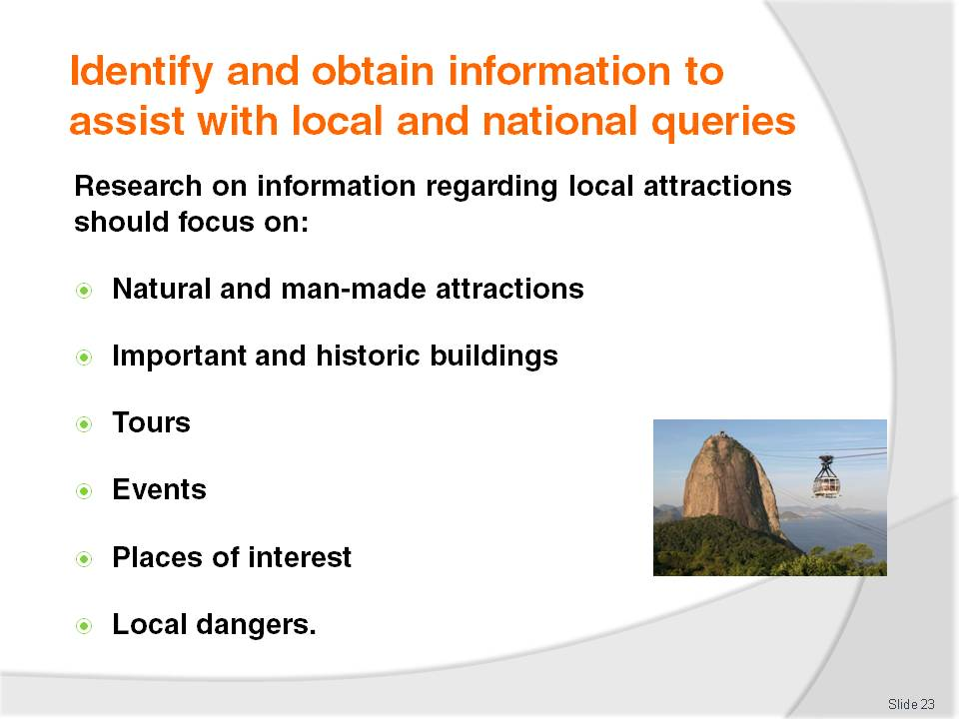
Slide No | Trainer Notes
Trainer suggests to trainees that in regard to obtaining information about local attractions, tours, events and places of interest they should focus their research on:
Natural attractions such as caves, mountains, the ocean/sea, gorges, sanctuaries, gardens, waterways
Man-made attractions (also known as ‘built attractions’) – entertainment centres, amusement parks, theme parks, lookouts, science centres, museums
Buildings – ancient buildings and ruins, government buildings, buildings with historic significance, former prisons and dwellings
Tours. These may be:
- Time-based – 2-hour, half-day, full-day, multiple days
- Subject-based and may focus on Sports tourism, Landmarks, Food tourism, Cultural tourism, Eco-tourism, Religious tourism, Arts or Area-based. These may focus on, for example:
- A town, city or region – a general tour visiting landmarks and other ‘places of interest’ (see below)
- The CBD of a city
- Shopping precincts
Events. These relate to special occasions conducted in an area and can include:
- Sporting events
- Religious observances/festivals
- Meetings, Incentives, Conventions, Exhibitions occurring in the area
- Local and national celebrations.
Trainer notes some local areas prepare a ‘Calendar of Festivals and Events’ detailing the upcoming events for the next 12 months:
Places of interest – this phrase can include almost anything including the already mentioned built attractions, landmarks and ruins, plus natural attractions. It can also cover:
- Sites of historic battles
- Unique architecture
- Groups of ethnic people and their houses, shops, religious shrines
- Squares, showgrounds and theatres
- Geographical features, fossils and forests
Local dangers. Attention must always be paid to ensuring visitors are provided with appropriate advice regarding any local dangers they may be subjected to, for example:
Wild animals
Currents and tides
Areas they should avoid because of the potential for attack (‘no go’ areas)
Geographical features with the potential to cause death or injury
Activities that may be inappropriate given the profile of the visitor. For example, a walking trail may be suitable for a young and fit tourist but totally inappropriate for a frail and elderly person
Weather conditions – rain, sun, wind.
Class Activity – Group Discussion
Trainer leads trainees in a discussion on information they would provide to visitors to their area regarding ‘local dangers’. Questions may include:
What local dangers do you think visitors need to be made aware of?
Why do think they should be given this information?
How would you provide this detail?
When and where would you provide it?
Who might you contact to make sure you are providing accurate, comprehensive and current safety information to visitors?

Slide
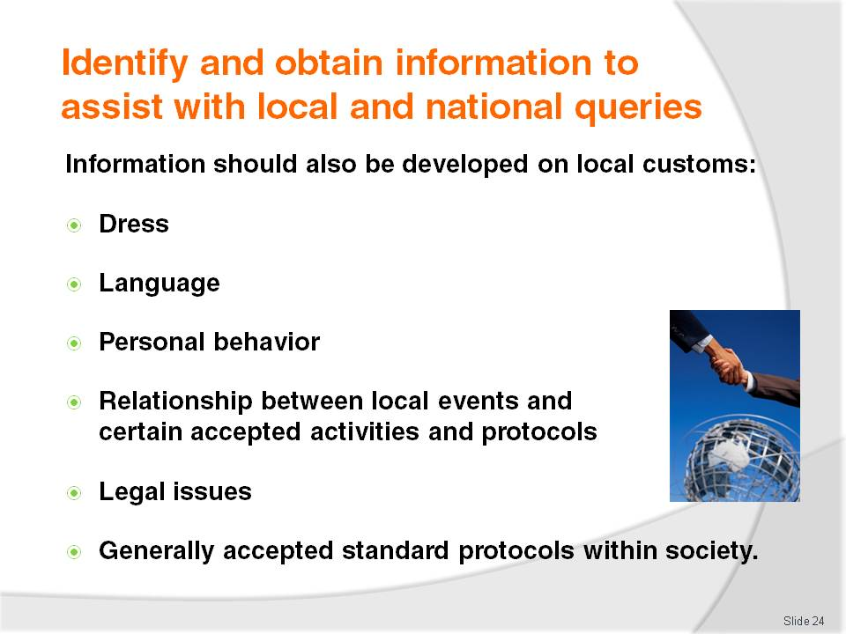
Slide No | Trainer Notes
Trainer urges trainees to also develop knowledge to pass on to visitors about local customs, suggesting this could include:
Dress – what to wear; what not to wear, requirements regarding footwear and covering parts of the body
Language – providing basic phrases/words such as ‘Yes’, ‘No’, ‘Hello’
Personal behaviour which may address:
- Eye contact and other non-verbal communication issues
- Shaking of hands when meeting/greeting a person
Local activities related to certain events, circumstances
Legal issues identifying what offences are provided for under relevant legislation
Accepted protocols identifying acceptable and unacceptable actions related to nominated occurrences, events, meetings, circumstances and normal daily life.
Class Activity – Individual Exercise
Trainer asks individual trainees to select one aspect of ‘local customs’ identified on the slide and prepare a comprehensive and accurate list of topics they would cover and information they would provide when advising visitors about local customs.

Slide
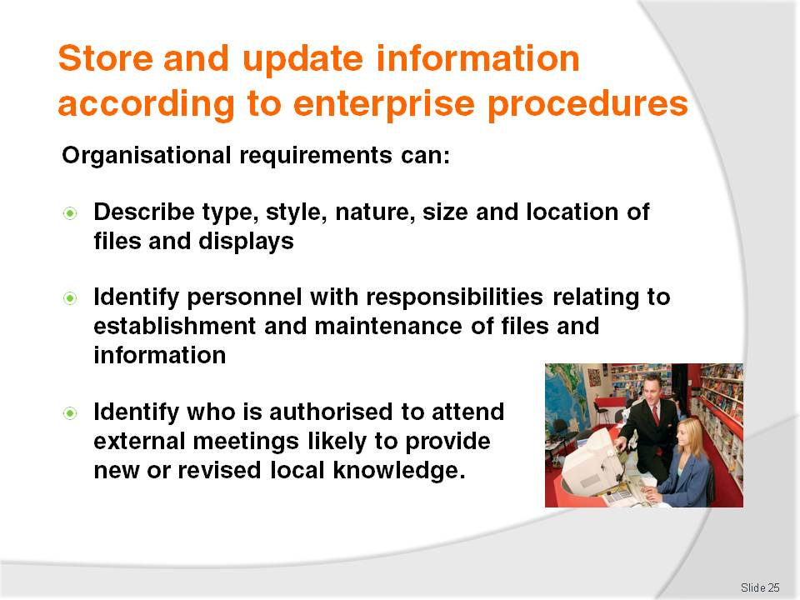
Slide No | Trainer Notes
Trainer presents to trainees that once relevant local information has been sourced, it must be stored for future use as deemed most appropriate by the enterprise, in keeping with any relevant policies and procedures the organisation has in place.
Trainer identifies organisational requirements will vary between establishments but may include policies and procedures relating to:
The type, style and nature of the storage and retrieval system to be used – see following slides (for example, the use of filing cabinets, public display options and the storage of information on electronic (or other) databases)
The type, style, nature, size and location of the information display and/or file which will usually embrace:
- Where brochures will be displayed to the public so they can ‘help themselves’ to brochures such as in the foyer area
- The materials to be placed in guest rooms – in the compendiums, on side-tables
- Information supplied to guests when they check-in
Identification of personnel with responsibility for:
- Capturing initial information, brochures, price lists, maps, flyers and promotional material from local and other attractions and venues
- Updating the information brochures to ensure it remains current providing up to date materials, prices, opening times
- Entering information into an electronic system to enter new or updated data into the system
- Maintaining the display to keep it looking neat and tidy and to remove soiled, torn materials
- Maintaining the store of materials to obtain materials to ensure the display never runs out of brochures
Identification of who is authorised to attend meetings to capture local information about upcoming events and to participate with others (venues, authorities, attractions) to attract visitors to the local area.

Slide
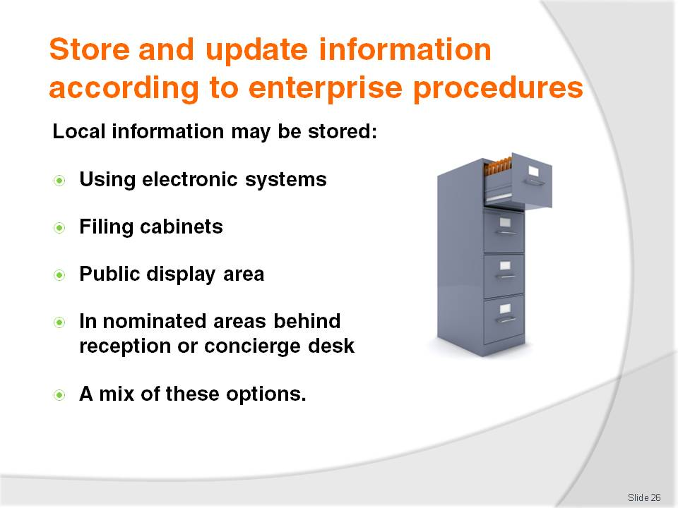
Slide No | Trainer Notes
Trainer indicates to trainees storage options for local information may include:
An electronic system such as entering information into a dedicated information database, or one that is integrated with a CRS
A filing cabinet system – filing paper-based material by category or in alphabetical order
A public display area where the public/visitors are encouraged to browse and help themselves to items of interest
Copies of information in nominated areas such as behind reception, at the concierge desk or contained within in-room compendiums
A mix of the above. This is the most common option: very few venues store local information only in one place.

Slide
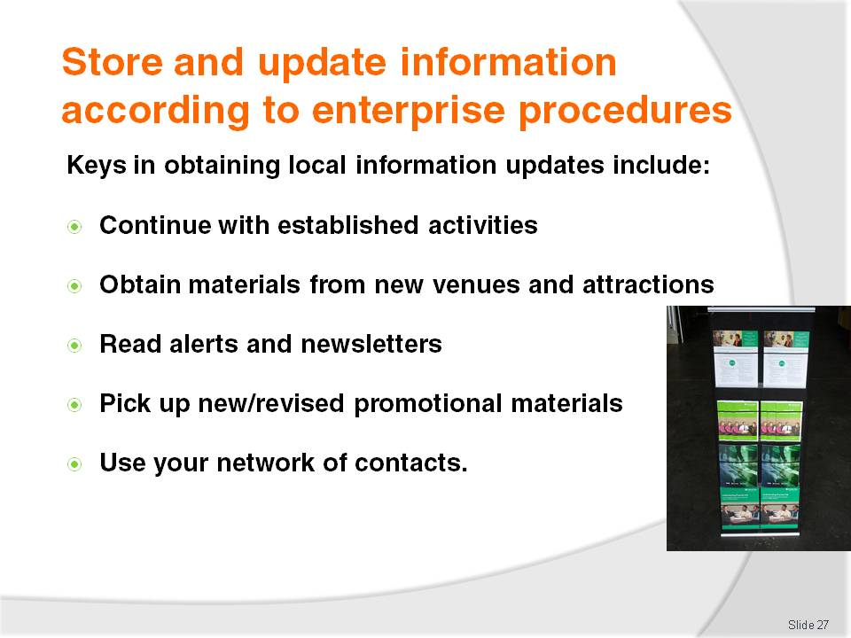
Slide No | Trainer Notes
Trainer explains to trainees that updating information requires (1) obtaining the u-dates, and (2) processing the new or revised information.
Trainer states to trainees that activities involved in obtaining the updates include:
Continue to do the activities initially undertaken to capture local information in the first instance, for example:
- Visit the Visitors Information Centre
- Attend local meetings
- Visit other venues and local attractions
- Read local newspapers, magazines, books
Obtain materials/information for new venues, attractions. From time to time new businesses and attractions will open and there is a need to be proactive in sourcing information from these to pass on to visitors/guests
Reading alerts, up-dates, emails, newsletters received as these are often sources of new/revised information
Picking up any copies of new tourist/visitor information and arranging to obtain multiple copies
Use network of contacts – can they advise of any new materials/information? Any changes/updates?

Slide
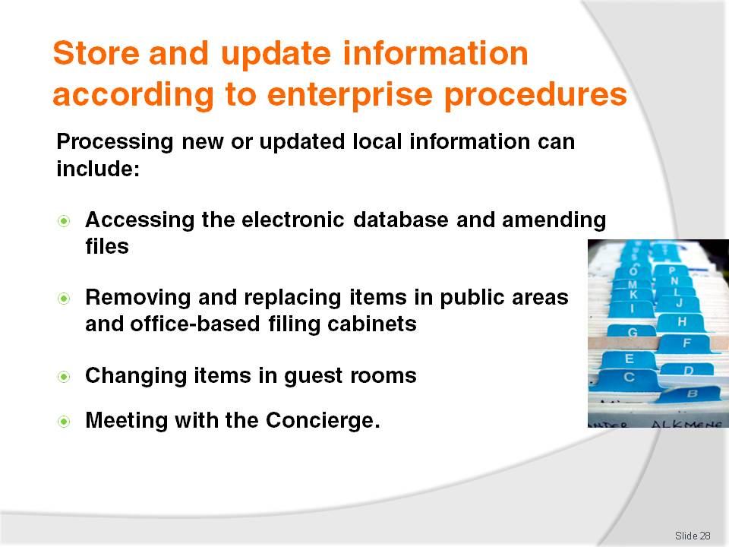
Slide No | Trainer Notes
Trainer informs trainees the processing of new or updated local information will depend on the system used in the workplace to store this information, but may include:
Accessing the CRS or other dedicated electronic database and adding, deleting or amending files and fields as necessary
Accessing the filing system for hard copy materials and:
- Removing and discarding previous versions of materials which will now be out of date due to the new/revised materials
- Replacing with the new materials
- Removing out of date materials from the display stands and racks and replacing with new/revised materials
Going to each guest room in the venue:
- Removing out of date materials from the in-room compendium and side-tables
- Replacing with new/revised materials
Meeting with Concierge and:
- Advising of new/revised materials
- Providing several hard copies to the Concierge who will then update their own files and database at their desk.
Class Activity – Excursion
Trainer arranges to for trainees to visit an accommodation venue with significant displays of local information to:
View the public display areas and identify the items available for the public
View the behind-the-counter or office-based filing systems used for storing local (and other relevant) tourist information
View any electronic database used to store tourism information
Visit guest room to view local information contained in guest room compendium
Talk with management and/or staff regarding:
- Benefits and disadvantages of the systems used by the venue for storing and/or displaying tourism information
- Processes involved in obtaining new and/or updated local or other relevant tourism information
- Activities involved in processing new/updated information so every display and/or storage option is effectively changed to reflect the new or revised information.

Slide

Slide No | Trainer Notes
Trainer stresses to trainees it is important for them to ensure the following elements are addressed as appropriate when updating information:
Thank the person, business, authority or body who provided the up-dated material. this acknowledges their effort and encourages them to keep sending new/updated materials
Act on new/revised information immediately. The day the material is received should be the day the old material is replaced with the new material/information
Discard all old and out of date materials. Never leave it lying around the place. It may inadvertently be used to provide incorrect advice/information to guests. Shred the old materials or dispose of them in the trash or recycling bin.

Slide
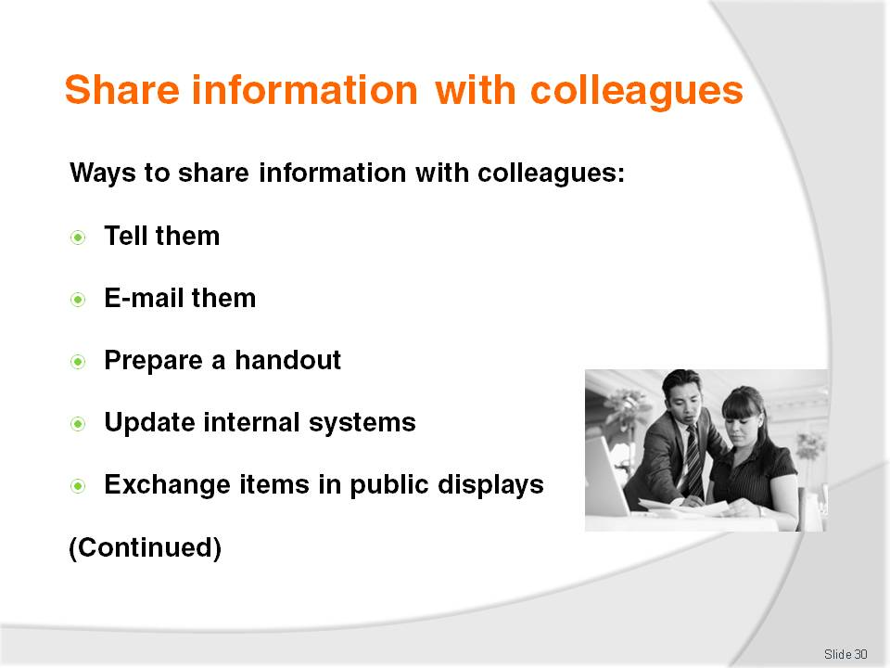
Slide No | Trainer Notes
Trainer advises trainees when they have managed to gather and update local information they must be prepared to share such information with work colleagues and incorporate it into their day to day work activities.
Trainer indicates to trainees the basic ways to share new and/or revised (updated) information with fellow employees are to:
Verbally tell your colleagues about what you have learned:
- On a one to one basis
- At staff briefings
- At staff meetings
E-mail co-workers with the information you have discovered attaching relevant information as applicable
Prepare a short handout. Put this:
- On the staff notice board
- Hand-deliver it explaining it at the time it is handed out
- In wages envelopes
- In the internal newsletter
Update the internal systems such as CRS, described in the previous Section
Replace and replenish internal displays and/or information points with new/revised materials – also described in the previous Section.

Slide
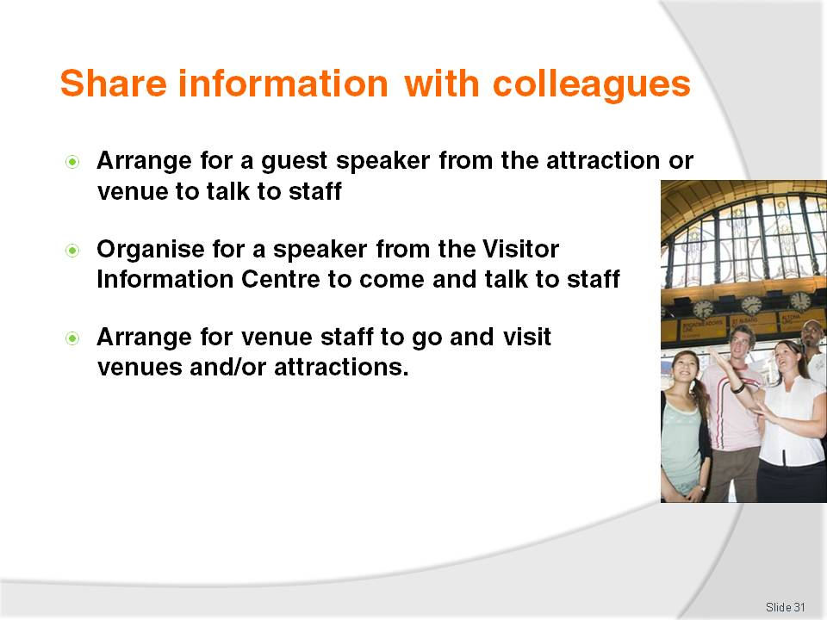
Slide No | Trainer Notes
Trainer continues to advise trainees about ways to share local information with fellow workers:
Arrange for a guest speaker from the venue/attraction to come and talk to staff explaining the venue/attractions, providing sample items or bringing promotional materials
Arrange for a speaker or representative from the Visitor Information Centre to attend and make a formal presentation to venue staff
Arrange for staff to visit the venue/attraction personally so they can gain first-hand experience of the venue/attraction. Management at attractions usually provide free entry to their site/venue for staff in the hospitality business knowing there is the potential for ‘referrals’ from these people. Ask Manager to arrange the visit, and free entry is almost guaranteed.

Slide
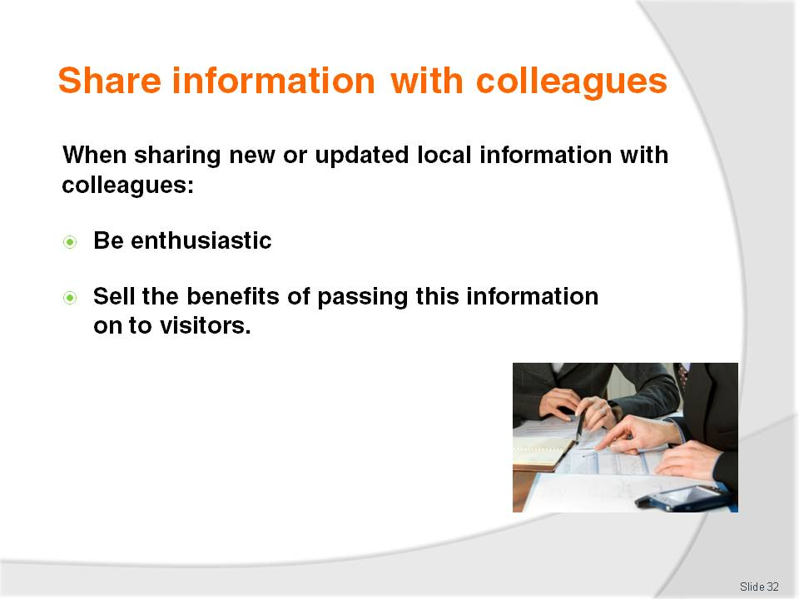
Slide No | Trainer Notes
Trainer suggests to trainees that when informing other colleagues about new or updated local information they should at the same time ensure:
They are enthusiastic when providing local information to other staff at the venue. Enthusiasm can be contagious and unfortunately if they are not enthusiastic, this too is contagious
They sell the benefits of providing up to date, accurate local information to visitors and guests.
These include:
Increased guest satisfaction with their stay leading to:
Repeat business from them. They are more likely to return at a later date and spend more time and money in the venue and in the local area
‘Referral’ business as they tell their friends and family and encourage them to visit or refer them to the venue for accommodation
Very real chance of guests/visitors spending extra nights in the area or at the venue leading to greater financial prosperity for the venue and area
More secure employment at the venue and the potential for venue growth
Increased chance of more work or extra hours for existing staff
Enhanced image of the area, district, town/city and country in the eyes of international tourists/visitors.

Slide
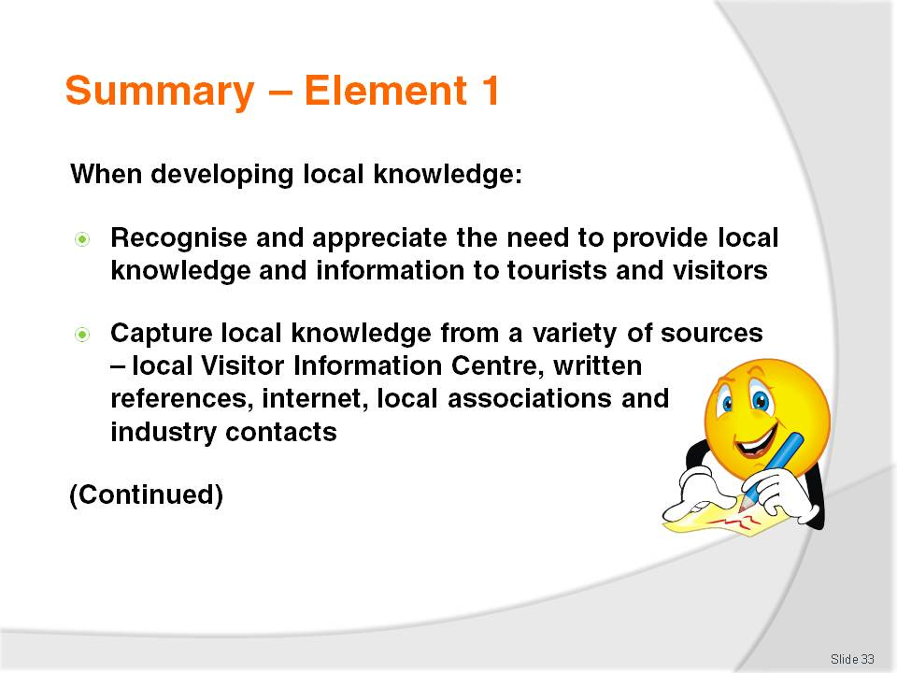
Slide No | Trainer Notes
 | Trainer provides a recap of the Element asking questions to check trainee understanding and responding to questions from trainees, as required.

Slide
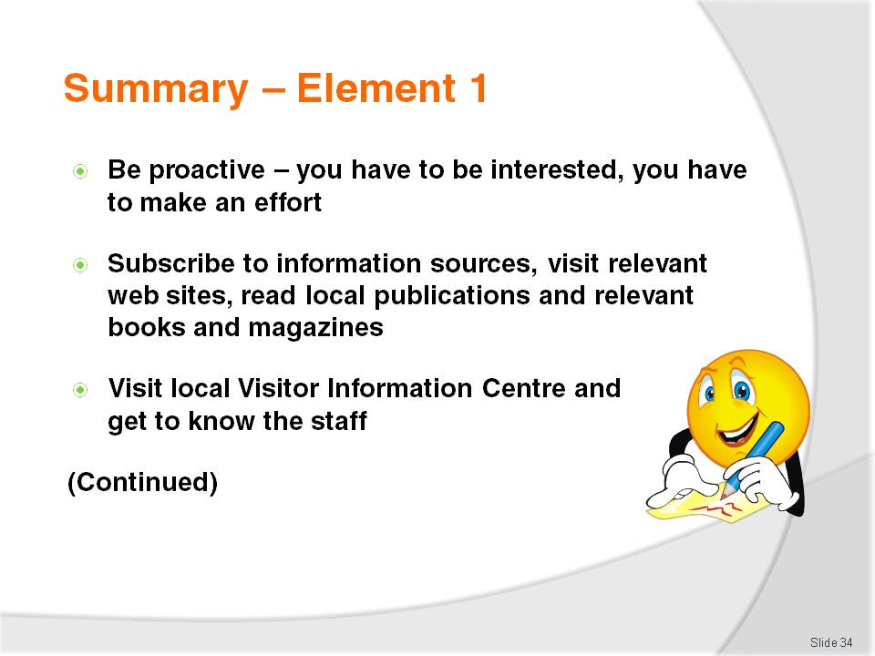
Slide No | Trainer Notes
 | Trainer provides a recap of the Element asking questions to check trainee understanding and responding to questions from trainees, as required.

Slide
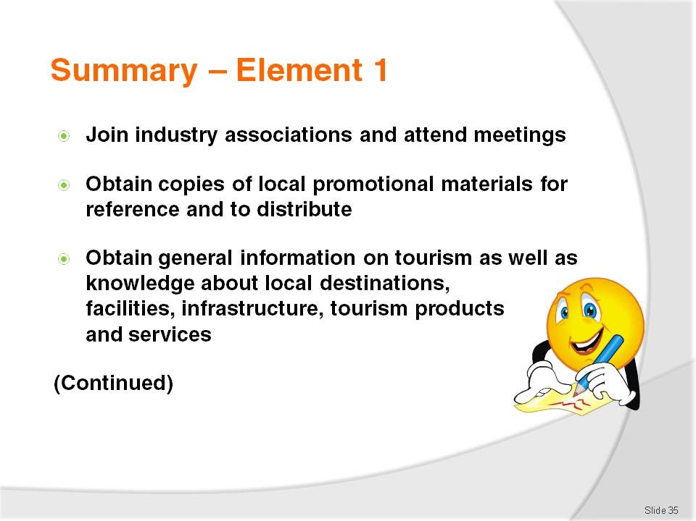
Slide No | Trainer Notes
 | Trainer provides a recap of the Element asking questions to check trainee understanding and responding to questions from trainees, as required.

Slide
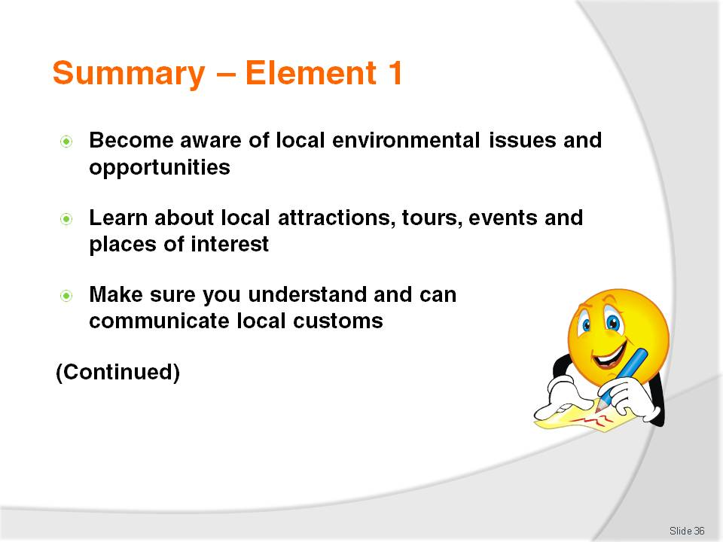
Slide No | Trainer Notes
 | Trainer provides a recap of the Element asking questions to check trainee understanding and responding to questions from trainees, as required.

Slide
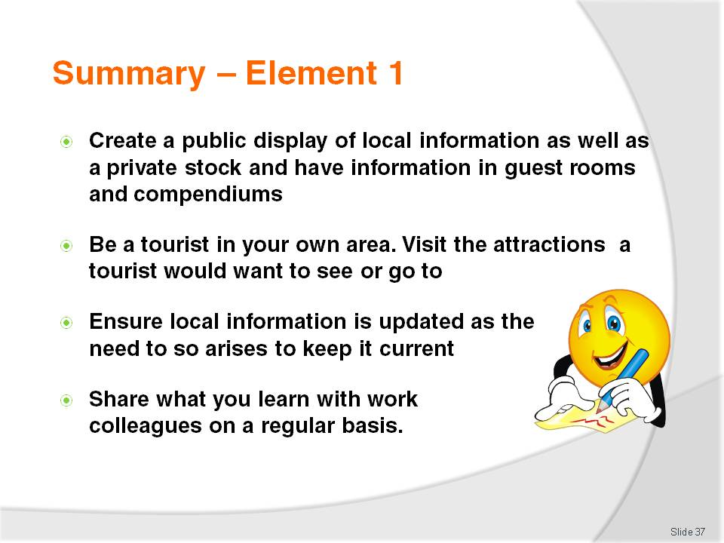
Slide No | Trainer Notes
 | Trainer provides a recap of the Element asking questions to check trainee understanding and responding to questions from trainees, as required.

Slide
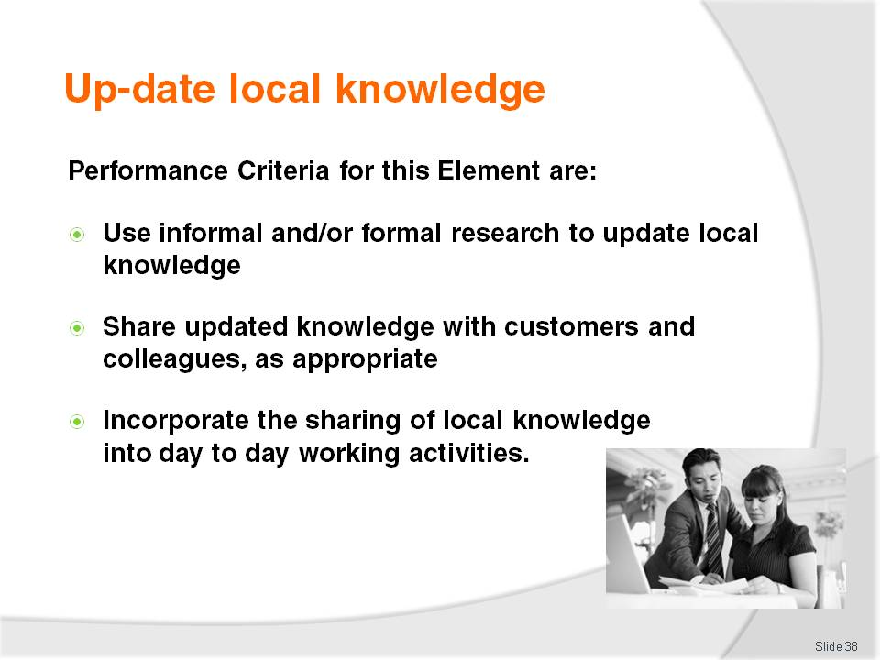
Slide No | Trainer Notes
Trainer identifies for trainees the Performance Criteria for this Element, as listed on the slide.
Class Activity – Discussion
Trainer asks trainees questions regarding their experiences and knowledge about updating local knowledge:
Why do you think it is important for local knowledge/information to be kept up to date?
How might a venue ensure it keeps all its local tourism information up to date?
Which staff in the venue might be involved in keeping local information current?
What might be the consequences of not keeping local tourism information up to date?
How could a venue ensure all its staff are kept updated about new local visitor information, or changes to existing local visitor information?
In what ways might staff at a venue incorporate new/updated local information into their day to day activities in dealing with visitors/tourists?

Slide
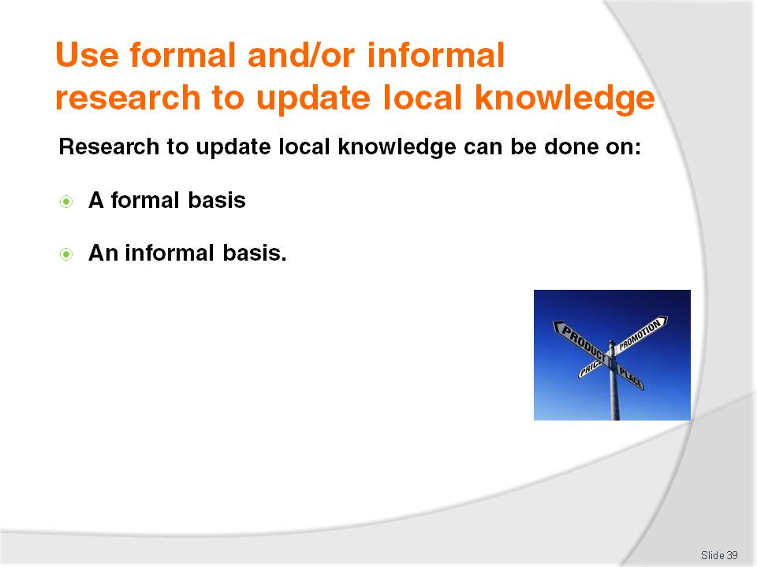
Slide No | Trainer Notes
Trainer tells trainees updating local knowledge can be conducted by undertaking research on an informal or formal basis describing:
Informal research is generally research happening more by accident than design or planning. It is information people just ‘come across’ in day to day life as opposed to deliberately searching it out. People often engage in informal research without realising it
Formal research, by contrast, is more structured, and has deliberate intent although it is possible to see some crossover between formal and informal research. With formal research, activities are undertaken with a specific purpose in mind.

Slide
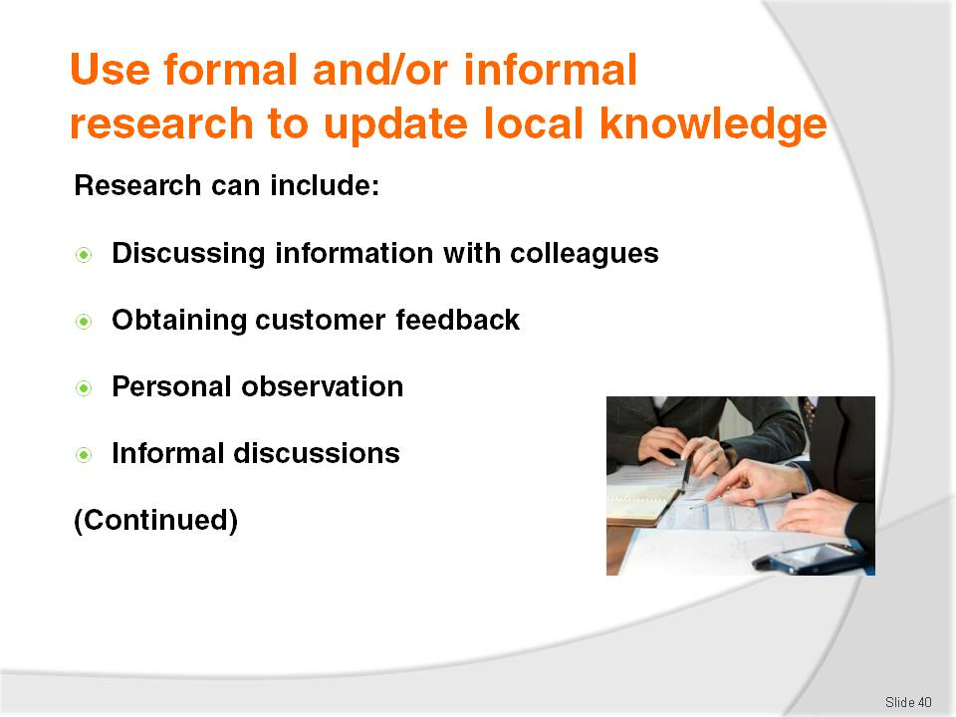
Slide No | Trainer Notes
Trainer presents various research options to trainees:
Discussing information with colleagues; finding out about their local experience, the information they have gained, and what they think
Obtaining customer feedback. This is easily done when talking with them at reception after they have returned from a tour or a visit to an attraction, or at the table when they are having a meal. Keys are to ask plenty of questions, and show genuine interest in what people say
Personal observation . This takes place when, for example, noticing something, just by chance, regarding an attraction, local event
Informal discussions with friends and family where the topic of conversation happens to include local attractions, festivals.

Slide
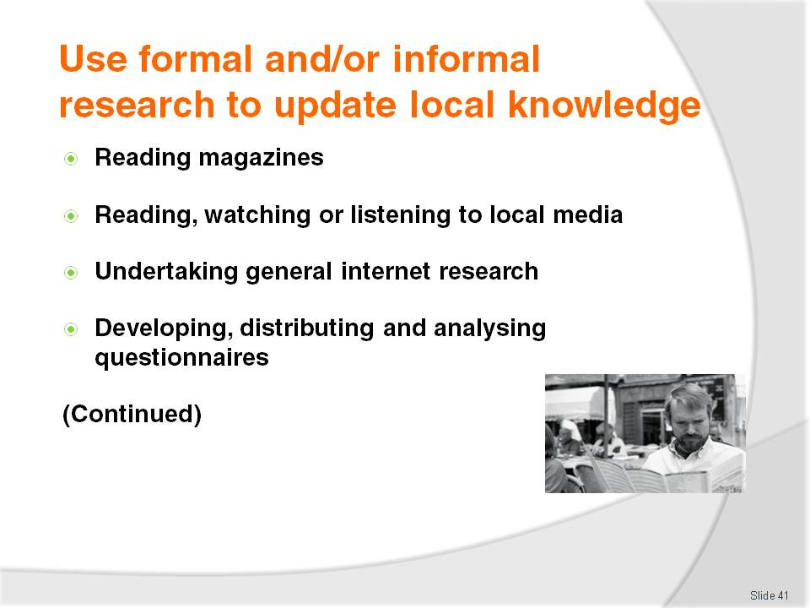
Slide No | Trainer Notes
Trainer continues to present research options for identifying updated local knowledge:
Reading a magazine (especially travel and tourism literature) or any form of printed material and discovering an article about the local area
Reading, listening to or watching the local media to identify what is happening locally, dates, features of the event
Undertaking general internet research. This is an excellent source of information and readily shows things as well as providing simple text. Look for new websites, and ‘bookmarked’ sites that have changed since previous visits
Developing, distributing and analysing questionnaires. This is a paper-based variation (or it may be electronic/online) on verbally asking questions. The production of a questionnaire will enable formalised responses and feedback to given questions and topics.

Slide
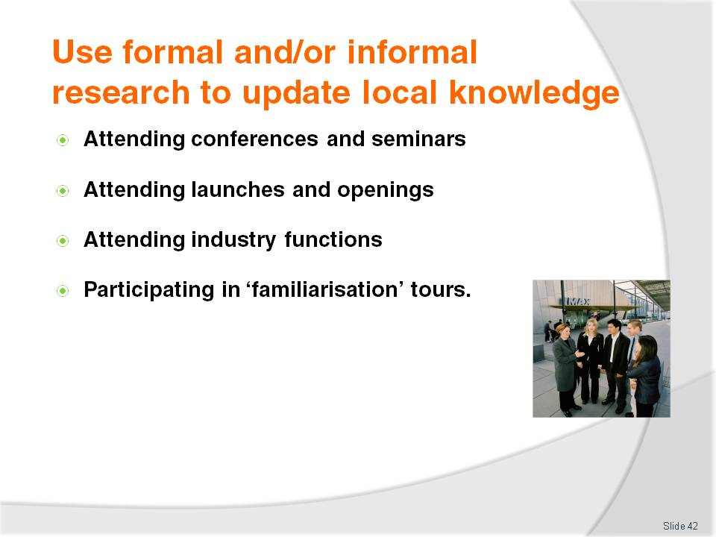
Slide No | Trainer Notes
Trainer continues to present research options for identifying updated local knowledge:
Attending conferences and seminars. Any time there is a conference or seminar on tourism and/or hospitality, make an effort to attend. The key is once again to become involved and be an active participant
Attending launches of new products/services and openings of new venues/attractions. Many local areas will launch a new tourism initiative and it can be very informative to be there when these initiatives are revealed to the public. There is usually significant media involvement in these launches
Attending Industry Association functions. These functions are a good networking opportunity and usually feature many representatives from support and associated businesses
Participating in familiarisation activities. Familiarisations (or ‘famils’) are tours of venues and attractions conducted by the operator to familiarise people (usually industry workers, but it can also apply to the media, potential customers/groups). A famil tour at a venue will include a tour of the venue, viewing of rooms and facilities, a talk by the manager and probably a free meal. At a theme park the famil tour would include free rides, entry to shows, a talk by the manager, participation in shows/tours and also a free meal. The idea of ‘fam tours’ (as they are also known) is to enable staff to return to their workplace and then tell their customers/guests from first-hand experience exactly what the venue/attraction is like and what it is like to go there.
Class Activity – Excursion
Trainer arranges for trainees to be granted a familiarisation tour of a local venue or attraction.

Slide
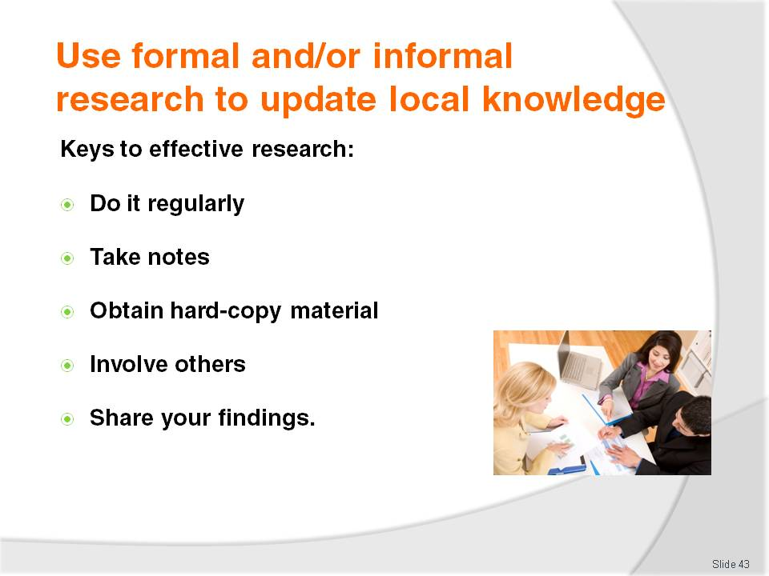
Slide No | Trainer Notes
Trainer advises trainees the keys to getting the most out of research are to:
Do it regularly – it should be on-going
Take notes – never rely just on memory
Obtain hard-copy material – pick up brochures, download and print internet sites, file magazine articles
Involve others – the benefit of involving other people seemingly multiplies learning
Share findings – pass on new information to both colleagues and customers.

Slide
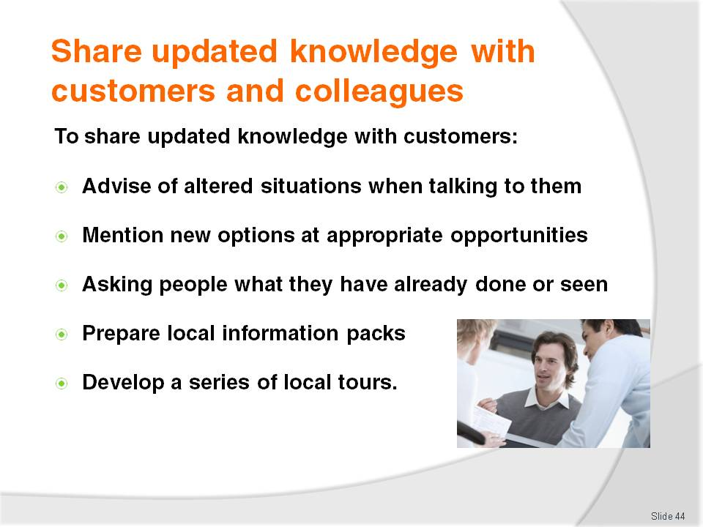
Slide No | Trainer Notes
Trainer explains to trainees any new or updated local information must be shared with colleagues and customers in order to enhance service delivery and optimise customer experiences.
Trainer defines, for the purposes of this Unit, ‘customers’ include guests, friends of guests and visitors generally. They can be individuals, families or groups of business people or tour groups.
Trainer presents to trainees options for sharing updated local information with staff:
Advising of altered conditions when talking to customers, guests and visitors. These ‘altered conditions’ may relate to:
- Opening hours for a venue, attraction or park
- Prices to enter, cost of tickets and tours
- Schedules and timetables of shows, buses, trains
Mentioning new options to customers/guests such as:
- Telling them about a new park, gardens, attraction
- Giving them a brochure about the new/revised attraction
- Providing a map and directions about how to get there
Asking people where they have already been and what they have already seen to enable:
- Recommendation of attractions they have not yet seen
- Provision of information or brochures about those places
- Giving first-hand impressions about the attraction , where applicable
Prepare local ‘information packs. These can simply be an assortment of information brochures relating to different types of places of interest, types of tourism, guest interests
Develop a series of tours suitable for guests or visitors. These should be supported by relevant information brochures, schedules and maps and encompass:
- Walking tours, self-drive tours, public transport-based tours
- Two-hour tours, half-day tours and full-day tours
- Night walks.

Slide
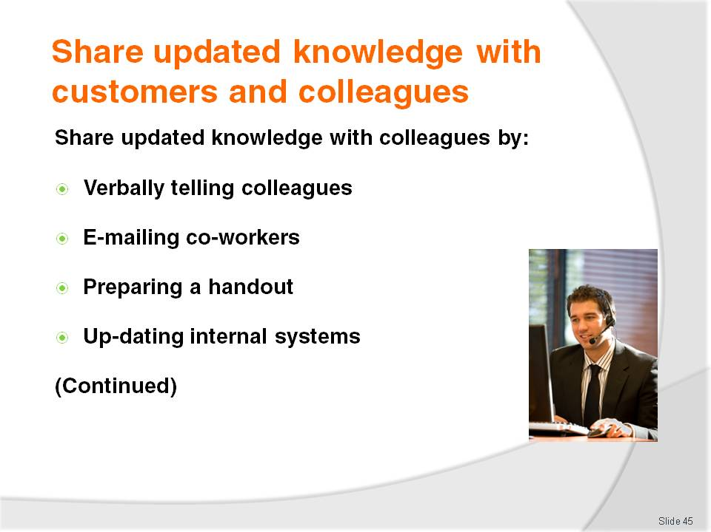
Slide No | Trainer Notes
Trainer talks again about ways in which local knowledge may be shared with colleagues in the workplace:
Verbally tell colleagues about has been learned
E-mail co-workers with information discovered
Prepare a handout and distribute
Update internal information systems such as databases and CRS.

Slide
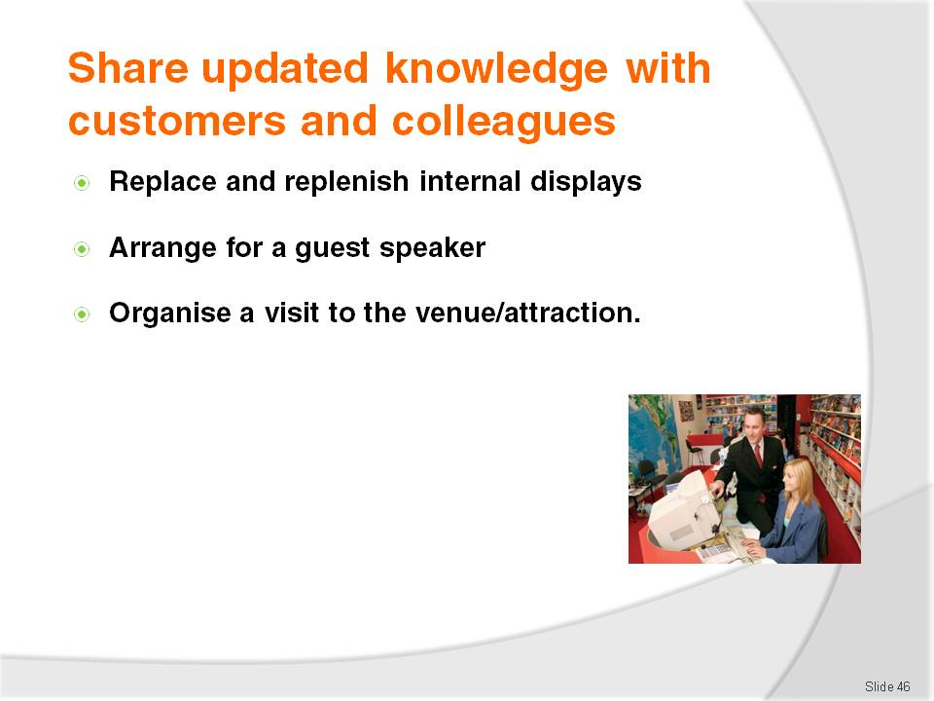
Slide No | Trainer Notes
Trainer continues to talk about ways in which local knowledge may be shared with colleagues in the workplace:
Replace and replenish internal displays. Ensure dated materials are discarded
Arrange for a guest speaker to come and talk to staff
Organise a visit to the venue/attraction for staff to gain first-hand experience and knowledge.

Slide
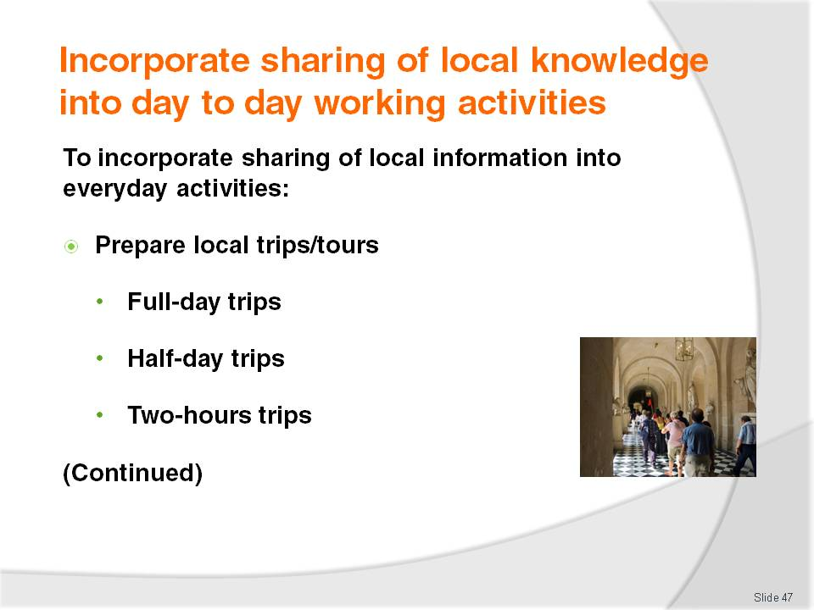
Slide No | Trainer Notes
Trainer highlights to trainees that it is critical for all venue staff to incorporate the sharing of local knowledge and information into day to day working activities with customers/visitors.
Trainer presents options to achieve this as:
Prepare some local trips/tours. The key aims of doing this are:
- To try to get the guest to stay another day or more
- To maximise their enjoyment during their stay to bring repeat and referral business
The full-day trip should spell out:
- The route to take
- The distances involved
- The times allowed for
- Details of all the destinations. Aim to put together as many of these types of trips as possible. There may be subtle changes between similar trips based on different opening days/hours for some attractions. For example, the area may have certain attractions not open on Tuesdays and Wednesdays.
Half-day trips:
- Should aim at a four-hour trip. There may be different ones for different days (again, because some places may not be open at certain times, or the animals are only fed at 4:00PM, or the tide comes in at a certain time), and different ones for the morning and afternoon. Different ones may be prepared to cater for different weather conditions. There may be different ones for different seasons especially where natural attractions are involved. Night walks are a fairly common extension of this concept
Two-hour tours:
- Are for people who want to squeeze a little bit extra in today, or before they depart the area tomorrow. The same advice as for the other types of trips applies. The trip is just shorter. Perhaps divide a half-day trip into two, or it may be a totally new idea
- It is a good idea to create one of these trips between the venue and the airport, for example, so the guest/visitor can a little bit extra on their way ‘home’
- These ‘trips’ can be ‘mud maps’ with hand-written features or produced on the workplace computer and printer. They can be professionally produced and printed for distribution
- Naturally the trip preparation or itinerary should be certain to describe any potential pitfalls, dangers, obstacles, hazards, or warnings. It should also list any items people should take with them. This may include petrol, sun screen, drinking water, coins for machines, and a hat
- Depending on clientele, prepare trip handouts in different languages to cater for the cross-section of international visitors the venue attracts.
Class Activity – Small Group Exercise
Trainer divides trainees into three groups and asks:
Group 1 to prepare a full-day tour for the region
Group 2 to prepare two half-day tours for an area
Group 3 to prepare four two-hour tours for the area.
Tours should be shared with the rest of the group, for comment and feedback.

Slide
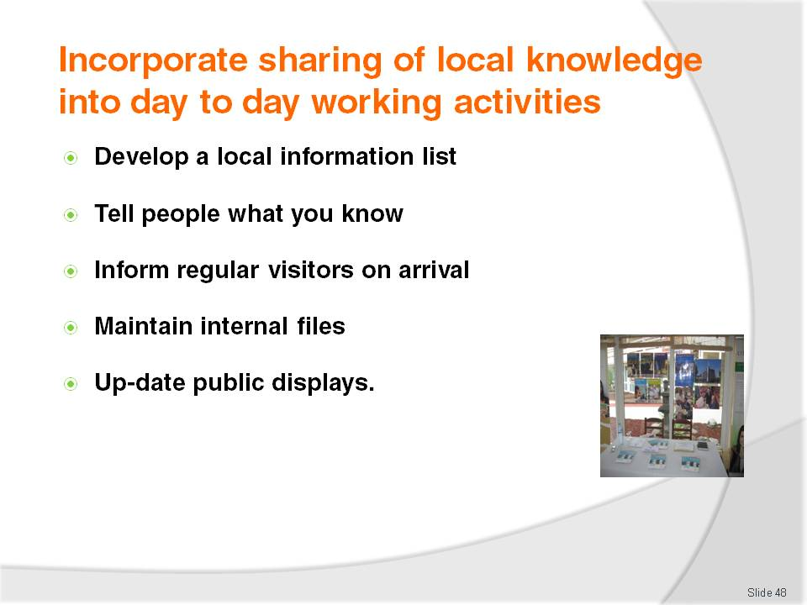
Slide No | Trainer Notes
Trainer continues to present ways in which trainees can share local knowledge by incorporating to into day to day activities:
Develop a local information list . If the local Visitor Information Centre does not already have any suitable lists accommodating this need, then it is up to venues to meet this need by creating their own list to help visitors. Consider making a big production out of this. Make the workplace venue a central feature, but be prepared to sell space to other operators who are likely to benefit (to help defray the costs of production). The list should cover:
- Local attractions
- Tours
- Opening hours of attractions
- Costs of tickets
- Distances of the attractions from the venue and time to travel there
Tell people. This should include:
- Involving all front-of-house staff in telling customers what is available. This can include:
- Reception staff on guest arrival
- Waiting staff in dining areas
- Bar staff in bars
- Making it standard procedure for staff to ask customers/guests what they have seen or done. They can then recommend something they have not seen, and something they have not yet done
- Providing relevant support materials to optimise the chance of customers/guests taking up suggestions made by staff. These can include maps, brochures, promotional materials
- Using personal experience as the basis for making suggestions by telling customers of their own experience at the attraction or on the tour. It is this ‘personal’ and first-hand experience which commonly makes the difference between whether a guest takes up the suggestion or not
Advise regular visitors on arrival:
- If aware a regular visitor/guest is arriving tomorrow and they love to go fishing in the local tidal river, then make sure they are provided, on arrival with, for example:
- A current copy of the tides and times
- A current price list of the boat hire charges from the local hire shop
- The same idea applies for any regular visitor if their tastes, preferences and hobbies are known. Go ahead and make the extra effort. It often will not take much to stand out from competitors because all too often they do nothing so it does not take much to beat them in this regard. Just follow through and take the necessary action
Maintain internal visitor information files. Update as required and discard dated brochures. Capture brochures/information for new venues, facilities and attractions. Nominate a person to be responsible for this
Make sure brochures provided in the public displays and other areas (in-room compendiums, concierge) are updated, kept filled and current.

Slide
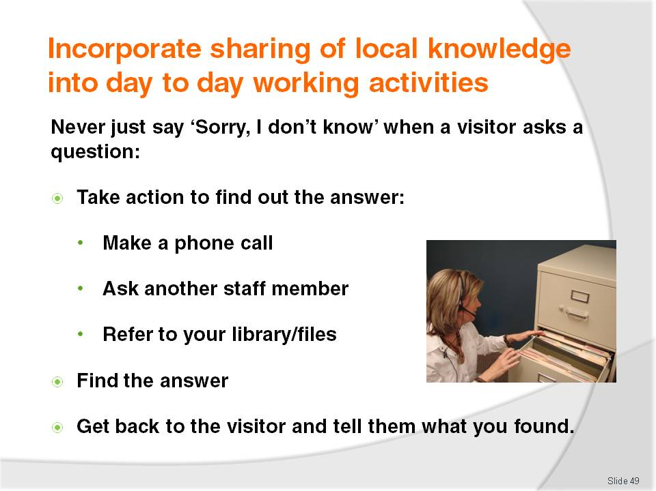
Slide No | Trainer Notes
Trainer explains to trainees that no one can possibly ever know the answer to every question visitors might ask BUT they are also never expected to just answer an enquiry they do not know about with a silly grin and the words ‘Sorry, I don’t know’.
Trainer urges trainees if they do not know the answer to a guest/visitor question it is acceptable to say they do not know the answer but they must then take appropriate action to follow-up, find out and get back to the visitor with the required information. This may involve:
Making a phone call for the tourist/visitor to the actual attraction or hotel they are making enquiries about, or phoning the Visitors Information Centre
Asking someone else if they know. There may well be another staff member who does know and who may be able to help
Referring to local library of tourist information. This could assist with finding out, for instance, prices, and the finer details (such as opening times, credit cards accepted).

Slide
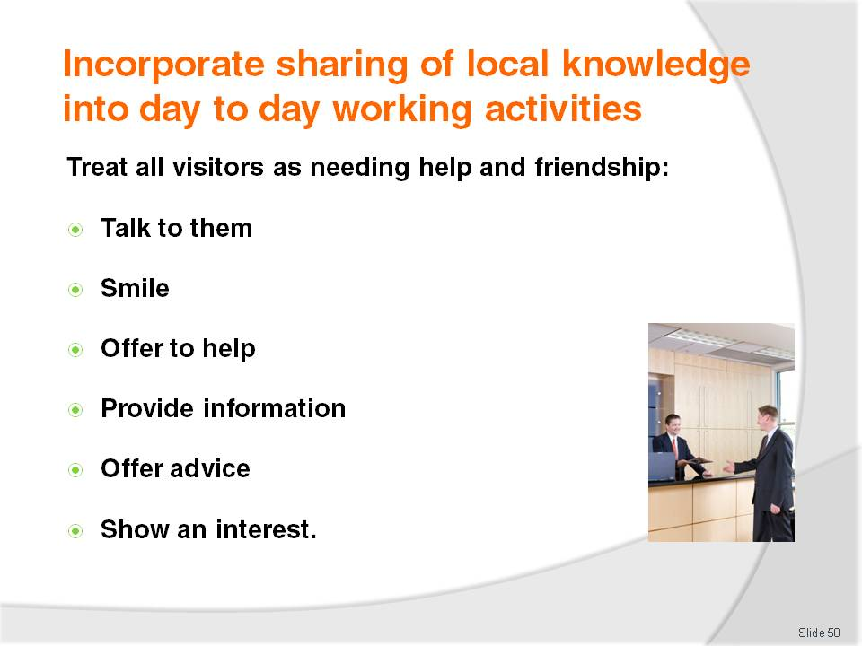
Slide No | Trainer Notes
Trainer stresses trainees must always remember most visitors are, obviously, not locals and hence do not have the same ‘local knowledge’
Many people take for granted.
Visitors need not only to be given local knowledge but also treated appropriately and helped which can involve:
Talking to people as opposed to ignoring them (which makes them feel unwanted, unappreciated and like an intruder)
Smiling. It is a universal language … and smiling is free
Offering to help without waiting to be asked. Read people’s body language and be proactive in making an offer of help or assistance
Providing information willingly in response to questions
Providing advice to supplement the information and to individualise the information given. Refer to personal experience
Showing an interest in them as individuals.

Slide
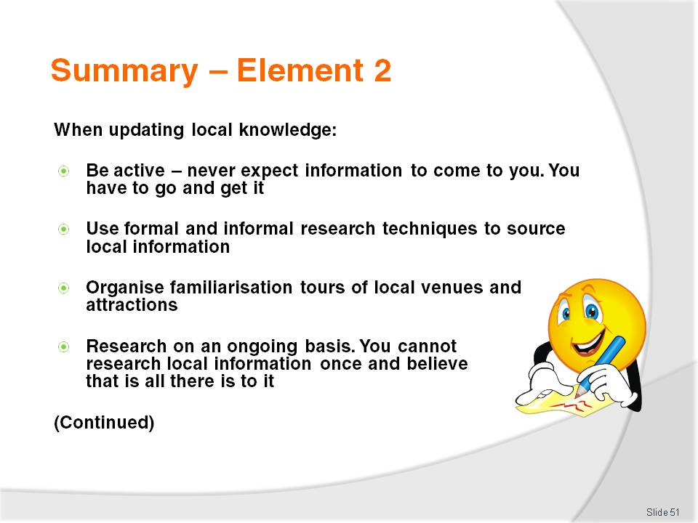
Slide No | Trainer Notes
 | Trainer provides a recap of the Element asking questions to check trainee understanding and responding to questions from trainees, as required.

Slide
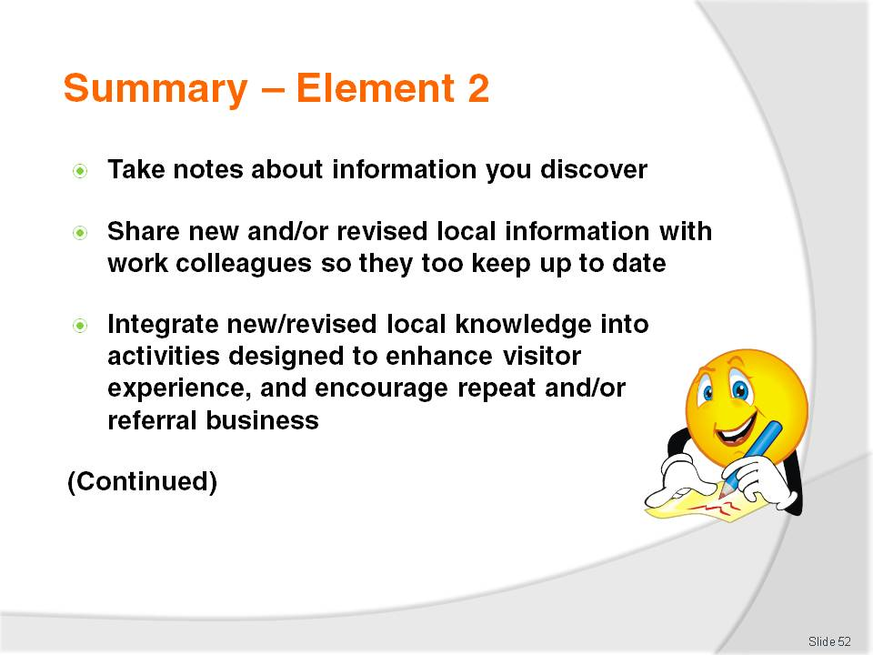
Slide No | Trainer Notes
 | Trainer provides a recap of the Element asking questions to check trainee understanding and responding to questions from trainees, as required.

Slide
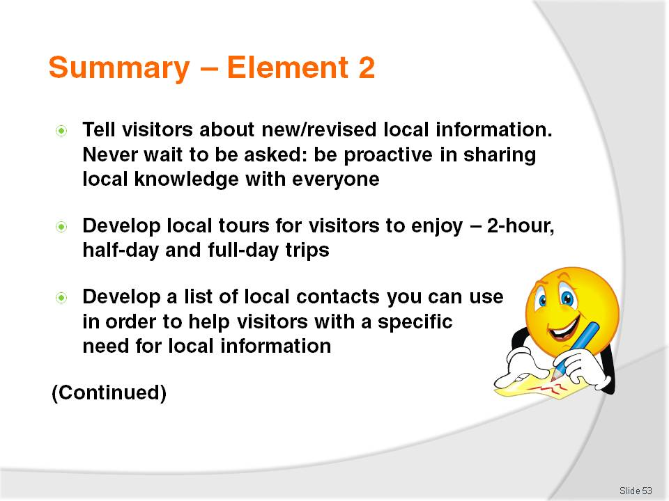
Slide No | Trainer Notes
 | Trainer provides a recap of the Element asking questions to check trainee understanding and responding to questions from trainees, as required.

Slide
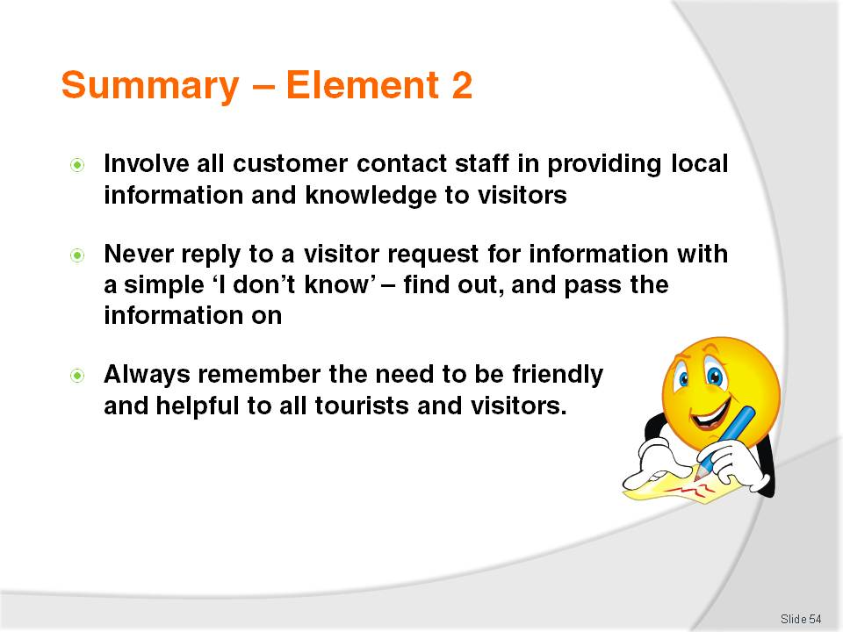
Slide No | Trainer Notes
 | Trainer provides a recap of the Element asking questions to check trainee understanding and responding to questions from trainees, as required.

Slide
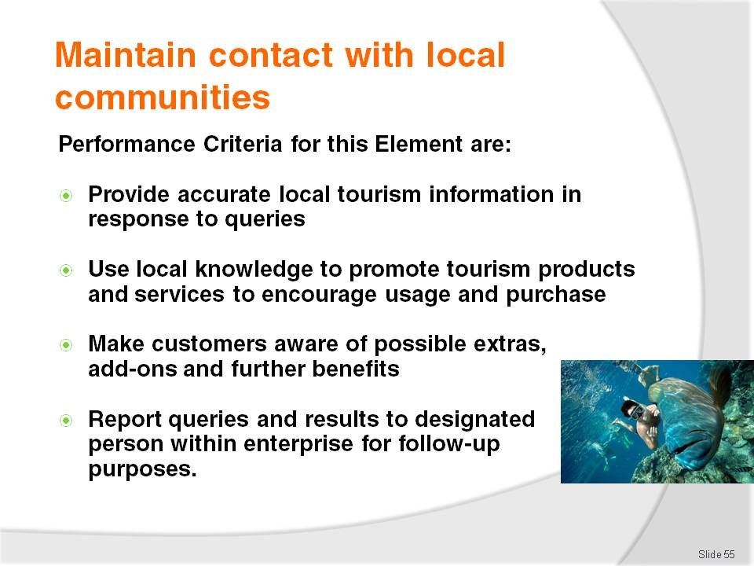
Slide No | Trainer Notes
Trainer identifies for trainees the Performance Criteria for this Element, as listed on the slide.
Class Activity – Discussion
Trainer asks trainees questions regarding their experience in relation to maintaining contact with local communities and what may be done to optimise spending and visitor enjoyment of their stay in the region/area:
Why is it important to maintain contact with local communities?
How might this occur?
What can a venue/attraction do to demonstrate it is trying to support the local community?
What is meant by ‘tourism products and services’?
How might local knowledge be used to encourage visitors to purchase and/or use local tourism products and/or services?
What are examples of add-ons and extras that staff may sell/suggest to visitors when promoting local tourism products and services?
Why might management at a venue or attraction want to know about the type of questions asked by visitors, and the effectiveness of the way staff respond to those questions?

Slide
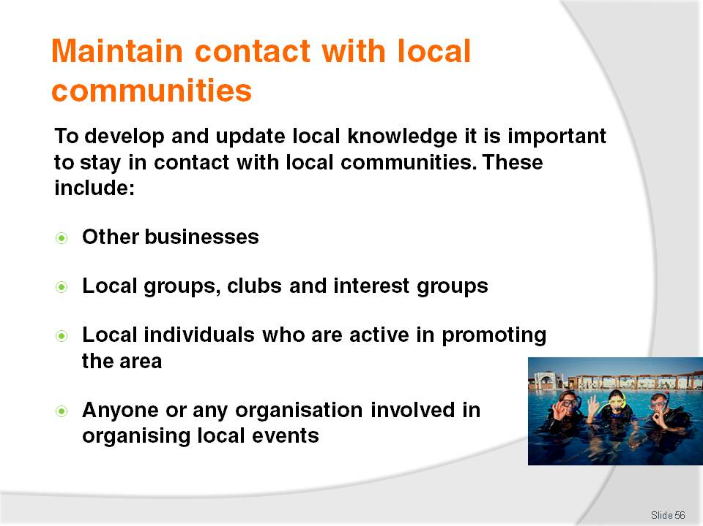
Slide No | Trainer Notes
Trainer reminds trainees in order to develop and update local knowledge effectively it is necessary to be proactive. Part of taking the initiative in this regard is the need to maintain contact with local communities.
Trainer states ‘local communities’ can include:
Other businesses in the area of any type. There is always a possibility a visitor may need to contact any type of business. Also it is important to form good working relationships with other businesses and to cooperate with them for mutual benefit
Local groups, clubs and interest groups who conduct events and/or support local tourism initiatives
Individuals who are active in promoting the local area. These are often the people who initiate events, work with other tourist destinations for mutual benefit and who work to bring visitors into the area
In brief, anyone or any organisation involved in organising local events or operating local businesses or attractions can be seen for the purposes of this unit as a ‘local community’.

Slide
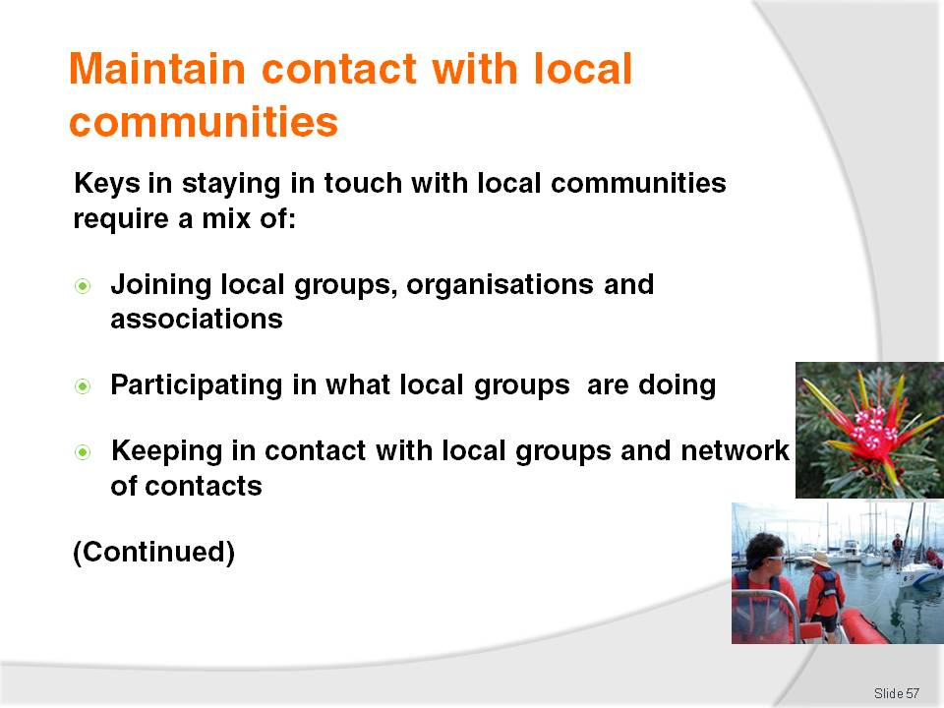
Slide No | Trainer Notes
Trainer informs trainees the keys in staying in touch with local communities require application of a mix of the following activities:
Joining local groups and attending their meetings
Participating in what local groups are doing including contributing assistance, information and resources to help them achieve outcomes that are mutually beneficial. Participation must be active and it must be substantial (that is, not just verbal support)
Contacting them on a regular basis. Visit them face to face or telephone them regularly.

Slide
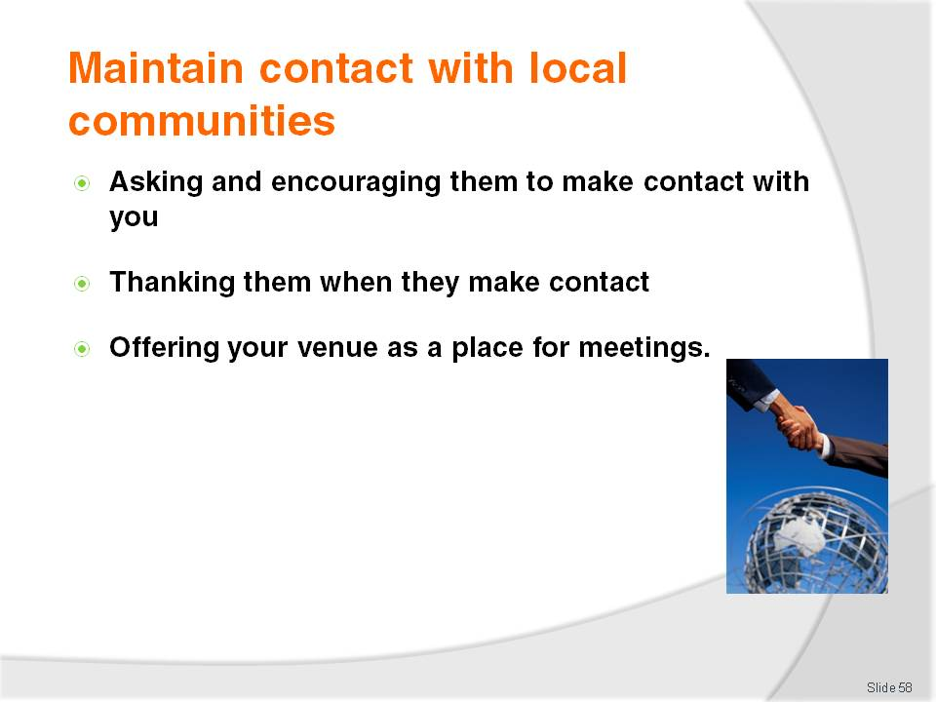
Slide No | Trainer Notes
Trainer continues to tell trainees of the keys in relation to maintaining contact with local communities:
Ask them to make contact. Encourage them to call/contact the venue and make it easy for them to do so. Let them the venue wants to maintain contact with them
Thank them whenever they make contact to encourage them to keep in contact
Offer the venue as a meeting place to keep the venue and its commitment to mutual promotion of the area firmly centred in their minds.
Class Activity – Guest Speaker
Trainer arranges for a speaker from a local ‘community to talk to trainees about:
The role of the organisation to which they belong regarding local tourism and promotion of the local area
How trainees might join the organisation
Cost to belong, if applicable
Examples of events they have organised
Details of where and when they meet and the duration of meetings
Advice they can give regarding promotion of the local area to visitors.

Slide
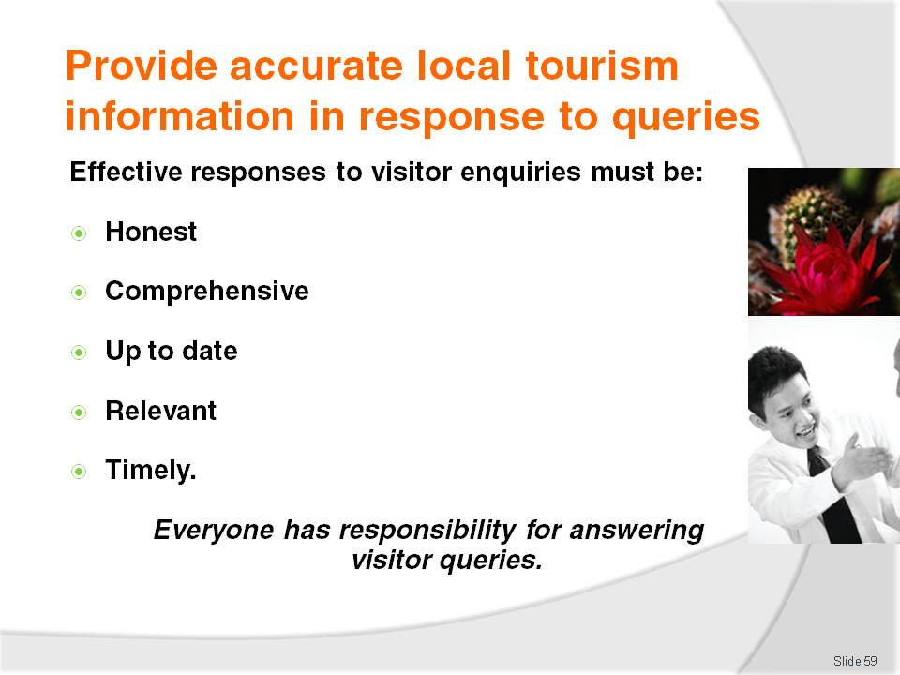
Slide No | Trainer Notes
Trainer stresses to trainees that it is important for them to provide accurate responses to all tourist queries, explaining effective responses to a visitor query about the local area must be:
Honest. Never tell an untruth or a half-truth about anything. Never say something is ‘good’ or ‘worth seeing’ unless it genuinely is
Comprehensive. Never tell a person ‘only the good bits’. If there are bad aspects to something, these must be presented and explained. For example, if the tour is excellent but is hot and dusty, tell people it is/can be hot and dusty
Up to date – all details about all aspects of the response (costs, times, opening hours, displays on show, animals ) must be current
Relevant. It is important to add any information that relates to the query but which has not been specifically asked about. For example, if the attraction does not have credit card facilities, EFTPOS or ATMs then tell people they will need to take cash with them when they visit
Timely. All responses must be given in a timely manner. In practice this means ‘straight away’ subject to the need to make enquiries (such as making a telephone call, or looking at an information database) on behalf of the tourist to determine specific information they are seeking.

Slide
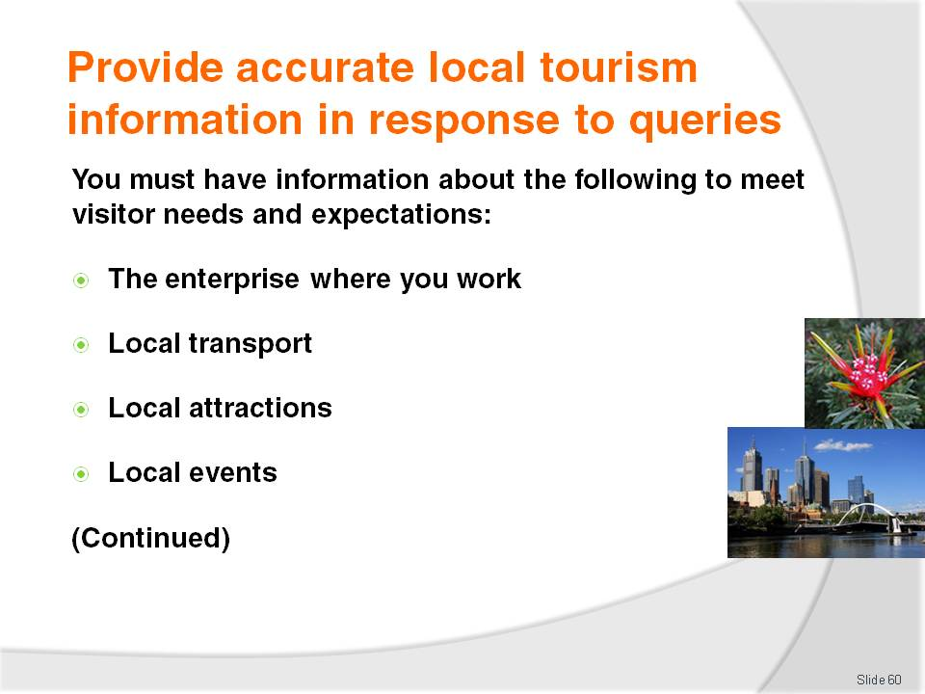
Slide No | Trainer Notes
Trainer emphasises to trainees the need for their venue to obtain sufficient local information to meet expected and identified visitor needs. This will vary between properties and is often dependent on the geographic location where the venue is situated.
Trainer identifies information about the following must be available to respond to visitor enquiries:
Venue knowledge. Also known as 'product knowledge' this covers details about the venue such as:
- When certain facilities (swimming pool, gymnasium, spa, bars) are open
- Prices –for everything the venue has to offer: drinks, meals, rooms, services
- How to make a booking –for a room, dining reservation, the tennis courts
- Check-out times
- The rooms and/or tables with the best views
- Arrangements for parking
- Type of credit cards taken
- Procedures and policies for a range of things such as lost and found items; deposits, discounts and refunds; security and safety of guests; dealing with complaints.
Local transport. Staff must have a basic working knowledge of what is available including:
- Transport options – especially trains, trams, buses but also taxis, hire cars and other more local alternatives such as tuk tuks, rickshaws, trishaws, pedal bikes
- Cost
- Where the station and bus stops are
- Frequency of public transport (buses, trams and trains) supplemented by current timetables. More detailed information should be in the in-house file together with contact details enabling even more detailed information to be accessed when required. In some locations, transport options can include all manner of modes of transports from canoes, to camels and four-wheel drives. They can include buggies, horses, motor bikes, scooters and push bikes. They may cover motor boats, ferries, and airplanes and helicopters
Local attractions. This must address:
- What is available
- How far away it is
- How long it will take to get there and return using a variety of commonly used transport/travel options
- What there is to see when they get there – displays, animals, activities, rides, tours
- How much it costs to enter the attraction, to go on a tour, to buy tickets for the rides or shows
- When it is open, including when it closes
- Man-made and natural attractions. Where the natural attraction conceals or contains some sort of danger this must be highlighted. The danger may be information about wandering stock, dangerous/wild animals, the possibility of dehydration, and the length (in terms of meters/kilometres and in terms of time) of walks
- Local customs must also be addressed so visitors do not give unintended offence to the locals
Local events. There should be:
- A list of all local events – dates and (where applicable) times
- Venues participating in the event/hosting parts of the event
- Cost to attend/participate
- Background to the event – why it is being held; local/national history of the event
- Protocols (if any) associated with the event. For example, things visitors should not say or do while attending the event.
Class Activity – Class Discussion
Trainer identifies one local event and asks trainees to contribute items of information about this event that should be communicated about it to visitors from another country.
Trainer records all contributions on the board for trainees to copy down.
Attention must be paid to following up any information by trainees considered ambiguous, incorrect or controversial.

Slide
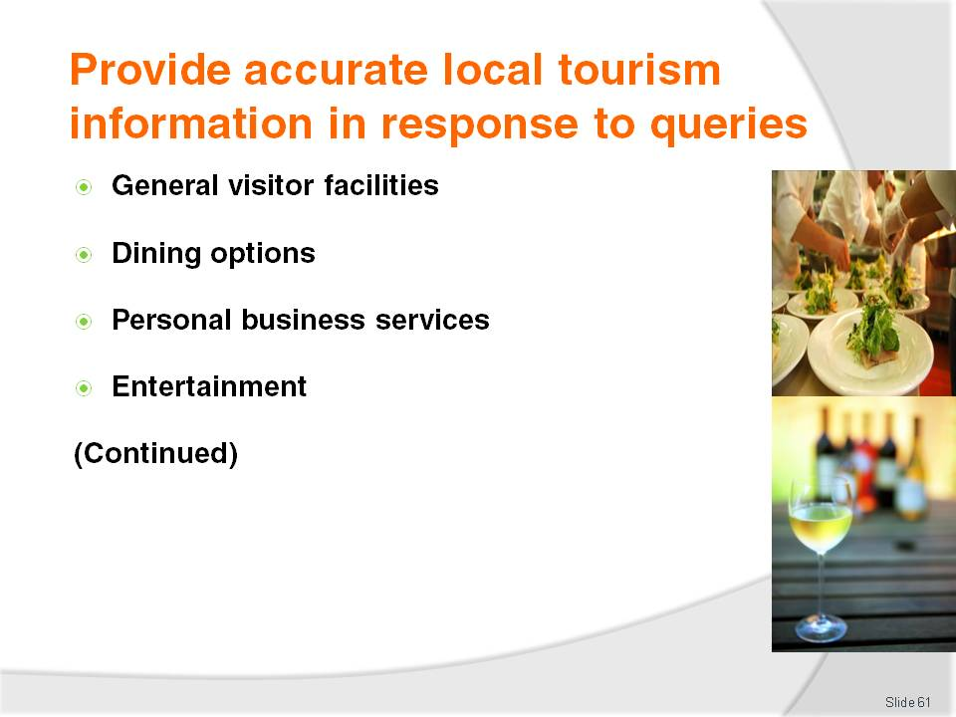
Slide No | Trainer Notes
Trainer continues to explain that information about the following must be available to respond to visitor enquiries:
General visitor facilities. In-house local information file should contain information about:
- Shopping locations
- Markets
- Currency exchange sites
- Post offices
- Banks and ATMs
- Emergency services
Dining options including all types/styles (fast-food, take-away food, local cuisine, western cuisine, fine dining) and bars/drinking venues. Before recommending a dining or drinking venue it is best to ask some questions of the guests so an appropriate recommendation can be made. Questions could include:
- Do they want a quick meal, or a full night out?
- How much do they want to spend?
- Do they have transport?
- Do they want a ‘local’ experience?
A menu of the dining venue should be provided where possible so visitors can gain a better idea of the venue before they attend.
Personal business services. This may include a detailed list (name, address, contact details, prices, plus other relevant information as indicated by the precise nature of each business) of local:
- Dentists
- Doctors
- Chiropractors
- Beauticians
- Remedial masseurs
- Podiatrists
- Travel agents
- Computer technicians – many people travel with a lap-top and need occasional but absolutely crucial IT support
Entertainment. This should embrace:
- Theatres
- Cinemas
- Entertainment venues
- Natural swimming spots (beaches, rivers, lakes), beaches and swimming pools
- Local sporting clubs
- Sporting facilities
- Health clubs and gymnasiums
- Golf courses
- Shooting ranges
- Fishing spots
- Tours and tour organisers.
Class Activity – Small Group Exercise
Trainer divides trainees into four groups, and:
Allocates each group one category from the above slide
Asks each group to compile in (for example, 30 or 60 minutes) as much local information as possible about the category they have been allocated
A representative from each group shares their list of information with other groups at the end of the allocated time
Feedback and comment from all trainees is encouraged
Attention must be paid to following up any information by trainees considered ambiguous, incorrect or controversial.

Slide
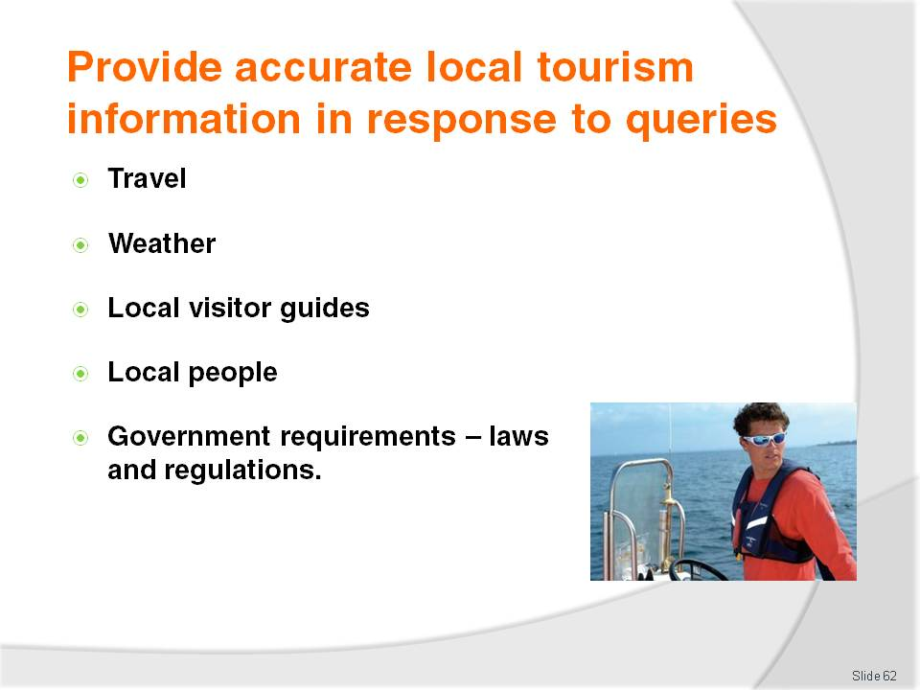
Slide No | Trainer Notes
Trainer continues to identify information about the following must be available to respond to visitor enquiries:
Travel. Important requirements are to have:
- Local maps
- A street directory
- Updates, alerts, advice and information from local police and motoring/car clubs
Weather. This should include short-term and long-term forecasts for the local area, as well as other locations in the country. The local newspaper may be sufficient to enable these to be provided or there may need to be a relationship with the Bureau of Meteorology (or similar)
Local visitor guides. These are one of the most asked for items of visitor information. Contact local Visitor Information Centre to ensure sufficient quantities to:
- Put in guest rooms
- Display in public areas
- Distribute from the reception desk
Local people. This is a list of people from the local area who have agreed to be on the list and who may be helpful and prepared to help. These can include visitors in various capacities such as:
- Providing local knowledge
- Being a local tour guide
- Assisting with research
- Introducing people to local businesses, groups
Government requirements. This is a list outlining or detailing:
- Local, regional and national laws that visitors must abide by such as issues relating to:
- Taxes payable by tourists and rebates (where applicable)
- Prohibitions on goods that can be taken out of the country
- Documentation required to take nominated items out of the country
- Immigration and visa requirements.
Class Activity – Guest Speaker
Trainer arranges for one or more representatives from Government agencies to attend and talk to trainees about:
Issues that tourists/visitors need to comply with when in the area
Materials available to support communication of these matters
Penalties that may apply
Level of tolerance, if any, with out of country visitors who breach legislated requirements
Help available from authorities and agencies to assist venues inform visitors of local, regional and/or national legal requirements.

Slide
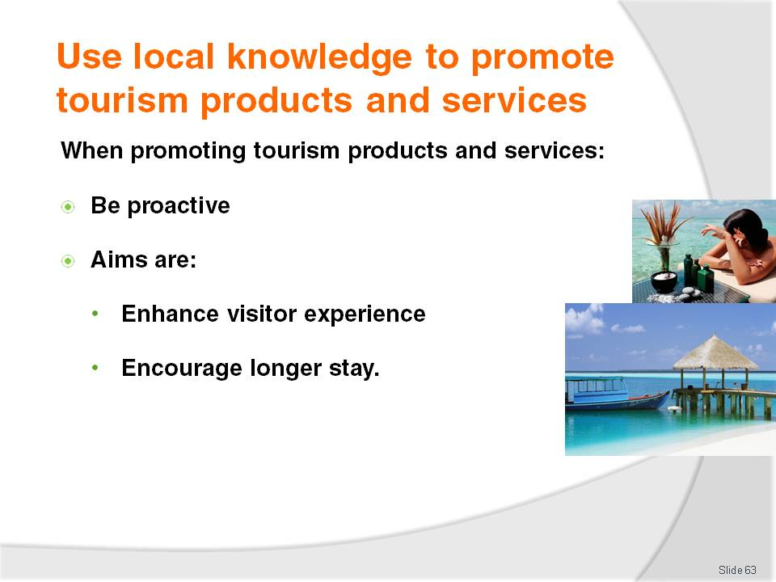
Slide No | Trainer Notes
Trainer reminds trainees when using local knowledge to promote tourism products and services they must remember:
To be proactive. It is vital an effort is made to sell these things: they will not ‘sell themselves’
The aims of promoting tourism products and services are to:
- Enhance/optimise the tourist experience. Local knowledge and local tourism products and services should enhance the visitor experience of the country/local area
- Encourage tourists to stay another night or two in the area. The longer people stay, the more they are likely to spend to help the local economy or community.

Slide
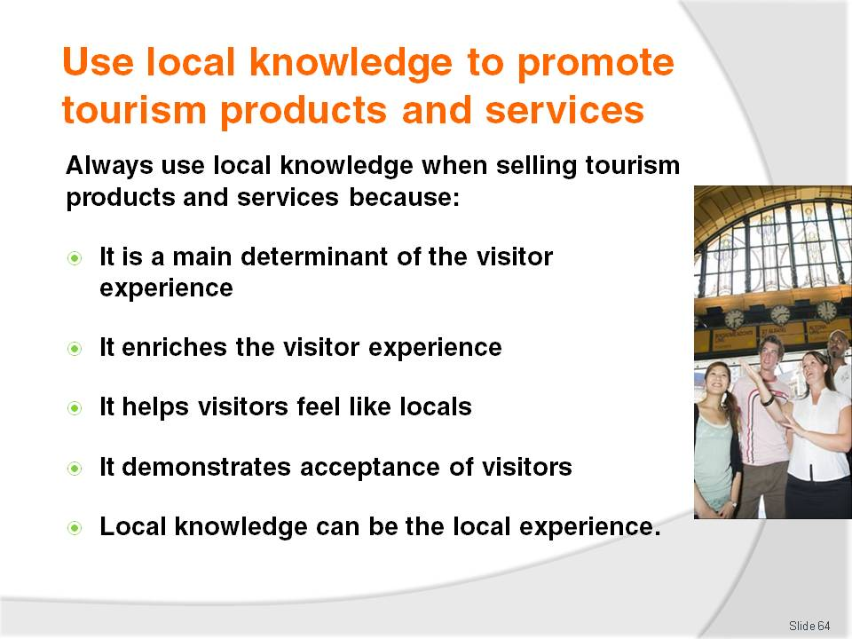
Slide No | Trainer Notes
Trainer tells trainees they must always use local knowledge when promoting local tourism products and services because:
The local knowledge passed on to tourists, customers, guests or visitors often decides whether or not the person has an enjoyable experience or not. This is a prime consideration in determining if those people generate return or referral business from the venue and/or the area or country
Local knowledge ‘enriches’ the tourism experience
Local knowledge enables the tourist/visitor to differentiate themselves from other tourists/visitors who do not have ‘local knowledge’ and hence cannot avail themselves of the benefits this local knowledge brings
Sharing local knowledge is an excellent way of demonstrating acceptance of the visitor/tourist. In many ways sharing local knowledge is like sharing a secret and there are many positive attitudes and orientations implicit in the simple act of passing on such information. Sharing local information is a way of:
- Demonstrating respect for the other person and regarding them as ‘an equal’
- Proving the desire to provide a memorable experience for the person
- Deeming the other person as worthy of local secrets and information
- Allowing the other person an insight into the country, culture they would not otherwise have
Sharing local knowledge is often the local experience. Without this local knowledge there would be little or no ‘local experience’ for the person to remember and talk about after they have departed.
Class Activity – Guest Speaker
Trainer arranges for guest speaker from a local attraction or tourist body to attend and talk to trainees about:
The importance of promoting local tourism products and services
What the local tourism products and services are
Techniques for promoting local tourism products and services
Examples of how they have promoted local tourism products and services
Support for the promotion/sales of local tourism products and services.

Slide
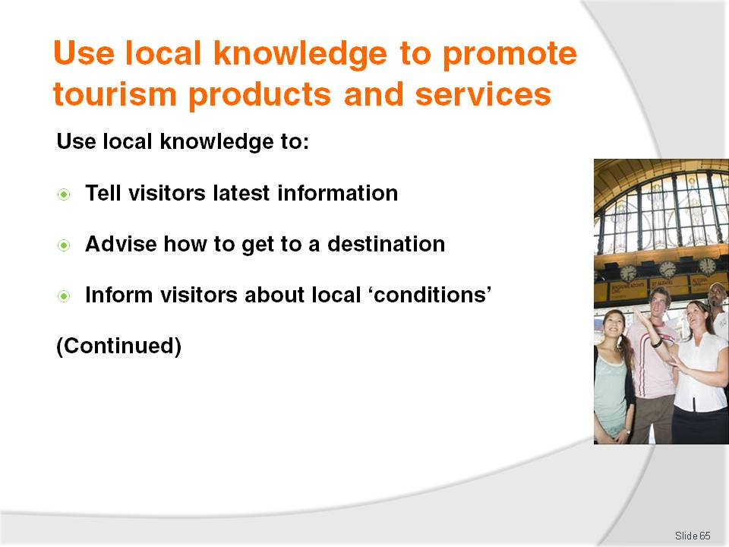
Slide No | Trainer Notes
Trainer informs trainees they should use their local knowledge to:
Tell visitors the latest information about the area or an attraction
Advise how to get to a destination/attraction – the best or quickest way, the most interesting way or a different way
Inform them about local conditions such as telling visitors of local traps and pitfalls to avoid.

Slide
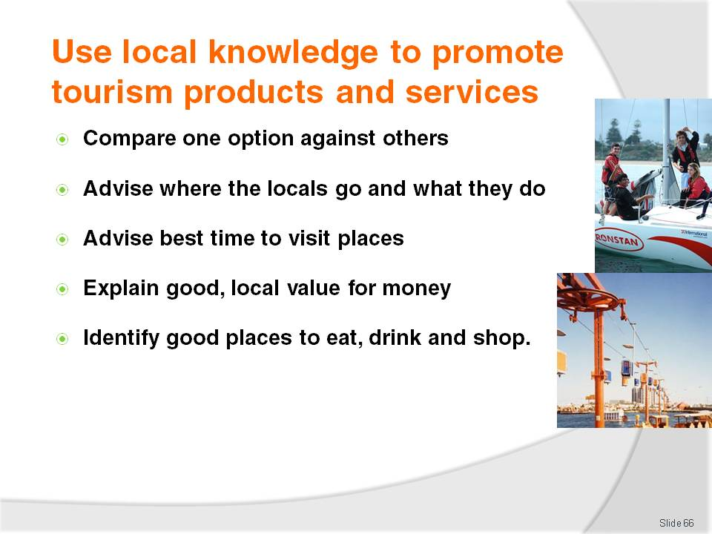
Slide No | Trainer Notes
Trainer continues to inform trainees they should use their local knowledge to:
Compare one option against another so visitors can make informed decisions about what to do, where to go, what to buy
Let visitors know where the locals eat, swim, fish, relax so they can get a true ‘local experience’
Indicate the best time of day to visit an area, landmark or feature in order to get the most from the experience
Explain what constitutes best value for money locally by offering alternatives and through basing options on local prices
Identify the best restaurants, bars and shops based on identified visitor needs and preferences.

Slide
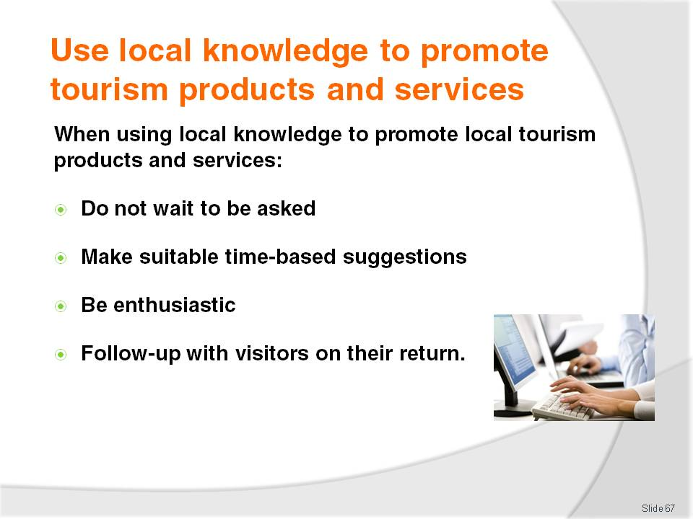
Slide No | Trainer Notes
Trainer emphasises trainees must be proactive when promoting local tourism products and services meaning they must:
Offer the local knowledge/information without having to be asked. If, for example, a tourist has asked about a local tourist attraction and there is an additional and interesting destination on the way to that attraction, they should be told about it, how to get there, and what the additional destination is all about
Making suggestions about what tourists/visitors can do with their time by:
- Asking what they have planned for the day
- Asking what they have already done which identifies local things they have not done, or local sites they have not visited
- Developing 2-hour, half-day and full-day tours – see earlier notes/slides
Showing enthusiasm for the suggestions made. There is a need to be 100% committed to how much fun an experience or attraction is, what a unique experience it is or how sad it would be for the person to be close to the attraction and not get to see or experience it. Implicit in this is the need to have pride in country, local area. In very many ways frontline staff are ambassadors for their region, country and venue
Talking to people after they return from a trip or experience suggested to them. This means asking them how they enjoyed it or what they learned. This conversation is also important because it provides feedback about whether or not the recommendation should be repeated to other visitors or not. It also provides feedback about what may have changed at the place or destination recommended.
Slide
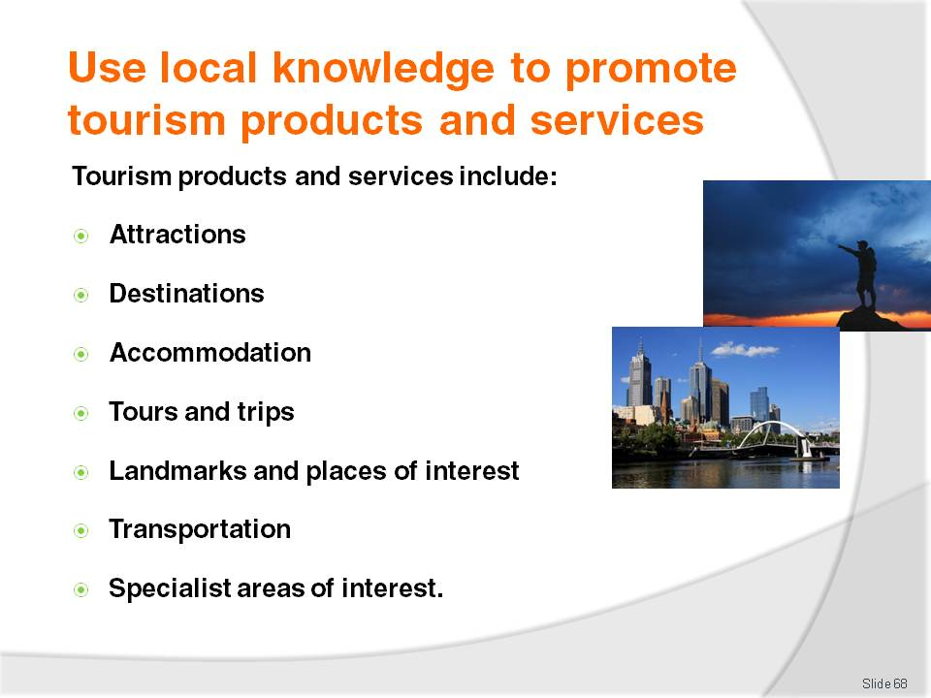
Slide No | Trainer Notes
Trainer explains to trainees there is no strict definition of exactly what constitutes ‘tourism products and services’ stating from a practical viewpoint. The term should be interpreted in the widest possible context to embrace anything the venue and the local area has for sale.
Trainer mentions to trainees some will insist ‘tourism products and services’ refers more particularly to items (products/goods and services) specifically aimed at tourists, such as:
Attractions – generally natural attractions or commercial attractions where people pay to enter
Destinations – a general location, area, village or location
Accommodation – venues of all types/star-ratings
Tours and trips – using any method of transport
Landmarks and places of interest – any place a visitor may wish to visit, see, enjoy (often historically significant)
Transportation – public or private
Specialist areas of interest for groups/tourists such as nominated shopping precincts, sporting events, religious festivals or local celebrations.

Slide
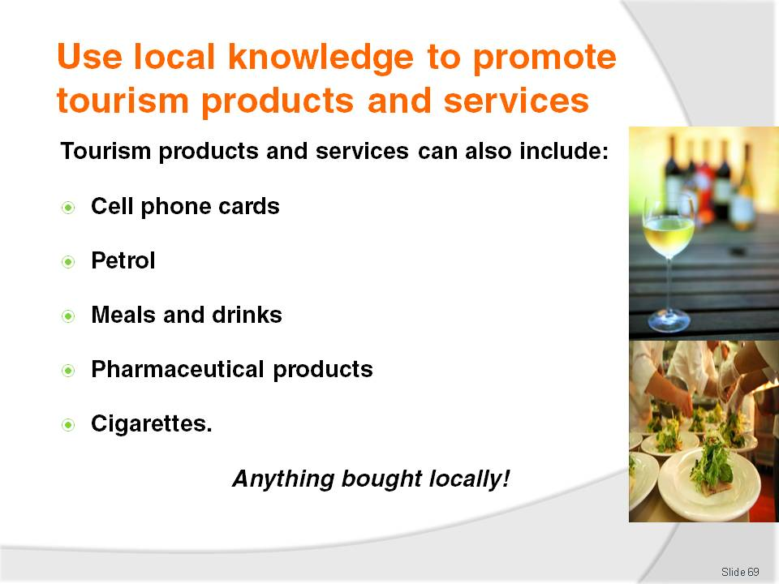
Slide No | Trainer Notes
Trainer informs trainees ‘local tourism products and services’ may also be seen as including a vast range of small and ancillary items all visitors may purchase as part of their day to day living requirements while on holiday or abroad, such as:
Cell phone cards to recharge their phone
Petrol for their own cars or hire cars
Meals and drinks including ‘proper’ meals, snacks, ice cream, take-away food
Pharmaceutical products – cosmetics and health products
Cigarettes and other items from stationers
Items of clothing
Anything visitors pay for.
Class Activity – Group Discussion
Trainer leads class in a discussion to identify the products and services a visitor to the area may purchase, and to identify the value of those purchases to the local community, by asking questions such as:
What physical products might a visitor from elsewhere within the country to this area need to buy?
How might these purchases differ to what an international visitor might need to buy?
What is the value of these purchases?
What is the local benefit of these purchases?

Slide
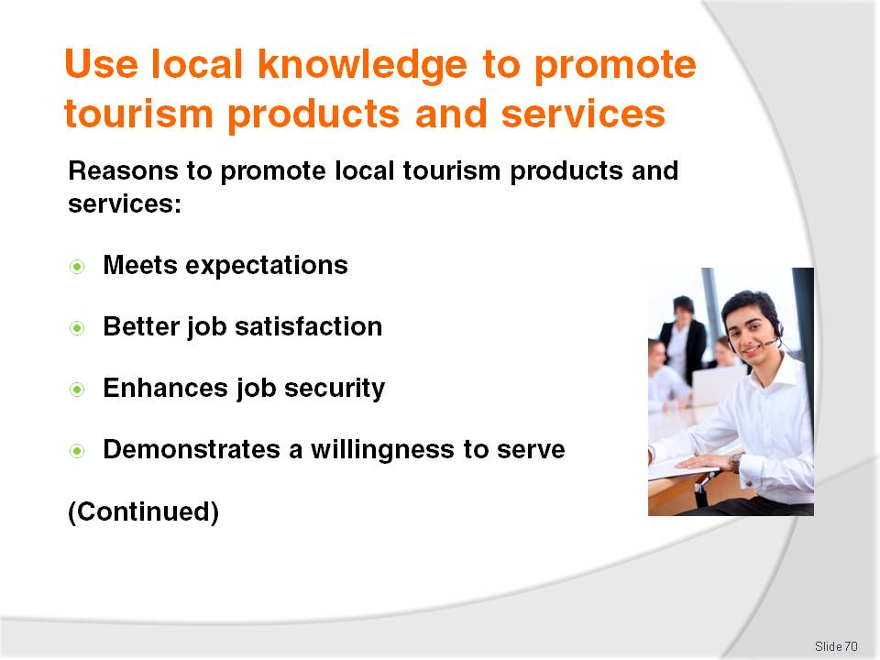
Slide No | Trainer Notes
Trainer advises trainees the reasons to promote local tourism products and services include:
Meets visitor/tourist expectations. It could be said failure to promote local products and services is a disservice to customers
Provides better job satisfaction. Work is more interesting when talking with others, learning from them, meeting new people
Enhances job security and enables extra hours to be worked
Identifies the individual worker as someone trying to help visitors and may identify them to management as someone with the potential for promotion or career advancement.

Slide
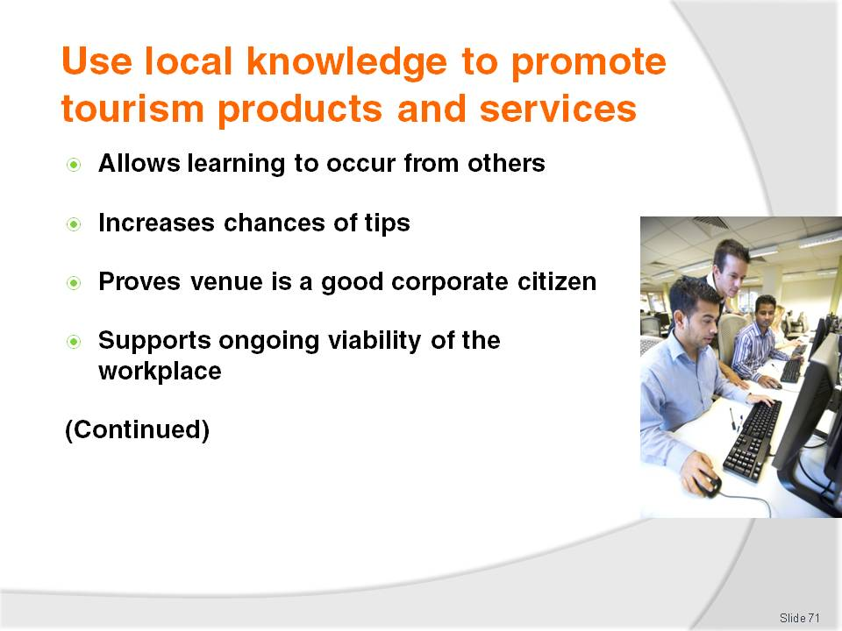
Slide No | Trainer Notes
Trainer continues to advise trainees about reasons to promote local tourism products and services:
Allows learning from other people to occur and creates the potential for a greater network of contacts
Increases the possibility of tips/gratuities. However it is important never to give the impression a tip is being sought or is expected
Demonstrates the venue is a good corporate citizen by sharing wealth and opportunity with others and the local community
Assists workplace maintain its ongoing viability by generating extra revenue and repeat and/or referral business.

Slide
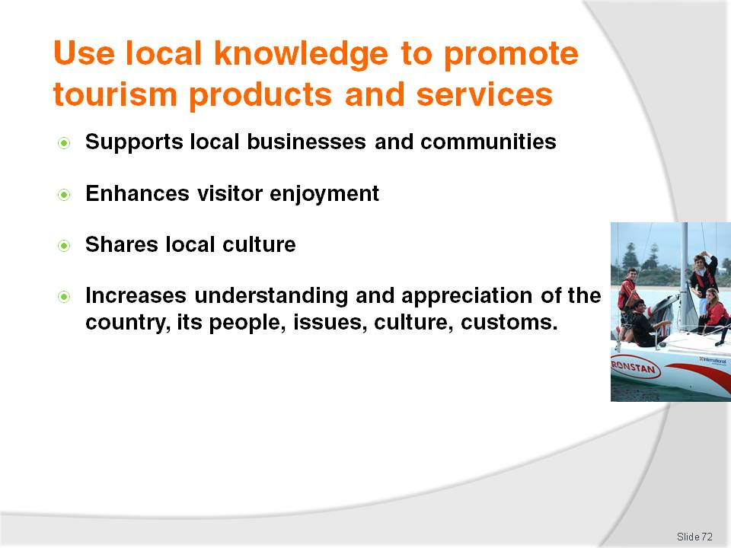
Slide No | Trainer Notes
Trainer continues to advise trainees about reasons to promote local tourism products and services:
Supports local businesses and the local community by generating income for them which creates and maintains local industry, employment
Enhances visitor/tourist enjoyment of the local area/region
Shares the local culture with visitors enabling better appreciation and understanding of the country/region amongst visitors/tourists
Gives greater insight into, and understanding of, the people and the country to overseas visitors.

Slide
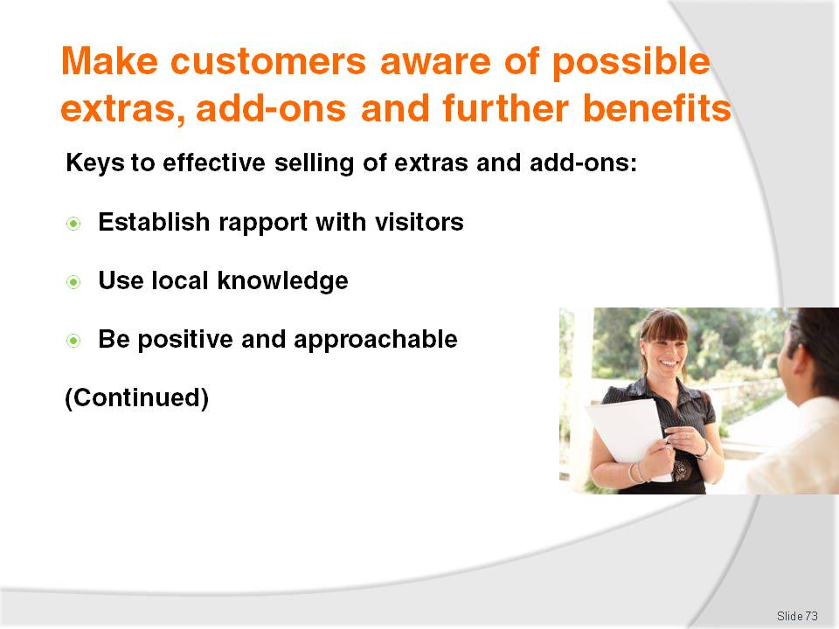
Slide No | Trainer Notes
Trainer highlights to trainees that when sharing local knowledge with visitors/tourists an opportunity regularly exists to make these people aware of possible extras, add-on and other benefits. These opportunities should be taken whenever possible to optimise guest/customer satisfaction and enjoyment, and maximise sales.
Trainer identifies to trainees the keys to effectively suggesting extras, add-ons and features to visitors and tourists include:
Establish a rapport with the visitors/tourists. This facilitates the exchange of ideas, questions and information. It increases the trust between the parties and encourages people to ask questions and to ask for advice
Make use of local, venue and product knowledge. The advice or information provided must be based in fact but overlaid with personal opinion and recommendation
Be positive and approachable. Be seen by tourists as someone who will help them, who is prepared to spend some time with them and who wants to share what they know. Open body language and smiling are important assets in this regard.

Slide
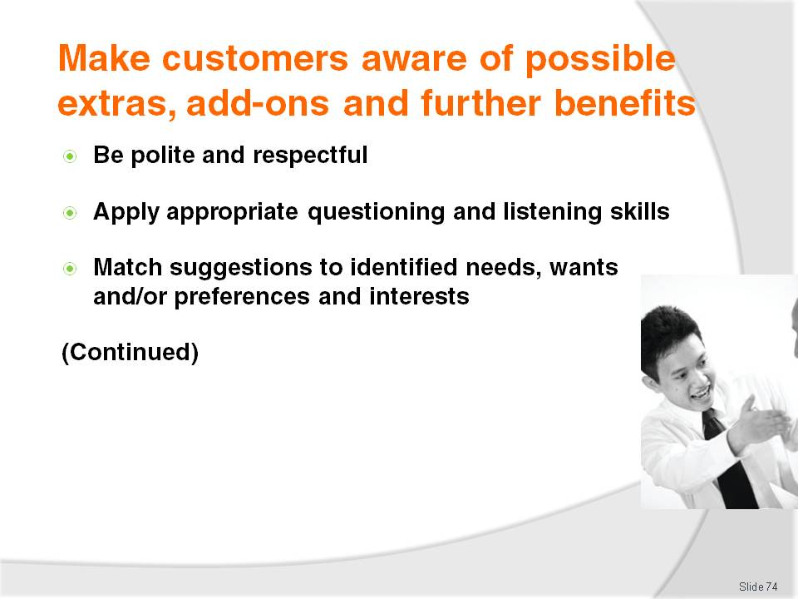
Slide No | Trainer Notes
Trainer continues to identify to trainees the keys to effectively suggesting extras, add-ons and features to visitors and tourists include:
Use polite and respectful language when communicating. The idea is to include the visitor in the conversation without making them feel they are silly for asking the questions they have, or are being ‘spoken down’ to
Apply questioning and listening skills. It is always useful and important to find out about the interests, needs, wants, preferences and constraints of people before providing local knowledge and/or advice on add-ons and extras. For example, are they interested in theme parks or natural attractions? How long do they have? What have they already done or seen? How much do they have to spend? How would they prefer to travel?
Match suggestions to identified need, parameters. If the visitor demonstrates an interest in theme parks it is inappropriate to start promoting the add-ons associated with visiting the local zoo. Talk about the extras, add-ons and benefits allied to what is known about the local theme parks - for example, the benefits associated with pre-purchasing ride tickets, entry tickets and tickets to shows/displays. If the tourist only has half-a-day, there is little point suggesting the benefits associated with a full-day tour.

Slide
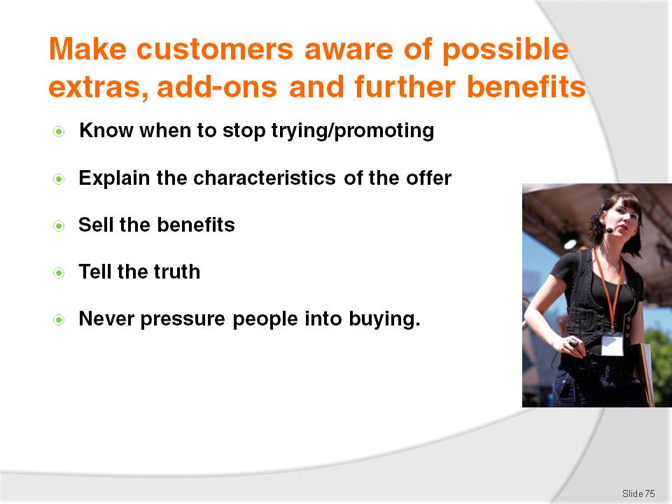
Slide No | Trainer Notes
Trainer continues to identify to trainees the keys to effectively suggesting extras, add-ons and features to visitors and tourists include:
Know when to stop. Be alert to the potential for visitors not to want to be given information about add-ons. Recognise these verbal and non-verbal cues quickly and stop ‘promoting’: insisting on trying to sell extras can only be counter-productive in these cases
Explain the characteristics of the add-ons and extras. These are the tangible factors related to the product or service: see ‘Examples of possible extras and add-ons’ on following slides
Describe the benefits of the add-ons and/or extras. These commonly relate to cost and time saving: see following slides
Tell the truth. Never adopt the belief there is a need to make a sale ‘at any cost’. Always be honest in everything, including telling people about any potential down-sides of suggestions or offers
Never put pressure on people to buy add-ons or extras. Make people aware of options and give them advice but never try to force people to purchase add-ons or extras.

Slide
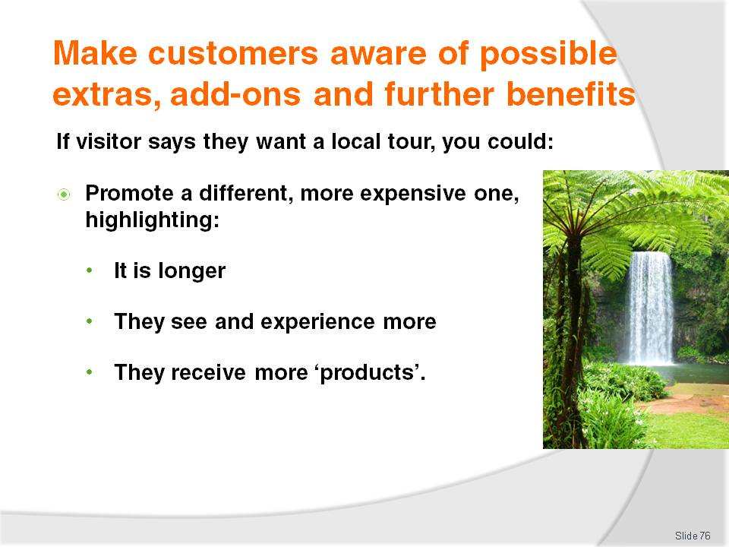
Slide No | Trainer Notes
Trainer highlights to trainees that selling extras and add-ons is all about promoting ‘complementary’ products or services.
Trainer provides the following examples of keys to effective promotion:
If the visitor has indicated they want to participate in a local tour, try to sell them a different tour (a more expensive one) to what they originally indicated they were going to undertake because it enables them to benefit from tangible elements such as:
- It is a much longer tour – an extra two hours
- It covers more things – for example, they might:
- See more animals
- Experience more shows
- Participate in extra activities
- Have access to restricted areas
- It gives them more products such as (perhaps):
- Merchandise – cap, T-shirt, pen
- A photograph of them with animals, standing in front of a monument, on a chair lift.

Slide
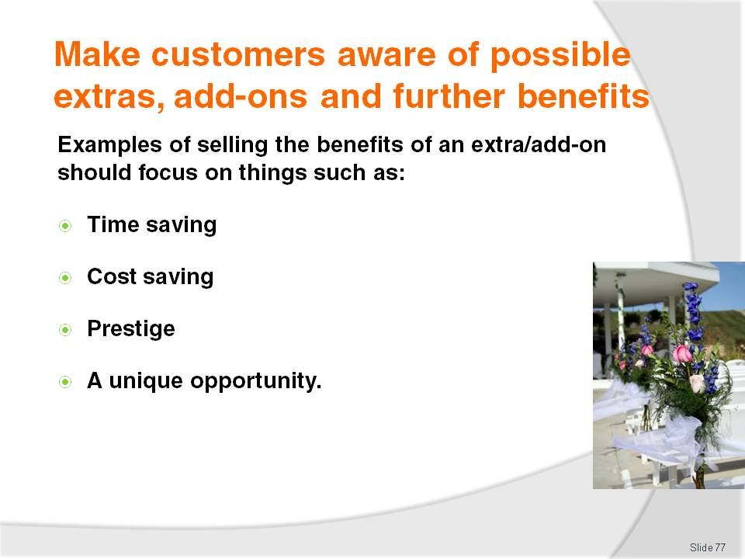
Slide No | Trainer Notes
Trainer provides trainees with examples of ‘selling the benefits’ (as opposed to the physical characteristics) of the add-ons and/or extras :
Pre-purchasing a certain ‘package’ may mean they do not have to queue on arrival at the theme park, zoo, to gain entry (time saving)
Buying a book of tickets means the cost of each ride is cheaper (cost saving)
Purchasing a tour means elements of the tour/packages are bundled and they receive better value for money (cost saving)
This particular tour is only available at this location and nowhere else in the world (making it ‘unique’ and giving it prestige).

Slide
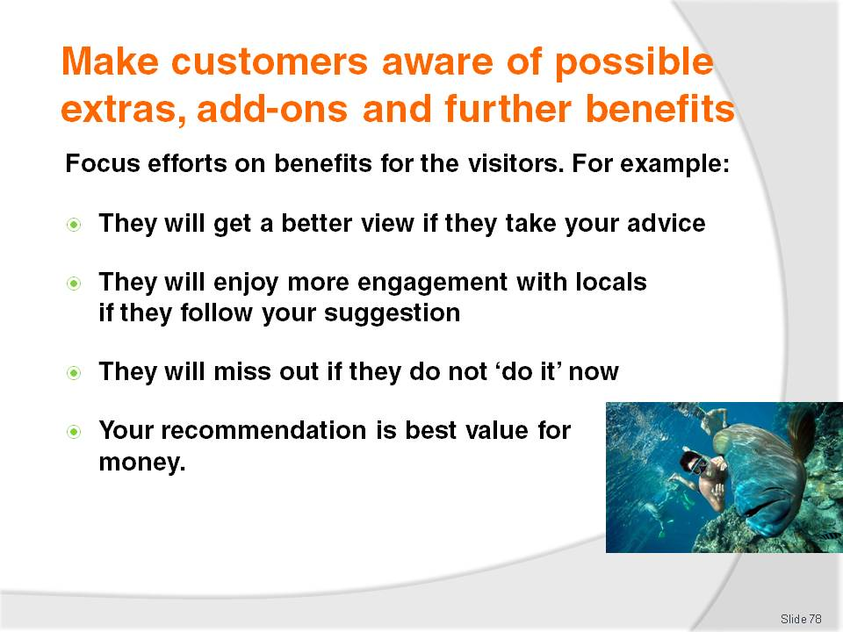
Slide No | Trainer Notes
Trainer further identifies trainees should use their local knowledge to advise people regarding their purchases by recommending a certain ‘add-on’ or ‘extra’ because:
It will give them a better view. For example, buying a higher-priced seat may mean the tourists are not looking into the sun, or they are sitting in a shaded area
It will enable them to have greater engagement with more/different people or animals or experiences or sites
The offering is only available today, this week, this month, this season, this year
The more expensive 4:30PM tour is better than the 10:00AM one because the later tour includes the feeding of the animals
Taking the cable car to the gardens will provide a spectacular view over the bay, the mountains and the city and it avoids heavy local traffic congestion.
Class Activity – Small Group Exercise
Trainer divides trainees into small groups and asks each group to:
Identify a tourism product or service
Identify the extras and add-ons that could complement the product or service
Explain how the identified add-ons/extras could be sold by describing the:
- Physical characteristics of the product/service
- Benefits of the product/service
- Demonstrate how they would promote what they have identified to visitors.

Slide
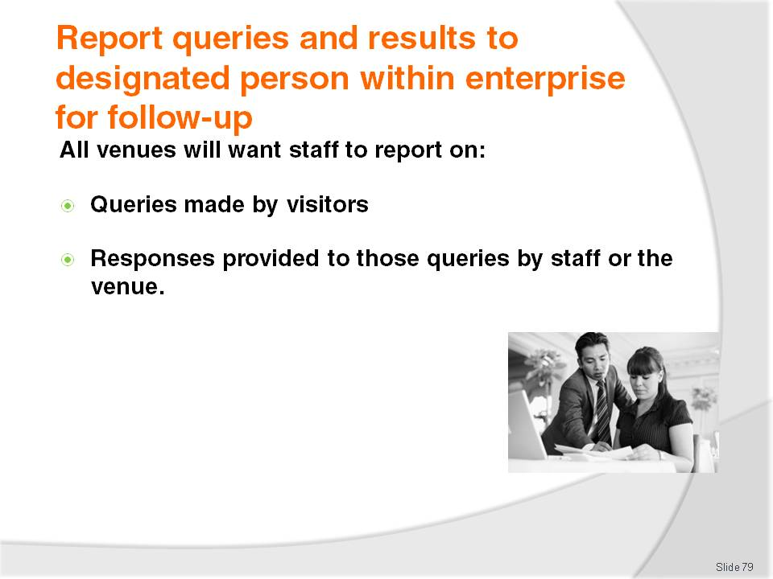
Slide No | Trainer Notes
Trainer explains to trainees it is standard operating procedure in most venues for staff who have face to face contact with customers/guests to provide feedback to management about their experiences involving visitors/tourists especially as they relate to the questions they ask and the result of advice or information provided to them.
Trainer identifies in this context ‘queries’ relates to any questions asked by customers, guests, visitors and tourists about:
Local events, attractions
What they can do and where they can go while staying at the venue or in the area
Local options for tourism activities, tours, displays, meetings, shows, displays
Local transport and local facilities
Local products and services.
In essence, any question asked by a visitor can be regarded as a ‘query’ for the purposes of this Section – even a basic type of question (such as when the dining area is open) – is a relevant query as it indicates a need for the venue to be able to supply this type of information.
Trainer further identifies ‘Results’ refer to the effectiveness of the response given by staff to visitors who asked questions explaining effectiveness should address issues such as:
Was there a communication problem?. For example, was a difference in language a problem preventing effective communication?
Could there have been a better option for providing the information? For example, would it have been more effective (with the benefit of hindsight) to have given the guest a map rather than verbal direction?
Was there a lack of knowledge about the question? This may indicate a need for the venue to capture more information on the topic in question
How well did the information provided by the staff meet visitor needs, wants, preferences, parameters? For example, when a guest returned to the hotel, did they indicate they enjoyed the tour/attraction suggested by staff, or not? If not, why not? Was it too expensive, too far to travel, too expensive, not interesting/exciting enough, unsafe?

Slide
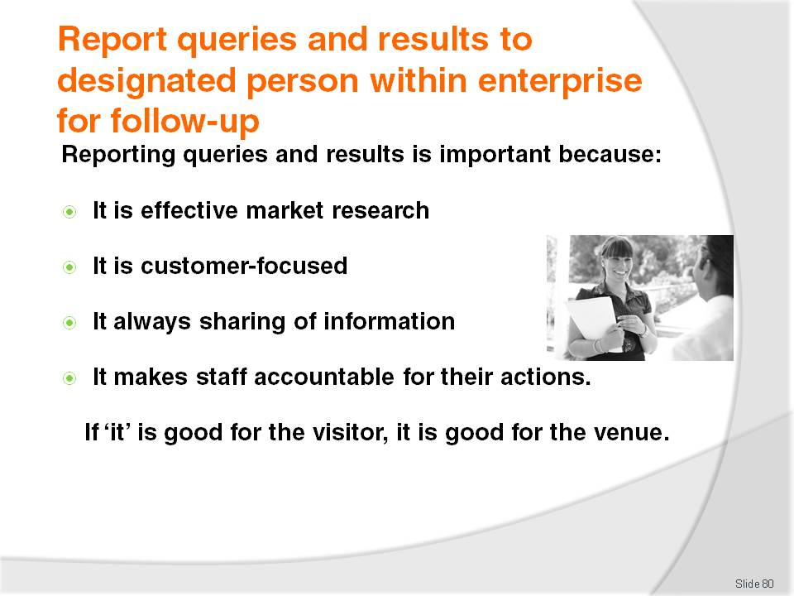
Slide No | Trainer Notes
Trainer stresses to trainees it is important for every tourist venue/destination to be actively involved in monitoring the queries of visitors, and the information provided to visitors by venue staff, because:
This is an effective and inexpensive way of identifying what is important and of interest to our visitors. It is cheap market research
It demonstrates customer focus – meaning the venue can use the research to better create experiences more appropriately suited to identified customer needs, wants and preferences
This is an excellent way of sharing information between staff at the venue about what to do, and about what not to do, say, suggest and about what is effective and what is not
It makes staff accountable. If employees know their actions and recommendations are going to be fed back to management they will tend to be more responsible, sensible and focused in what they suggest
Regular meetings of this nature amongst staff and with management help staff maintain a focus on customers and their needs, as opposed to creating a focus on themselves and the venue. The focus must always be on the customers/tourists and what is best for them
If ‘it’ is good for the visitor, it will ultimately be good for the venue.

Slide
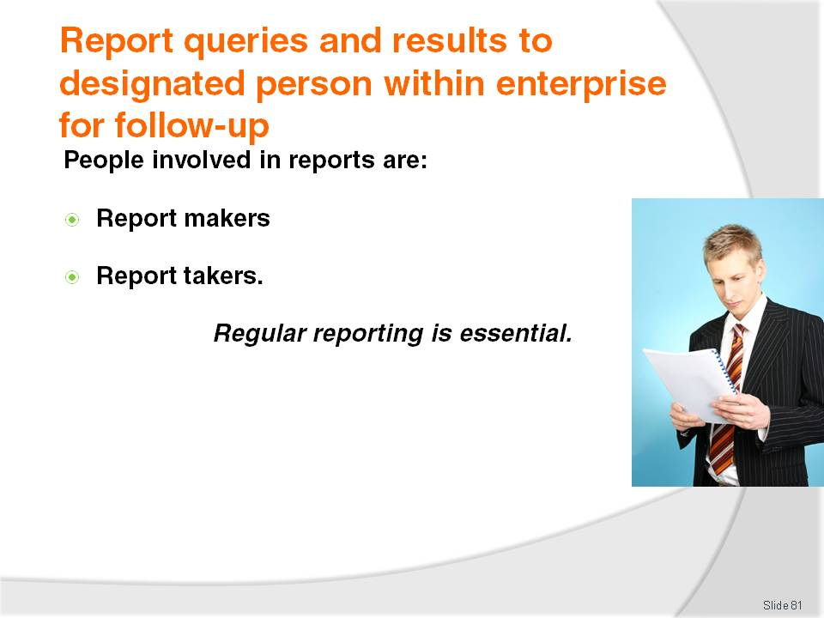
Slide No | Trainer Notes
Trainer identifies personnel involved in reports are:
Report makers. This includes all customer contact or frontline staff:
- Reception/front office staff
- Porters and concierge
- Waiting staff – food and beverage
- Bar staff
- Attendants in retail outlets within the property
- Tour guides and tour vehicle drivers
- Ride attendants
- Ushers and Information officers
Report takers may include:
- Owner of the business
- Managers
- Marketing department
- In-house trainers
- Safety and security officers.

Slide
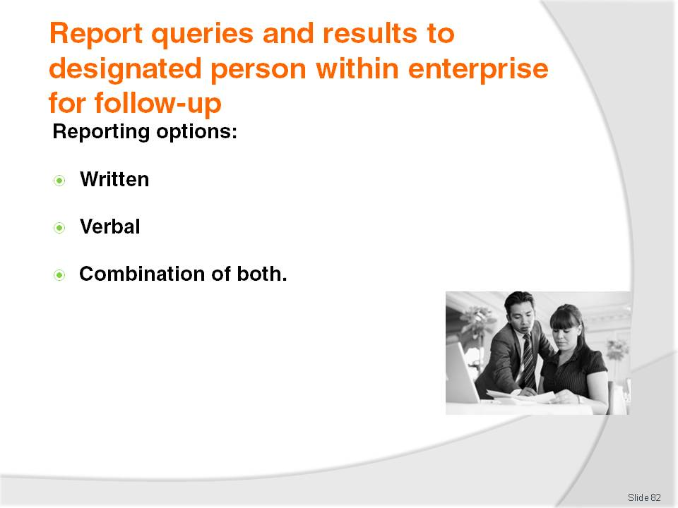
Slide No | Trainer Notes
Trainer identifies to trainees the basic options for providing these reports is:
Written report –which often involves completion of a pro forma document to ensure relevant items are covered, and to speed up the process. The written report may be delivered in hard copy form, or electronically forwarded via the intranet
Verbal report on a face to face basis either one on one or in a group setting such as a staff meeting, briefing or training session
A combination of the verbal and written feedback. This is arguably the most effective and informative but is also the most expensive and time consuming.

Slide
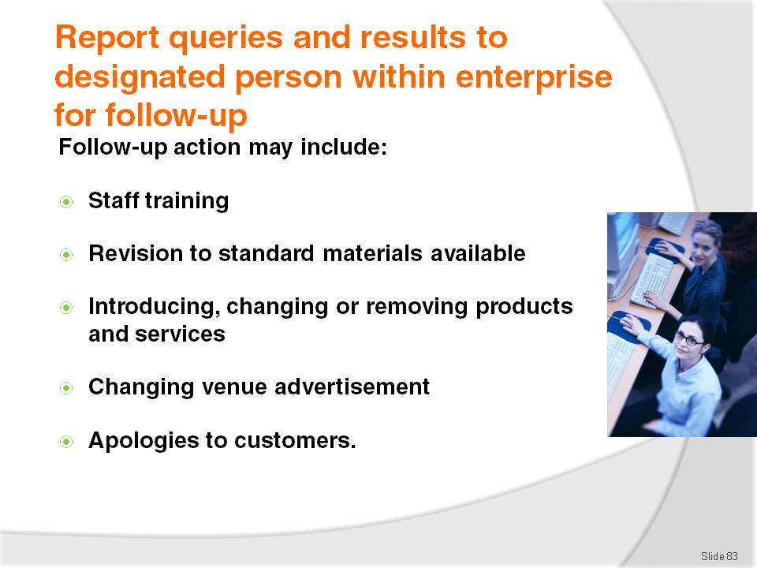
Slide No | Trainer Notes
Trainer explains the nature of the follow-up required to queries and results will depend on the nature of the issues identified, but possible action may include:
Staff training which could involve:
- Learning more venue, product and local knowledge
- Learning another language or some simple/useful phrases or words from the language of another country from which lots of visitors come
- Learning how to more effectively question and/or listen to people to better identify their needs
- Revisions to standard internal training materials and content
- Revising the suggestions, recommendations and information to be given to visitors
Revision to standard materials available at the venue, for example:
- Obtaining more or different brochures, flyers, maps, schedules, price lists
- Updating materials identified as being out of date. These can be found in displays, behind reception, at the concierge desk and in the room compendiums
- Creating materials to meet an identified need where no other materials exist
Introducing, changing or removing products and services:
- To better meet identified needs
- Notifying sales representatives and commission agents about changes
- Promoting the new/revised products, services or packages and inclusions
Changing venue advertisements:
- In order to better accommodate/target identified needs, wants and preferences
- In terms of online advertisements, brochures for the venue, media advertisements and entries in travel books and with Visitor Information Centres
Apologies to customers which may involve:
- Verbal or written apology
- A refund or substitute product or service or a discount or special offer for another product or service.
Class Activity – Guest Speaker
Trainer arranges for a suitable management-level person from a venue/attraction to attend and talk to trainees about:
The importance of knowing about visitor needs, wants and preferences
How they identify what their guest/visitor needs, wants and preferences are
How they encourage their frontline staff to report on visitor queries
How they obtain ‘results’ regarding their provision of advice and information to visitors
Action they might take in response to:
- Positive outcomes
- Negative outcomes.

Slide
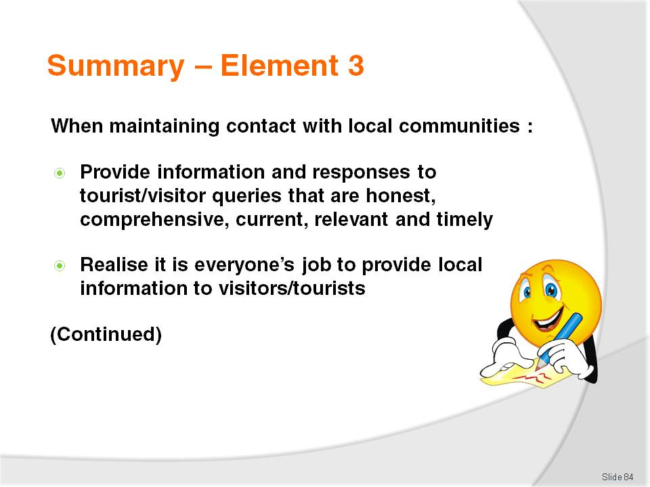
Slide No | Trainer Notes
 | Trainer provides a recap of the Element asking questions to check trainee understanding and responding to questions from trainees, as required.

Slide
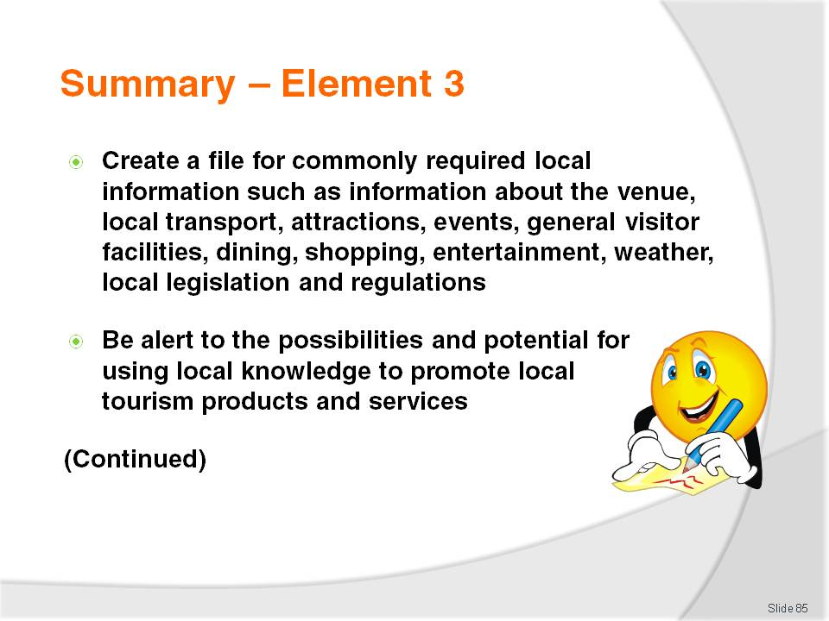
Slide No | Trainer Notes
 | Trainer provides a recap of the Element asking questions to check trainee understanding and responding to questions from trainees, as required.

Slide
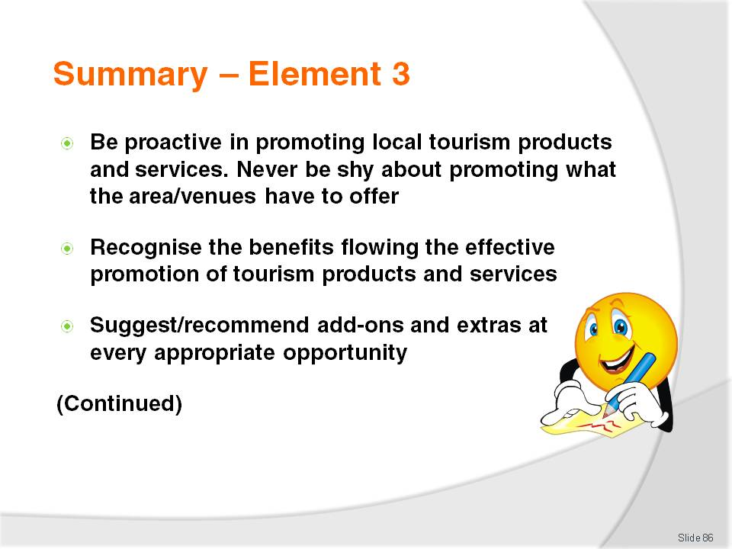
Slide No | Trainer Notes
 | Trainer provides a recap of the Element asking questions to check trainee understanding and responding to questions from trainees, as required.

Slide
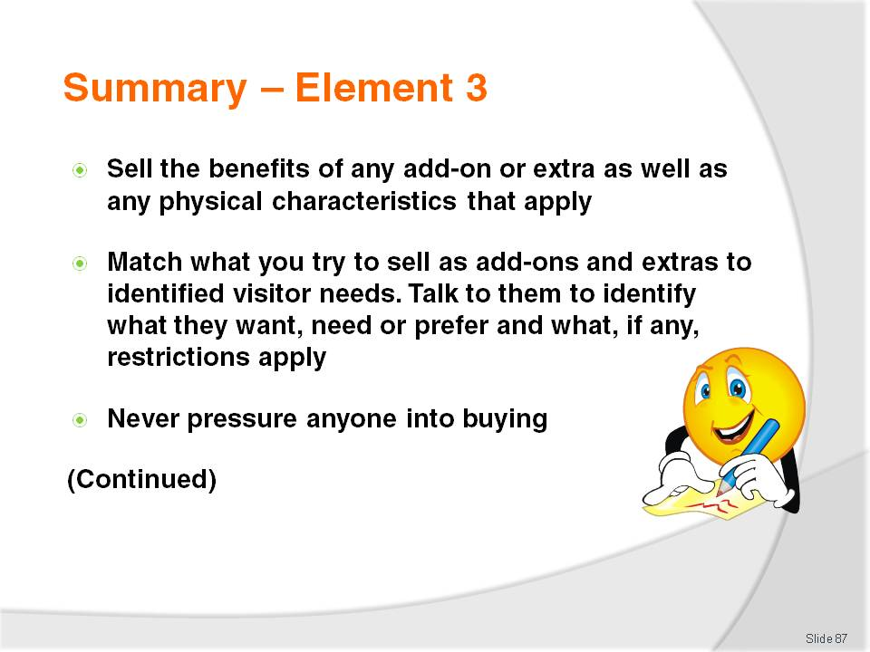
Slide No | Trainer Notes
 | Trainer provides a recap of the Element asking questions to check trainee understanding and responding to questions from trainees, as required.

Slide
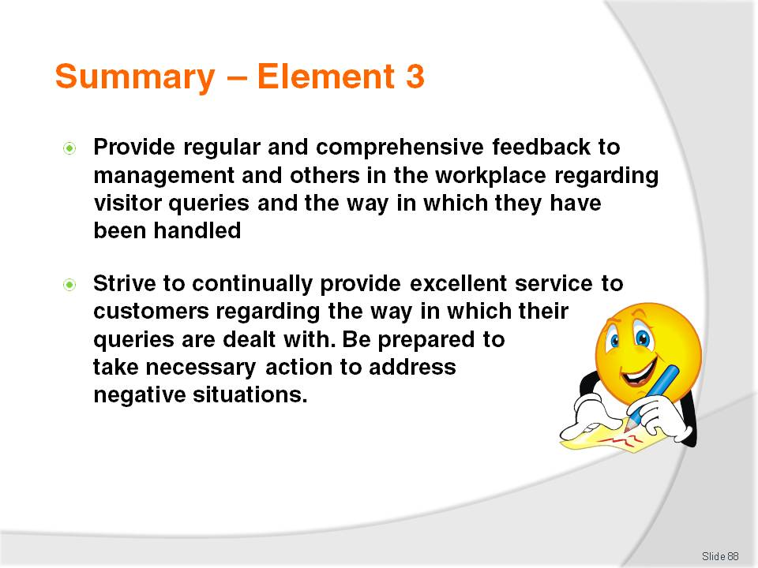
Slide No | Trainer Notes
Trainer provides a recap of the Element asking questions to check trainee understanding and responding to questions from trainees, as required.
Trainer thanks trainees for their attention and encourages them to apply course content as required in their workplace activities.

Recommended training equipment
Computerised Reservation System with local knowledge/information database
Samples of promotional materials from the local Visitor Information Centre relating to the local area such as (but not limited to) advertising materials (flyers, pamphlets, booklets and brochures, operating schedules and opening hours, price lists, alerts, local customs, local maps, national street directory) for the local area, venues, attractions and events
Posters depicting local attractions, scenes, and events
Filing cabinets and supporting materials – manila folders; file boxes
Brochure display standards/carousels
Computer with Internet access
Telephone
Samples research questionnaires
Sample venue ‘information kits/packs’
Sample ‘local information’ lists
Sample local visitor information – ‘This Week In …’
Marketing-related reports from local bodies, businesses and agencies
Local resources
Information relating to the local area as available in:
- Advertising materials (flyers, pamphlets, booklets and brochures) for local venues, attractions and events
- The series of ‘Lonely Planet’ books as applicable to individual countries
- Local industry and trade magazines
- Local newspapers
- Local telephone books
- Newsletters from local organisations and bodies.

Instructions for Trainers for using
PowerPoint – Presenter View
Connect your laptop or computer to your projector equipment as per manufacturers’ instructions.
In PowerPoint, on the Slide Show menu, click Set up Show.
Under Multiple monitors, select the Show Presenter View check box.
In the Display slide show on list, click the monitor you want the slide show presentation to appear on.
Source: http://office.microsoft.com
Note:
In Presenter View:
You see your notes and have full control of the presentation
Your trainees only see the slide projected on to the screen
More Information
You can obtain more information on how to use PowerPoint from the Microsoft Online Help Centre, available at: http://office.microsoft.com/training/training.aspx?AssetID=RC011298761033
Note Regarding Currency of URLs
Please note that where references have been made to URLs in these training resources trainers will need to verify that the resource or document referred to is still current on the internet. Trainers should endeavour, where possible, to source similar alternative examples of material where it is found that either the website or the document in question is no longer available online.

Appendix – ASEAN acronyms
AADCP | ASEAN – Australia Development Cooperation Program.
ACCSTP | ASEAN Common Competency Standards for Tourism Professionals.
AEC | ASEAN Economic Community.
AMS | ASEAN Member States.
ASEAN | Association of Southeast Asian Nations.
ASEC | ASEAN Secretariat.
ATM | ASEAN Tourism Ministers.
ATPMC | ASEAN Tourism Professionals Monitoring Committee.
ATPRS | ASEAN Tourism Professional Registration System.
ATFTMD | ASEAN Task Force on Tourism Manpower Development.
CATC | Common ASEAN Tourism Curriculum.
MRA | Mutual Recognition Arrangement.
MTCO | Mekong Tourism Coordinating office.
NTO | National Tourism Organisation.
NTPB | National Tourism Professional Board.
RQFSRS | Regional Qualifications Framework and Skills Recognition System.
TPCB | Tourism Professional Certification Board.







